

**SYNTHESIS REPORT**

**Authors:**

Liesbeth de Schutter, Stefan Giljum, Rene Polly

(Vienna University of Economics and Business, Austria)

Prajal Pradhan, Tobias Seydewitz, Anne Warchold

(Potsdam Institute for Climate Impact Research, Germany)

Patricia Fuentes Saguar

(University Pablo de Olavide, Seville, Spain)

Alfredo Mainar-Causapé

(University of Seville, Spain)

Sebastian Poledna, Nikita Strelkovskii

(International Institute for Applied Systems Analysis, Austria)



**Content**

About the BIOCLIMAPATHS project and this Synthesis Report 3

1. EU bioeconomy in a context of increasing climate extremes 6

1.1 Dual role of EU bioeconomy in sustainability transformations from a climate change and climate hazard risk perspective 6

1.2 Biophysical impacts of climate extremes on primary activities in the EU bioeconomy 7

1.3 Risk propagation channels of climate extremes in the EU bioeconomy 10

2. Regional patterns of climate extremes in the EU 13

2.1 Introduction 13

2.2 Changes in climate extremes in the last decades 14

2.3 Weather extremes 17

2.4 Synthesis of results 18

3. Direct biophysical impacts of climate extremes in the EU bioeconomy 19

3.1 Introduction 19

3.2 Past and future crop yield damages across Europe 20

3.3 EU hotspots of losses in biomass production due to climate extremes 22

3.4 Climate extreme impacts on crop production at the EU level 26

3.5 Synthesis of results 27

4. Indirect biophysical impacts of climate extremes in the EU bioeconomy 28

4.1 Brief method description 29

4.2 Impact propagation of climate hazard related shocks in the EU bioeconomy: supply perspective 30

4.3 Impact propagation of climate hazard related shocks in the EU bioeconomy: industrial demand perspective 30

4.4 Network analysis of risk transmission channels in the EU bioeconomy 30

4.5 Synthesis of results 30

5. Monetary impacts of climate extremes in the EU bioeconomy 30

5.1. Database and frameworks 30

5.2. Analytical methods and main research products 31

5.3 Selected results 33

5.4 Synthesis of results 39

6. Vulnerabilities in regional bioeconomies under climate extremes (case study Austria) 39

6.1 Brief method description 40

6.2 Impacts and vulnerabilities in the current bioeconomy in Austria 40

6.3 Synthesis of results and outlook 44

7. Bioeconomy transition paths for Austria 46

7.1 Brief method description 46

7.2 Regional assessment of fossil carbon use 47

7.3 Regional assessment of biobased carbon supply and use 49

7.4 Regional markets for biobased carbon and conversion factors for biorefinery products 50

7.5. Synthesis of results and outlook 51

8. Interactions between SDGs and bioeconomy 52

8.1 Introduction 52

8.2 Data for SDGs and bioeconomy 52

8.3 Synergies and trade-offs between SDGs and bioeconomy 55

9. Synthesis 61

9.1 Reflection and discussion on the interdisciplinary approach 61

9.2 Summary of results and their potential use 63

9.3 Recommendations for further research 65

References 66

# About the BIOCLIMAPATHS project and this Synthesis Report

This synthesis report is a product from the ERANET-AXIS project “BIOCLIMAPATHS” on the assessment of impacts, risk propagation channels and potential vulnerabilities from changing patterns of climate extremes in the EU bioeconomy. The report summarises the project’s main findings for stakeholders in the EU bioeconomy, including research communities, actors in food and non-food bioeconomy supply chains, policy makers and others concerned with climate related disruptions of the biobased foundation of our economic systems and societies. In line with the theme of the 2018 AXIS funding scheme, i.e. the assessment of cross-sectoral climate impacts and pathways for sustainable transformations, BIOCLIMAPATHS contributes to broadening the knowledge base that helps guiding sustainable EU bioeconomy strategies towards meeting the Paris Climate Agreement and the UN Sustainable Development Goals (SDGs). This is realised through an assessment of complex social and ecological impacts, risks and (positive and negative) feedback effects associated with climate extremes. Based on the summary of research activities in BIOCLIMPATHS, this synthesis report provides insights for designing and assessing bioeconomy strategies for more resilient societies in the context of fundamental uncertainty and change in the global biosphere.

The **objectives** of the BIOCLIMAPATHS project and this synthesis report are to

(1) contribute to more accurate estimations and better quantified uncertainties with respect to the relation between the **most relevant climate extremes and primary biomass production** at the sub-national level of the EU;

(2) identify and understand **risk propagation channels of climate extremes** in terms of shocks in primary biomass supply and their impacts on biobased supply chains;

(3) identify (potentially) **vulnerable economic activities, regions and social groups** for climate hazard related risks in a bioeconomy, in particular farmers and households, both in the current as well as in more advanced bioeconomies;

(4) develop the first EU databases of **national and** **sub-national input-output (IO) tables** with **disaggregated bioeconomy sectors**, to assess social and environmental impacts of climate hazards on food and non-food biomass supply chains from a global trade network perspective;

(5) advance macro-economic modelling in the field of climate impact research by developing a bioeconomy focused regionalised **Agent-Based Model embedded in the national IO table (hybrid IO-ABM).** For the first time, the transmission of climate hazards has been traced through bioeconomy supply chains onto individual agents in regional socio-economic systems;

(6) present a **novel SDG framework to assess bioeconomy strategies**, capturing both their role as mitigation strategy towards curbing anthropogenic CO2 emissions, as well as their role as driver of adverse (feedback) effects in the climate system, both in terms of unsustainable resource use and related environmental pressures in the global resource system.

To achieve its objectives, the BIOCLIMAPATHS project developed an interdisciplinary methodological framework for comprehensive knowledge production on climate risk transition paths in a bioeconomy from a cross-sectoral, i.e. social and ecological, perspective. Its approach is based on soft-linking biophysical and economic databases into a step-wise modeling approach to address **five key research questions** on novel risks related to bioeconomy transitions in the EU economy:

**R1:** What are (future) climate hazard hotspots in the EU and how do climate hazards affect primary production in the EU bioeconomy?

**R2:** How can we assess biophysical and socially amplified risk transmission channels of climate extremes in the EU bioeconomy?

**R3:** How are food and non-food bioeconomy sectors affected by direct and indirect impacts of climate extremes in the EU?

**R4:** To what extent are heterogeneous regions and vulnerable groups affected by climate extremes in a bioeconomy?

**R5:** How is socio-economic and social-ecological resilience, in particular food, climate and economic security, affected and promoted in different bioeconomy transition paths subject to climate hazard risk?

Figure 1 provides an overview of the **methodological approach** to address the research questions with the step-wise, interdisciplinary, approach.

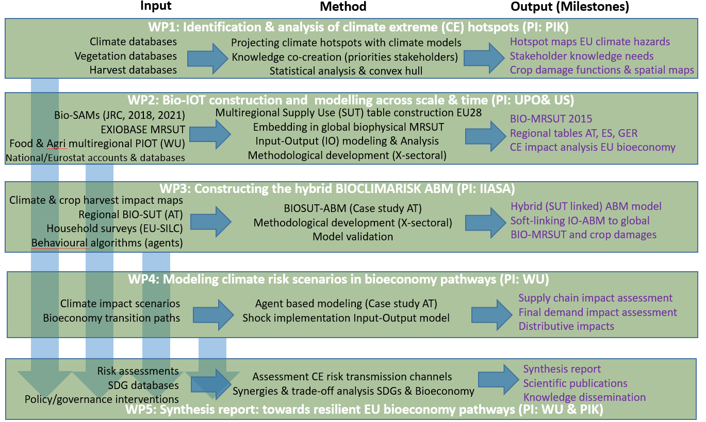

Figure 0‑1: Overview of the BIOCLIMAPATHS methodological approach by means of 5 work packages (WPs). PIK: Potsdam Institute For Climate Impact Research, UPO: Universidad Pablo d’ Olavide, US: Universidad de Sevilla, IIASA: International Institute for Applied Systems Analysis, WU: Wirtschatsuniversität Wien/Vienna University of Economics & Business.

Climate, vegetation and crop production databases are the starting point for the assessment of biophysical risk transmission channels. Biophysical and monetary Supply-Use Tables have been constructed and/or updated for the analysis of climate extreme impacts at the level of national and sub-national regions, including bioeconomy supply chains and institutional sectors. Finally, firm and socio-economic databases at the sub-national level of Austria have been used to regionalize both the national level Input-Output Table and an Agent-Based Model towards regional (NUTS2 level) input-output tables with a high bioeconomy sector resolution. The assessment of climate extreme risk transmission channels of climate hazard risks in the Austrian Bioeconomy has been achieved by soft-linking biophysical, input-output and agent-based models.

The project has been implemented as five interrelated work packages by an **interdisciplinary research team** between April 2020 and December 2022.The team consisted of researchers from Germany (*Potsdam Institute For Climate Impact Research), Spain (Universidad Pablo d’ Olavide and Universidad de Sevilla) and Austria (International Institute for Applied Systems Analysis and the Vienna University of Economics & Business), together* representing multiple scientific disciplines, climate regions and stakeholders in the EU bioeconomy. The project has been co-funded by the Federal Ministry of Education, Science and Research in Austria, the Federal Ministry of Education and Research in Germany, the Ministry of Science and Innovation in Spain, as well as by the European Union, as partners in the AXIS 2018 call “Assessment of Cross(X) - sectoral climate impacts and pathways for sustainable transformation”[1]. Apart from this report, scientific publications and other communications can be found at the project’s web-site [www.bioclimapaths.eu](http://www.bioclimapaths.eu).

As a deliverable of the project, this **Synthesis Report** summarises the main findings and results of the BIOCLIMAPATHS project and addresses the listed research questions, both throughout the chapters and summarized in its final chapter. In the first chapter (Ch.1), we will define the EU Bioeconomy and the BIOCLIMAPATHS research approach from an interdisciplinary social-ecological systems perspective and, based on the literature, highlight the relevance of studying climate extreme impacts in a bioeconomy transition context from a risk transmission perspective. Chapter 2 highlights changing patterns of climate extremes for selected climate extremes in the context of the EU bioeconomy. Chapter 3 describes the use of climate extreme databases for the methodological development of yield and production impact analysis and shows results of direct climate extreme impacts for selected crops at the NUTS1, national and aggregated level of the EU.[2] The following two chapters extend the direct impact analysis of climate extremes towards indirect impacts on supply chain activities in the EU bioeconomy, both from a biophysical perspective (Chapter 4) and a monetary perspective (Chapter 5). Chapter 6 connects EU level impacts of climate extremes with the regional level in Austria and shows that the methodological integration in BIOCLIMAPATHS goes beyond the state of the art in sub-national impact assessments of climate extremes on heterogeneous agents in a bioeconomy context. It should be noted that the model and presented results have been applied to the current bioeconomy in Austria and that we continue to work on more advanced bioeconomy transition paths in the Austrian context after project closing. To that purpose, Chapter 7 describes the assumptions and estimates transition capacities of four bioeconomy transition paths at the regional (sub-national) level of the Austrian bioeconomy. Chapter 8 presents the SDG framework to assess the dual role of bioeconomy strategies, both as mitigation strategies towards curbing anthropogenic CO2 emissions, as well as potential driver of adverse (feedback) effects in the biosphere. In chapter 9, we answer the research questions to the extent possible, by synthesizing the results of the different chapters.

1. EU bioeconomy in a context of increasing climate extremes

1.1 Dual role of EU bioeconomy in sustainability transformations from a climate change and climate hazard risk perspective

In the context of climate change and the continued high dependency on fossil fuels, the European Union (EU) has launched a bioeconomy strategy in 2012 (European Commission, 2012). Through the replacement of non-renewable fossil fuels by renewable biobased resources in material and energy supply chains, mainly based on primary and secondary products from agricultural and forestry activities, bioeconomy strategies aim at mitigating climate change by reducing anthropogenic greenhouse gas emissions. In this context, bioeconomy is defined as the production, utilization, conservation, and regeneration of biological resources, including related knowledge, science, technology, and innovation, to provide sustainable solutions (information, products, processes and services) within and across all economical sectors and enable a transformation to a sustainable economy (Global Bioeconomy Summit, 2018). The original aim of the EU Bioeconomy Strategy was to support research and development of industrial innovations, as well as at their upscaling for the enhancement of competitive markets, green growth and employment at the European and Member State level. However, the evaluation and update of the EU Bioeconomy Strategy in 2018 recognised ecological risks and potentially adverse impacts related to unsustainable use of biobased resources in the global resource system and emphasized the importance of ‘regional bioeconomies’ that take stock and respect ecological boundaries in local, largely rural, resource use contexts (European Commission, 2018). As a result, an increasing number of sub-national regions are in the process of designing and implementing bioeconomy strategies, based on their ecological, agricultural, industrial and/or logistical conditions (Biber-Freudenberger et al., 2018; European Commission, 2022).

At the same time, climate extremes including floods, storms, heat waves and droughts in the EU have increased in frequency and intensity as a result of anthropogenic climate drivers, of which an estimated one third is generated by land use change and greenhouse gas emissions in the global food system (Vermeulen et al., 2012; Tubiello et al., 2021). Furthermore, as a bioeconomy transition implies a more direct dependency of a wide variety of economic value chains on primary biomass production and productivities (yields), and because extreme events due to climate change are projected to increase (Spinoni et al., 2018; IPCC, 2022), socio-economic exposure and related vulnerabilities to climate hazard risk are likely to increase in societies with more advanced future bioeconomies. As such, bioeconomy strategies may not only contribute to climate change mitigation, but may also drive environmental degradation, increase inequalities within and among societies and may hamper the achievement of the EU 2030 climate and energy targets and the UN SDGs. Improving our understanding of the dual role of a bioeconomy transition in relation to increasing climate hazard risk from a social-ecological systems perspective is a fundamental step to building social-ecological resilience and to plan effective mitigation and adaptation strategies. This also includes the sub-national level where regional bioeconomy strategies are to be implemented (Kircher, 2019; Schutter et al., 2019).

1.2 Biophysical impacts of climate extremes on primary activities in the EU bioeconomy

A wake up call on the potential impacts of extreme climate events in Europe has been the extreme drought and heat wave in the summer of 2003, when summer temperatures have been 20 to 30% higher than the seasonal average in an area ranging from Spain to the Czech Republic, as well as from Germany to Italy (Copa-Cogeca, 2003). The co-occurring heat and drought wave has been associated with a large number of casualties among elderly, destruction of forest areas (by forest fires), disruptions of water ecosystems and a substantial decrease in agricultural production (Bono et al., 2004). In total, an estimated 647,069 hectares of forest area had been destroyed, largely in Portugal and Spain. In crops, compared to the 2002/2003 growing season, fodder output decreased by 60% in France, 40% in Italy and 30% in Germany, Austria and Spain. Maize production dropped with nearly 30% in France, 25% in Italy and 14% in Spain, whereas wheat production dropped with nearly 20% in France and Austria. Potato output had suffered production declines of ca. 37% in Spain, 26% in France and 25% in Germany. Apart from yield drops, the harvested potato area was also lower (smallest area since 1995). Overall, the arable sector suffered from an aggregated drop of ca. 10% in production compared to the previous year. In addition, the livestock sector has been severely impacted by reduced feed grain and fodder supplies, resulting in higher feed costs and depressed farm incomes. Fresh grass and hay (from pastures) had suffered from moisture shortage and the resulting lack of green forage negatively affected the beef and dairy sector by decreased milk supply, lower milk quality and early slaughterings. Among the livestock sectors, eggs and poultry meat had been hit hardest (by heat stress) with decreased productivity and a reduction in the poultry flock of up to 30% in Spain. Support to relieve vulnerable groups in society mainly included measures to increase feed supply (Copa Cogeca, 2004).

For the year 2018, one study (Beillouin et al., 2020) found that both extremes in temperature and in precipitation were associated with negative yield anomalies in Europe, but with varying impacts among regions. Multiple and simultaneous crop failures due to drought and temperature extremes in spring and summer in Northern and Eastern Europe, in particular of wheat and barley (not maize), were found to be nearly offset by favorable higher than usual yields due to favorable spring rainfall conditions in Southern Member States. Furthermore, this study found that no single climate variable explained a large fraction of the yield anomalies and that no clear trend in the frequency of extreme yield losses could be identified for any of the considered crops between 1990 and 2018. The authors stress the importance of considering both single and compound climate extremes to analyse the causes of yield damages. Lesk et al. (2016) applied a superposed epoch analysis to estimate average national per-disaster cereal production losses due to droughts, floods and extreme temperature disasters between 1964 and 2007. Most importantly, the authors showed that cereal production in Europe, as well as in other technically advanced, high-income regions, decreased by almost 20% on average per climate extreme event, as compared to lower than the global average reductions in low-income regions. However, average yield responses in high-income regions generally reflect high yield levels and resulted from a limited number of extreme impacts and a large majority of moderate yield responses.

The above indicates the potential severity of climate extreme impacts at the national level. However, research shows that national level impacts may largely differ from local impacts and that it is important to pay more attention to the impacts of extreme weather events at the sub-national level (Pagliacci and Russo, 2019). In particular, it has been shown that agri-food activities in rural regions are highly vulnerable to climate related shocks, both in developing and developed regions. Although the majority of climate extreme related literature at the local level tends to focus on flood related events, as these are reported as monetary damages in institutionalised disaster databases, heatwaves, water scarcities and droughts have been associated with increasing farm and public level impacts in agriculture and rural communities (Iglesias and Garrote, 2015; Aguiar et al., 2018).

Based on our own analyses of sub-national production losses in the 20 most important wheat producing regions at the NUTS1 level of the EU (including Denmark and Czech Republic as national level regions), we found mixed results for changes in frequency and intensity of climate extreme impacts over the period 1981-2000 (Figure 1.1). In terms of frequencies of extreme years, including events of heat, cold, drought and precipitation extremes, we find evidence for a tendency towards a higher frequency in Northern (Germany) and Eastern (Hungary, Poland) regions of the EU in recent decades, but not in the largest producing regions of France. With respect to the intensity of climate extremes, a decrease in impacts has been noted in the regions that were most strongly affected in the 1981-2020 period, i.e. wheat producing regions in Spain and Germany, whereas most other regions show no clear pattern of increase or decrease in impact intensity. This could indicate that climate extreme adaptations in the most affected regions may have been successfully implemented. In particular, such adaptations involve the storage and access to water sources for irrigation, as water sources tend to become inaccessible during periods of drought extremes (Schewe et al., 2019).

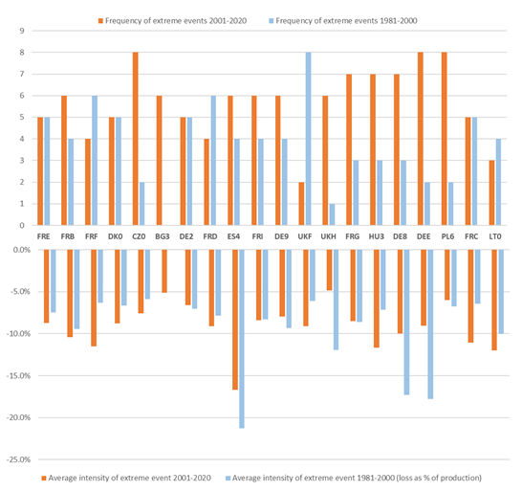

Figure 1.1: Frequency and intensity of extreme events for the 20 largest EU wheat-producing regions (period 1981-2000 and 2001-2020) (Source: Yield and production data from Eurostat; Climate extreme data from ERA5-Land reanalysis dataset)

As for the future, the IPCC sixth assessment (IPCC, 2022) indicates that (most of) European agriculture will be exposed to three key climate hazard risks. (1) heat stress, including expanding fire hazard risk, resulting in substantive agricultural (and forestry) losses, (2) expanding water scarcity, which will affect irrigation possibilities and aggravate the impacts of heat stress and (3) crop losses related to more frequent river flooding. With respect to the modelling of impacts under future climate change scenarios, however, it has been shown that state-of-the-art global impact models underestimate the impacts of climate extremes on gross primary production. Most integrated assessment models capture gradual changes in crop yields and water resources in response to climate change, as well as extreme impacts on water levels. However, severe impacts of climate extremes, in particular droughts, on arable and ecosystem productivity show to be underestimated by a large margin, both by sector models as well as by crop model ensembles (Schewe et al., 2019). As such, existing climate change scenarios may be sub-optimal to assess the societal risks of climate extremes in a bioeconomy transition context. In BIOCLIMAPATHS, we therefore (also) identified historical years of climate extremes and analysed their impacts on primary production (and bioeconomy supply chains) with empirical approaches.

1.3 Risk propagation channels of climate extremes in the EU bioeconomy

A bioeconomy can be characterized by the use of biological inputs and the supply of biobased outputs by multiple food and non-food supply chains such as chemistry, textiles, construction materials and energy (for example, Kircher, 2021). As an emergent behavior of the climate system, climate extremes adversely affect ecosystem productivity and propagate as biomass supply shocks through biobased supply chains on to the household level in society. Climate induced impacts on supply chains and households, however, prove hard to isolate due to differences in the definition of extreme events, the lack of robust databases, as well as to model limitations (Arto et al., 2014; Schewe et al., 2019). Apart from the biophysical shocks, economic impacts of extreme weather events are even more challenging to estimate due to the complexity of the risk propagation channels and their feedback effects in interrelated social-ecological systems (Challinor et al., 2018). Agriculture and food activities are generally understood as complex adaptive systems in heterogeneous contexts (Lansing, 2003) and their complexity is further increased by transnational supply chains in the global food trade network (Puma et al., 2015; Bednar-Friedl et al., 2022). FAO (2011) warns that disproportional impacts of agricultural commodity or food price shocks on society emerge because governments and households assign low probability to the occurrence of extreme shock and, hence, are not prepared for large-scale (trade) disruptions. In line with this, (Foti et al., 2013; Dalin et al., 2017) point at potential similarities with ecosystem behavior, where “increasing connectivity corresponds to increasing robustness for small shocks but to decreasing robustness in the face of large, cascading shocks up to the system”. Building on that knowledge base, BIOCLIMAPATHS’ scientific basis for the logic flow of knowledge production is grounded in a systems perspective on bioeconomy transition paths in the interdependent social-ecological system (Figure 1.2).

Interdependency means that social systems are dependent on life sustaining services from ecosystems and the climate system, and that the behaviour of ecosystems and the climate system is largely influenced by human (economic) conduct and their governance structures in society (Anderies et al., 2004). Indeed, climate hazard risk can be understood as emergent properties in the social-ecological system (Díaz Simal et al., 2011), where bioeconomy transition paths can both mitigate and exacerbate the intensity of impacts and, hence, understanding their impacts is critical for social-ecological resilience in societies under climate change (see also chapters 6 and 7).

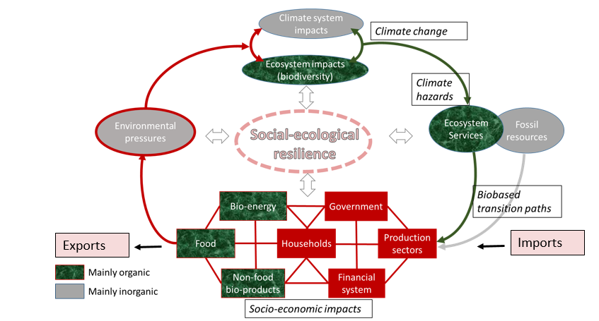

Figure 1.2: Conceptualisation of bioeconomy transition paths from a social-ecological systems perspective

From an interrelated systems perspective, a typology for two distinct transmission channels of climate risk has been proposed in the literature (Challinor et al., 2018), i.e. (1) climatic risk transmissions and (2) resource-generated transmissions of climate hazards. Single, recurring or tele-connected weather extremes **(“Hazard”**) may cause resource generated shocks in primary production **(“Direct Impact”**), leading to socially constructed amplification responses that affect prices of commodities and value added of supply chains in the global resource system (**“Indirect Impacts”**). The risk transmission channel approach takes a global network perspective, which is different from a spatially oriented risk perspective in climate impact research.

In a bioeconomy context, the first, climatic risk transmission channel, e.g. El Nino leading to large-scale drought events, may affect supply and related access to food and feedstock along multiple regions and sectors in the global resource system. We call this the **biophysical risk transmission channel** of climate hazards. The second – parallel - type of risk transmission channels is associated with real or perceived resource limitations from supply shocks by exposed activities, regions or societies as a whole, resulting in e.g. export restrictions or other (price affecting) governance measures in the global resource system. We call this the **social amplification channel of climate hazard risk** in a bioeconomy context. As an example, yet in a different context, price increases of food commodities in the world market have been associated with trade measures in response to disrupted supply chains by the war in Ukraine and Russia (Figure 1.3). This has affected food security of marginalized groups in the global resource system, especially in lower income countries (Mamonov et al., 2022).

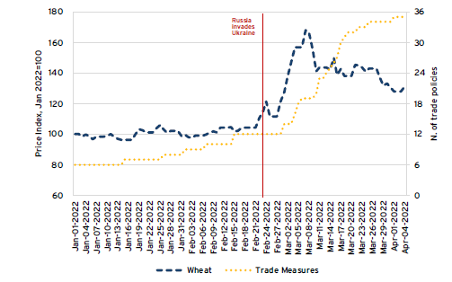

Figure 1.3: International wheat prices and trade policy measures (Source: Ruta, 2022. Figure copied with permission)

The risk that a climate extreme propagates a crisis through disproportional impacts along its transmission channels also needs to take the concept of **vulnerability** into account (i.e. the inability of households, sectors, communities, countries to absorb adverse impacts). For example, rice price increases are generally easier absorbed by high-income regions than by low-income, often more rice dependent, regions. Hallegatte and colleagues (2016; 2020) stress the importance of identifying (and defining) poor people in the disaster context, for example the bottom 20% of the consumption distribution. With this definition, both in low and high income countries, a substantial share of farmers and workers in agriculture and food related activities qualify as poor[3]. From a supply perspective, vulnerability tends to be related to a series of factors that include the type and pattern of climate extremes, soil conditions, lack of irrigation possibilities, dependence on imports to meet food needs, linkages with other sectors and the broader transmission of events in the macro-economy including exchange rate volatility and inflation uncertainty, among others (Prakash, 2011). From a consumption perspective, it is important to focus on vulnerability stemming from shocks in final demand because agriculture, food and non-food bioeconomy activities and products are of particular importance (as compared to other economic activities) for the satisfaction of subsistence needs such as food, housing, clothing, and energy needs in society (Schutter et al., 2019).

In BIOCLIMAPATHS, we address the logical chain of single and co-occurring climate extremes (chapter 2), their direct impacts on crop yields and agricultural production at the sub-national level in the EU (chapter 3) and the indirect impacts of climate extremes on activities the EU bioeconomy (chapter 4) from a biophysical risk transmission channel perspective. In chapter 5, we provide insights on the potential social amplification of biophysical risks in the EU bioeconomy in a global trade context (yet, due to a lack of price mechanisms in the methodology, the results still mainly reflect biophysical impacts). Chapter 6, finally, provides insights on socially amplified risk transmission channels and vulnerabilities in heterogeneous regions at the sub-national level of the Austrian bioeconomy (subject to the same limitations as Ch.5). Figure 1.4 summarises the cross-sectoral assessment of climate extreme risk transmission channels in BIOCLIMAPATHS.

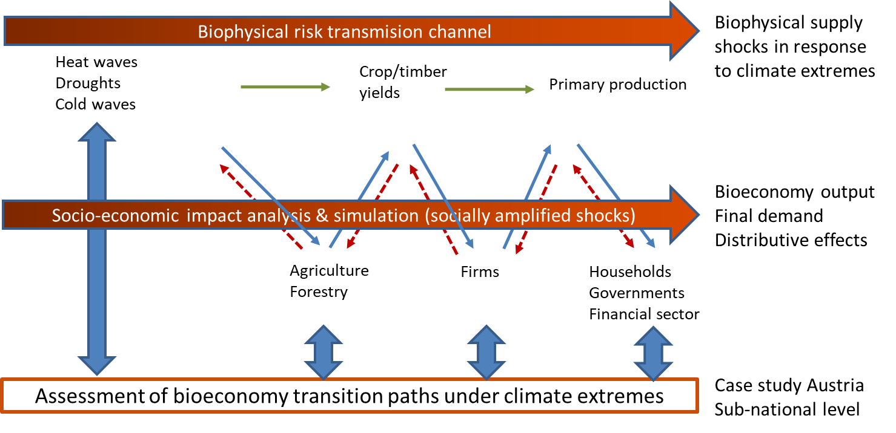

Figure 1.4: Summary of the cross-sectoral assessment of climate extreme risk transmission channels in BIOCLIMAPATHS

2. Regional patterns of climate extremes in the EU

In this chapter, we describe and carry out a temporal analysis of single and spatial patterns of climate extremes and aim at answering the following research questions:

* What changes in patterns of climate extremes can be observed in the EU?
* What are spatial hotspots of (changes in) climate extremes at the sub-national level of the EU, relevant in the context of the EU Bioeconomy?

The results, i.e. climate extreme hotspots maps for heat waves, cold waves and flash droughts at the NUTS1 level, are available at [www.bioclimapaths.eu/climate-maps](http://www.bioclimapaths.eu/climate-maps).

2.1 Introduction

The recent decades observed changing patterns of climate extremes worldwide, both in terms of their frequency and intensity, as well as their spatial extent, duration, and timing. For example, the number of cold nights has decreased, but the warm ones have increased. The number of heavy precipitation events is growing with regional variations. Climate extremes are becoming more frequent and co-occurring in a warming world, resulting in compound hazards (Forzieri et al., 2016; AghaKouchak et al., 2020). For example, a few European regions faced droughts, heatwaves, and wildfires in the same year during the period 1990–2018 (Sutanto et al., 2020), see also Chapter 1 above. More frequent climate extremes lead to a decreased return period (Lehner et al., 2006), resulting in more persistent climate extremes. For example, Europe has observed consecutive record-breaking high temperatures in recent years (Su et al., 2017). These climate extremes are and will negatively impact social and environmental systems (Forzieri et al., 2018). Thus, it is essential to better understand ongoing changes in climate extremes and their projected changes under different global warming scenarios. This chapter briefly reports our two investigations on climate extremes in Europe.

First, Pradhan and colleagues (2022) investigated changes in climate extremes for the last seven decades, considering the aggregated changes in cold, heat, drought, and precipitation extremes. For this, we used data on climate indices as measures for climate variability to derive climate extremes (Hansen et al., 1998). Our investigation is based on 39 climate indices belonging to four climate index groups (i.e., cold, heat, drought, and precipitation). We obtained the data from the European gridded observational (E-OBS) climate indices (version 22.0e) from the Copernicus Climate Change Service (C3S) for the period of 1950 to 2020 (Cornes et al., 2018). We considered a climate extreme as a climate index value beyond two standard deviations of the mean for the baseline period 1961—1990, accounting for upper and lower ends of severity.

Second, we use a percentile-based approach to assess the annual exceedance index of the three weather extremes heat waves, cold waves, and droughts for the past (1981–2020) and future (2021–2100) (Zhang et al., 2005). We provide a robust extreme event impact assessment based on this statistical non-parametric definition of weather extremes. For the past, we used daily weather records on a grid level (around 11 km at the equator) from the ERA5-Land reanalysis dataset, and for future projections, we use modelled daily weather records from EURO-CORDEX (Muñoz, 2019; Christensen et al., 2020). The baseline period for the historical scenario is 1981–2010, and for future projections 1981–2005. The shorter historical baseline for future projections is related to the fact that global circulation models were forced with different emission scenarios (RCPs) by the start of 2006. Daily thresholds for heat waves, cold waves, and flash droughts are estimated from the 90th percentile of the daily minimum and maximum temperature, 10th percentile of the daily minimum and maximum temperature, and 30th percentile of the soil volumetric water content (0–28cm), respectively (Sutanto et al., 2020). We use a five days centre data window for all three extreme events to estimate the thresholds from the previously listed baseline periods. The annual exceedance index for heat waves is calculated as the sum of days, at least for three consecutive days; the daily temperature values exceed the thresholds for June, July, and August. For cold waves, the annual exceedance index is the sum of days, at least for three consecutive days; the daily temperature values are below the thresholds for January, February, October, November, and December. Heat and cold wave exceedance indices are rescaled to NUTS1 regions using a maximum resampling. We use sequent peak analysis to detect annual flash droughts, remove minor droughts, and pool interdependent droughts for the season from June to October (Biggs et al., 2004). Droughts are rescaled to NUTS1 regions by using a mean resampling.

## 2.2 Changes in climate extremes in the last decades

We observed more frequent, co-occurring, and persistent climate extremes in the second than in the first half of our study period. A higher share of locations faces the upper end of climate extremes than the lower end. Around half of the study area experienced more frequent, co-occurring, and persistent climate extremes, considering at least two climate index groups. This section discussed the three features of climate extremes separately.

### 2.2.1 Changes in climate extreme frequencies

We observed more frequent climate extremes in the second than in the first half of our study period (Figure 2.1). Climate extreme frequency has increased for at least two climate index groups for most locations (93%), considering the upper end of severity. These locations are distributed across Eastern Europe and the Mediterranean region.

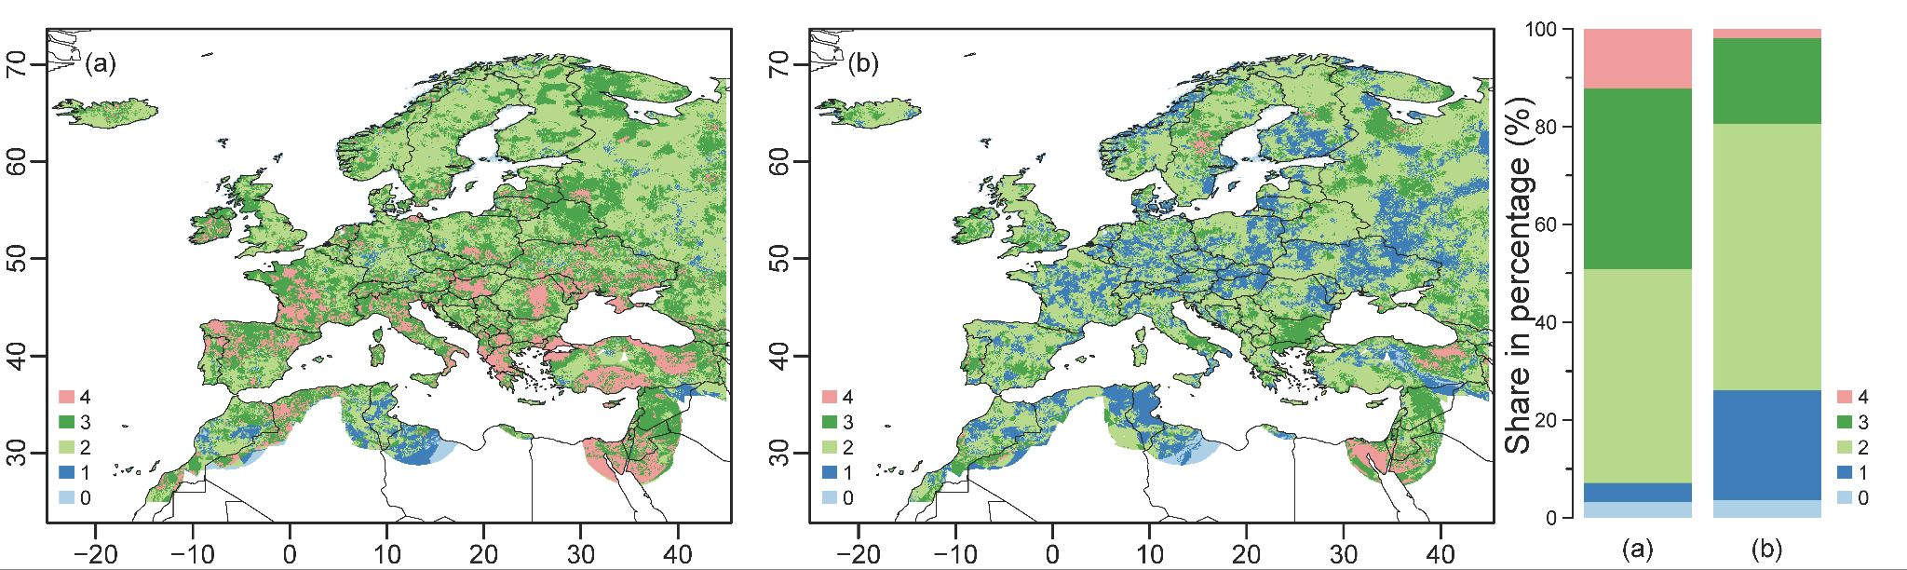

Figure 2.1: Climate extremes are becoming more frequent in the second than in the first half of the study period (i.e., 1950--1984 and 1985--2019, respectively) for (a) upper and (b) lower ends of severity. The colour represents the number of climate index groups showing this phenomenon, with the bars showing the share of locations. Note reprint from (Pradhan et al., 2022).

Changes in extreme climate frequencies vary across climate index groups. For example, fewer locations (<20%) had similar or more extreme “frost days”, “ice days”, and “heating degree days” in the second half of the study period compared to the first one. This reflected not-so-harsh winters in most locations in recent decades. However, five or more indices had more frequent heat extremes (upper end) for most locations (87%). For example, more than 65% of locations faced similar or more extreme “summer days” and “tropical nights” in the second half of the study period compared to the first one. These findings indicated that heat extremes have become and will become more intense, frequent, and longer-lasting with changing climate.

In recent decades, there has been a more frequent drought in Southern Europe and the Middle East. In the second half of the study period, around one-third of our study locations had increased drought extremes (upper end) for at least one index. Similarly, most of our study area (52%) experienced more frequent precipitation extremes (upper end), i.e., for five or more indices. These locations were distributed across the study area to a lesser extent in the Mediterranean region. However, the increased heavy precipitation was at the expense of light and moderate rainfall (Trenberth et al., 2003; Sun et al., 2007). Therefore, the Mediterranean region faced more frequent drier weather conditions.

### 2.2.2 Changes in climate extreme co-occurences

We observed an increased number of co-occurring climate extremes in the same year and location in the majority of our study area (Figure 2.2). Between the first and the second half of the study period, the share of locations with co-occurrence of climate extremes (upper end) belonging to three or more climate index groups has increased from 53% to 64%. Mainly, cold, heat, drought, and precipitation extremes have increasingly occurred in the same year in these locations. In recent decades, parts of Western Europe and the Mediterranean region have become hotspots for climate extreme co-occurrences (Figure 2.2). In contrast, climate extreme co-occurrences have decreased in parts of Eastern and Northern Europe. There were variations in co-occurrences of climate extremes within a climate index group across our study area. See Prahan et al. (2022) for these variations.

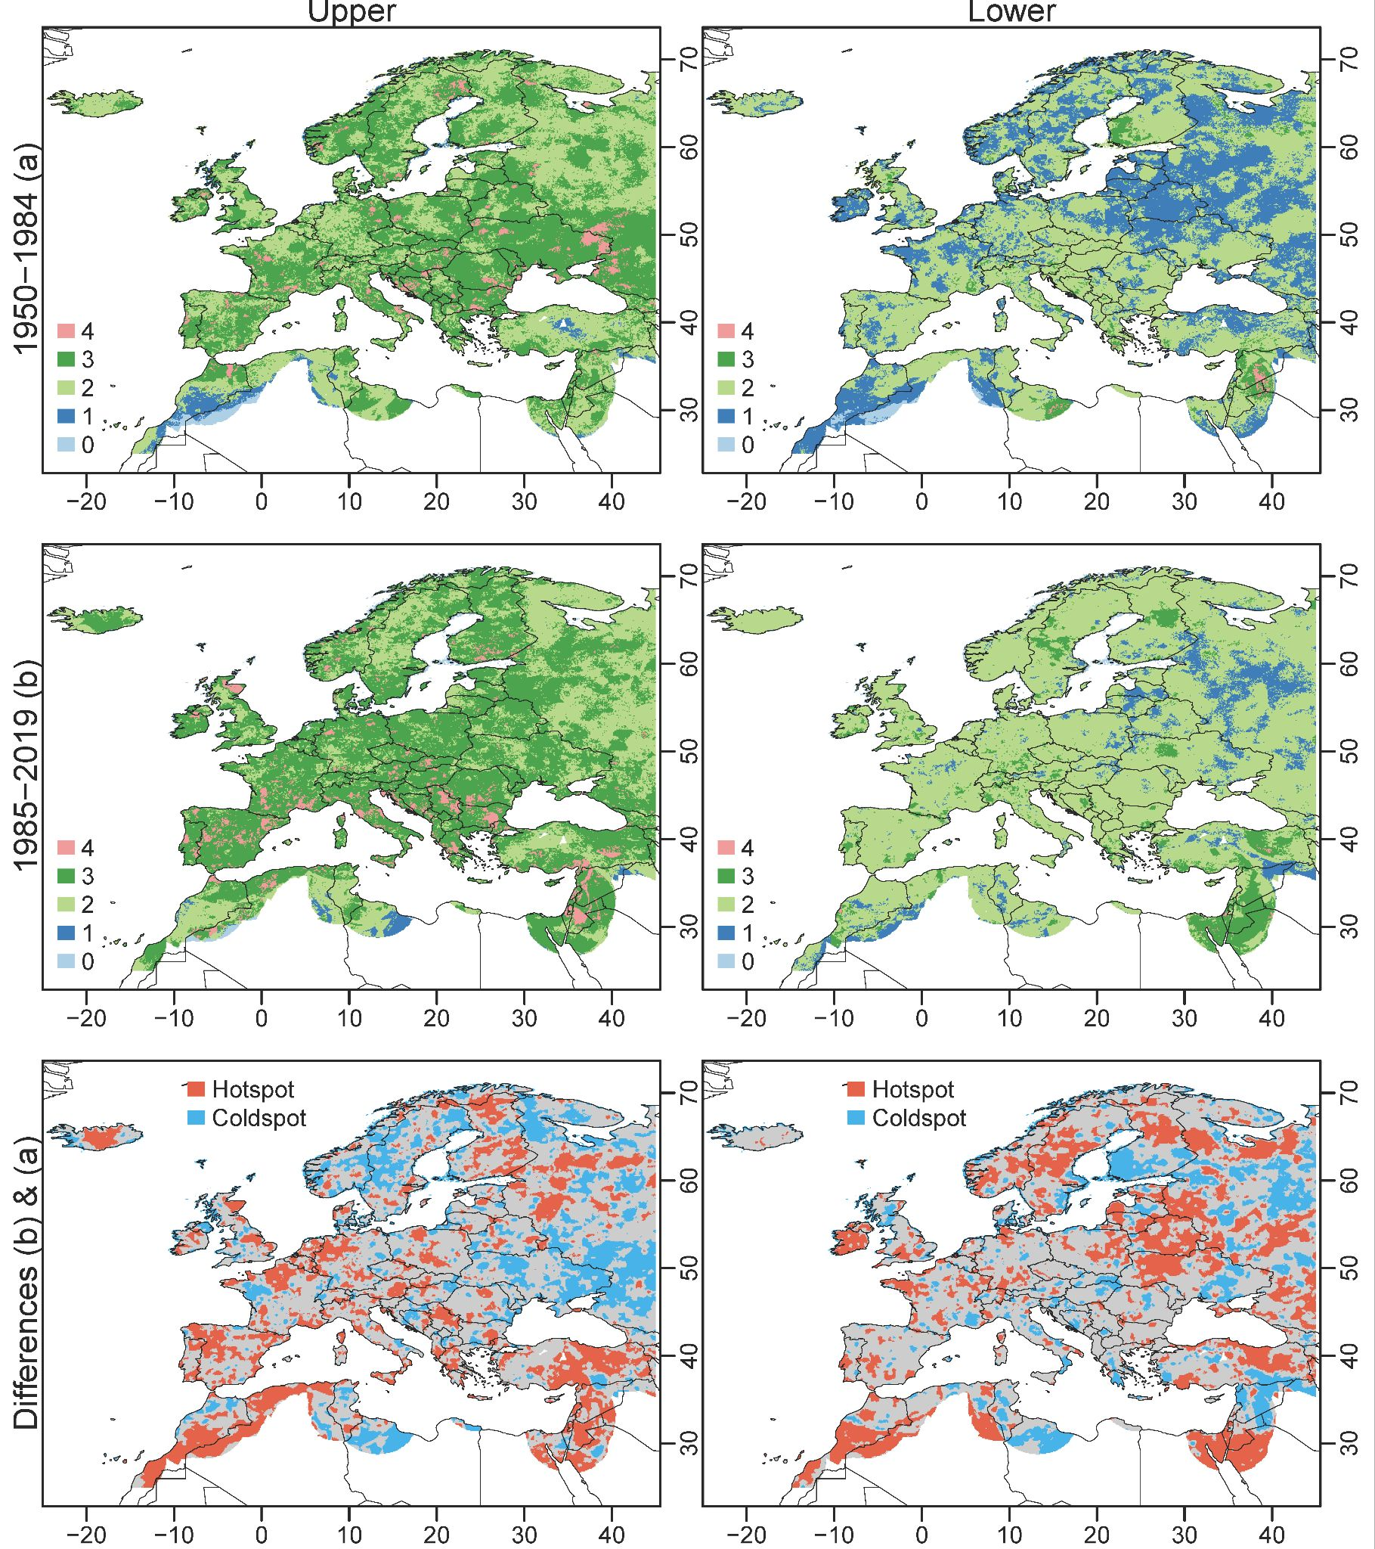

Figure 2.2: Climate extremes are becoming more co-occurring in the second (b) than in the first (a) half of the study period (i.e., 1950--1984 and 1985--2019, respectively) for the upper and lower ends of severity. Climate extreme hotspots and coldspots are identified based on the differences in the number of climate index groups between the second and the first half of the study period. Note reprint from (Pradhan et al., 2022).

### 2.2.3 Changes in climate extreme persistence

In the second half of the study period, climate extremes have also become more persistent compared to the first half. Between these periods, the share of locations with climate extreme persistence (upper end) has almost doubled, considering indices belonging to three or more climate index groups. Spatially, parts of Eastern Europe and the Mediterranean region are hotspots because they have experienced more consecutive climate extremes for different climate index groups in recent decades. The share of locations with consecutive climate extremes (lower end) has also increased from 20% to 61% between the two periods, considering indices belonging to two or more groups. Parts of Eastern and Northern Europe are hotspots at the lower end in terms of climate extreme persistence. There were variations in climate extreme persistence within a climate index group across our study area. See Pradhan et al., 2022 for these variations.

## 2.3 Weather extremes

We observe that the frequency of heat waves will increase in future across Europe while the frequency of cold waves will decrease (Figure 2.3). Our study shows that the frequency of heat waves will drastically increase in the European south and north compared to the past. Moreover, heat waves will be more frequency under a higher warming scenario of RCP 8.5 compared to a global warming below 2 °C. A greenhouse gas concentration under RCP 8.5 pathway would result on a temperature increase of about 4.3˚C by 2100, relative to pre-industrial temperatures, which will be below 2 °C under RCP 2.6. The higher increase in temperature would also result in a higher decrease in cold waves under RCP 8.5.

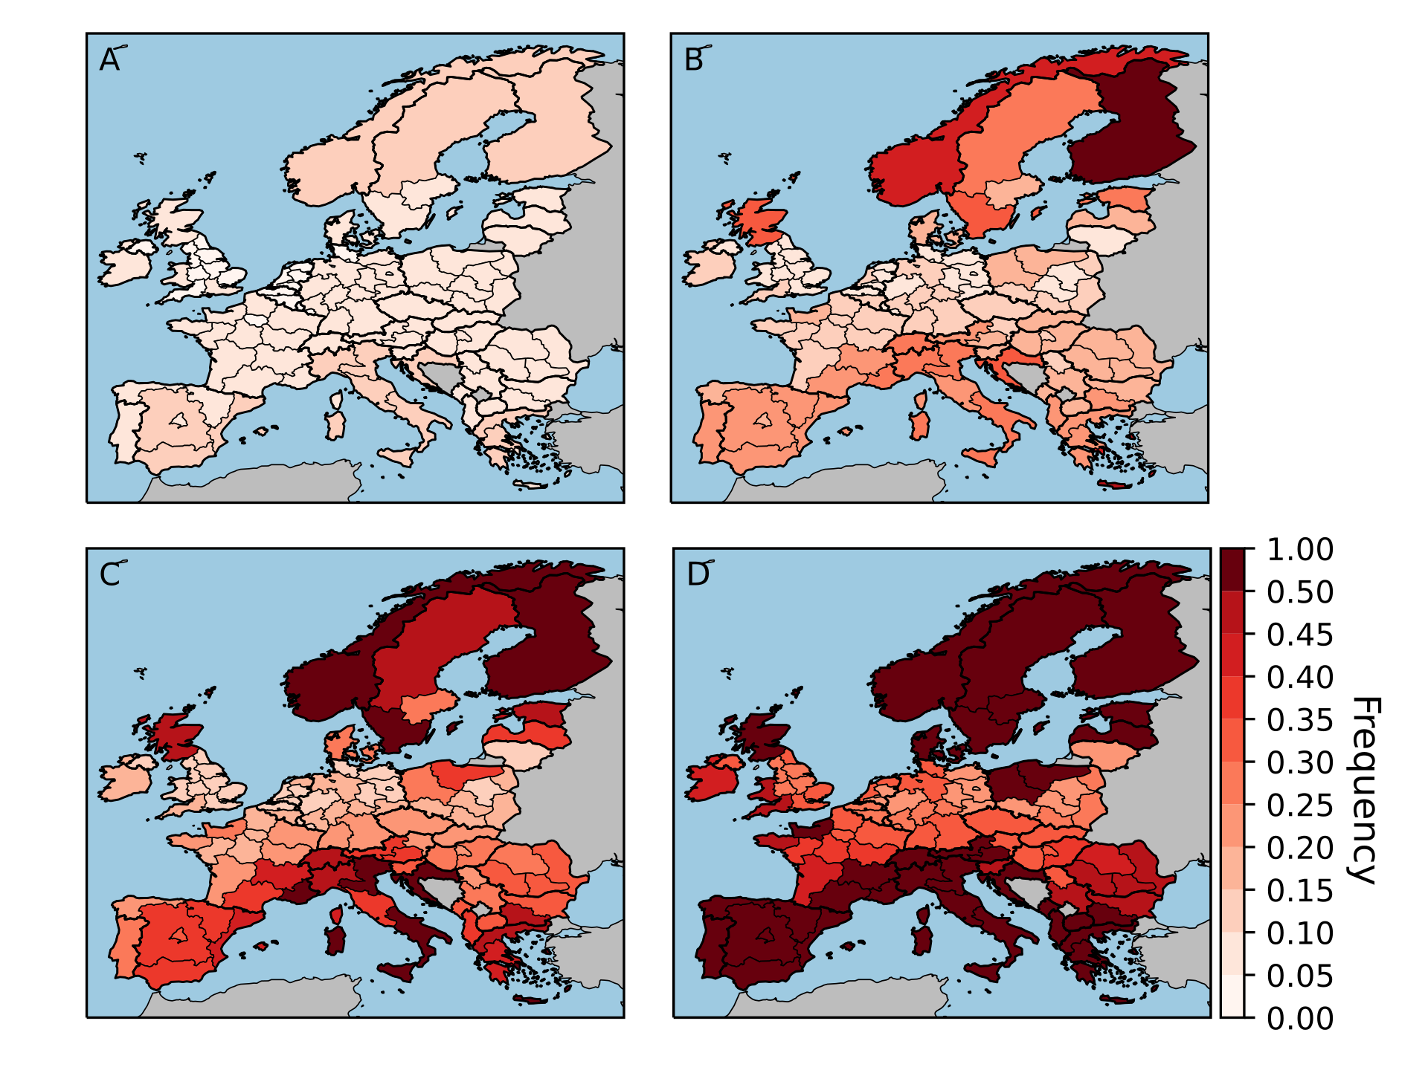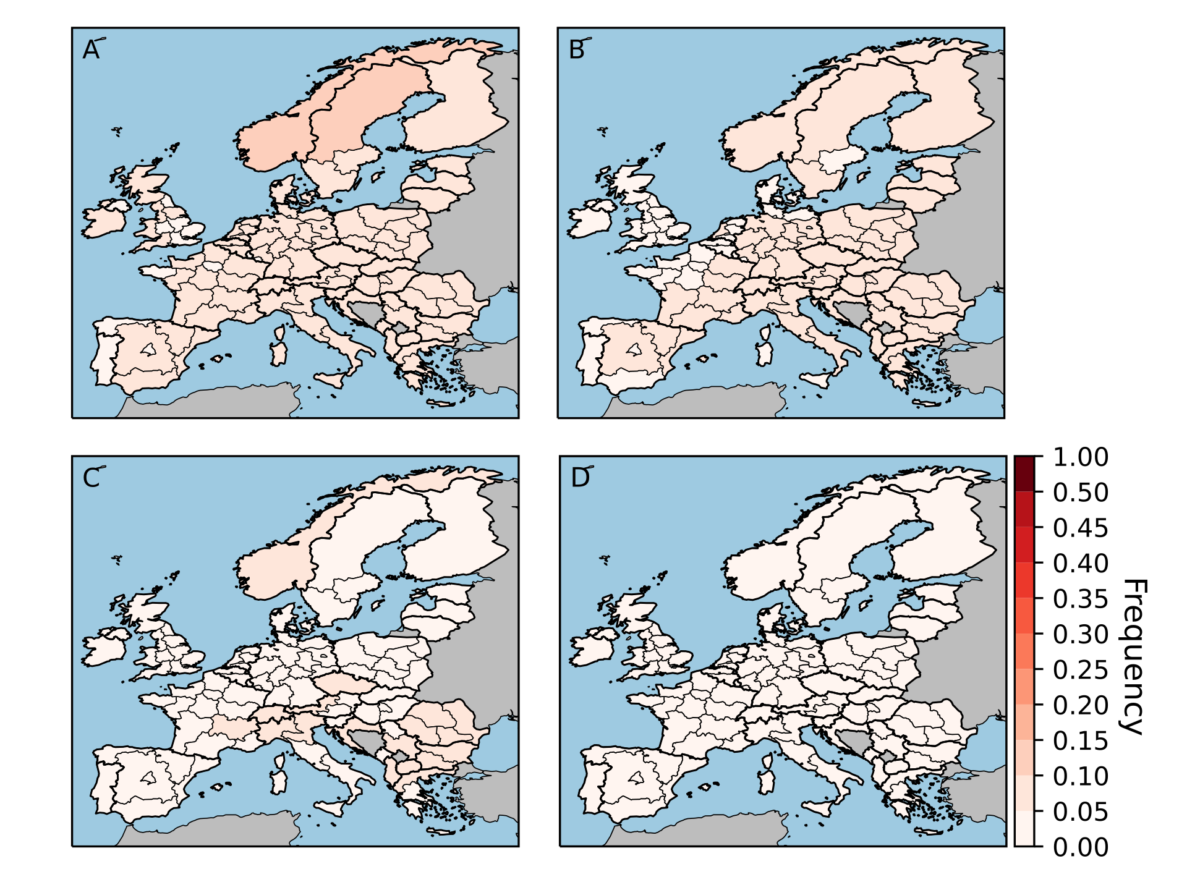

Figure 2.3: Frequency of heat waves (left panel) and cold waves (right panel) for historical 1981–2020 (A) and the future 2021–2100 scenarios RCP2.6 (B), 4.5 (C), and 8.5 (D). In future, the frequency of heat waves will increase across Europe while the frequency of cold waves decreases.

For flash droughts, we find that the centre of France and Germany experienced the highest frequency while the north of Great Britain and Ireland experienced the lowest frequency (Figure 2.4). The alpine regions of Austria, Switzerland, and Italy also experienced a low frequency of flash droughts. Our analysis of flash droughts is resticrted to the historical events because of limited data availability for future projection. Droughts are complex weather conditions, resulting from low precipitation over an extended period and often together with heat waves. All results based on our weather extreme analysis can be obtained from the open repository Zenodo (Seydewitz, 2022).

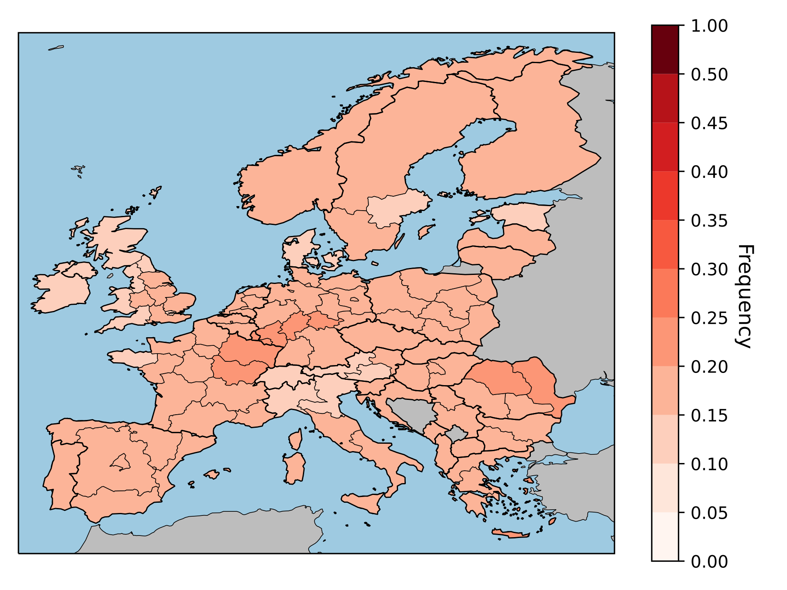

Figure 2.4: Historical (1981–2100) flash drought frequency across Europe.

## 2.4 Synthesis of results

In summary, climate extremes are becoming more frequent, co-occurrent, and persistent in Europe in recent decades. These changes in climate extremes vary across Europe spatially. For examples, most parts in Europe are experiencing warm winters while a few are suffering from cold ones. Ongoing climate change will further exacerbate climate extremes depending on the global warming scenarios. For example, heat waves will be more frequent under RCP 8.5 than RCP 2.6 scenario. Increasing climate extremes will be problematic for multiple sectors, e.g., agriculture, food, wood, non-food bioeconomy, transport, and energy, resulting in negative impacts on social and environmental systems. Interpretation of our findings also requires a discussion on limitations of the applied methodology. First, selection of the climate baseline matters on understanding climate extremes. Thus, using other baselines may vary the results on climate extremes. However, our key finding, i.e., climate extremes are becoming more frequent, co-occurrent, and persistent, will be still valid because it is based on differences between two study periods. Second, our results are based on selected datasets, which could be improved by using multiple datasets. Nevertheless, our weather extreme analysis is based on multi-model ensemble data. Third, we considered meteorological drought instead of hydrological or agricultural one, making our results less suitable for the assessment of impacts of climate extremes on social and environmental systems. Nevertheless, we investigated linkages between climate extremes and crop yield losses, deriving crop damage functions. Our next chapter elaborates on this topic.

3. Direct biophysical impacts of climate extremes in the EU bioeconomy

In this chapter, we assess the impacts of climate extremes (hazard) on net primary production in agriculture, as the first step of the propagation channel of climate hazard risk in bioeconomy supply chains. The guiding research questions for this work are:

* How have climate hazards affected primary production in the EU bioeconomy?
* What impacts of climate extremes can be expected under different climate change scenarios?

In trying to answer the above research questions, we first analysed historical impacts on crop yields and, based on that, developed yield damage functions to model yield impacts under future climate extremes. Second, we translated yield impacts in losses of net primary production at the NUTS1, national and EU level.

3.1 Introduction

Climate change and the increasing frequency of specific weather extremes and their impacts are common topics in climate science, as several studies for different ecological and economic sectors show (Seneviratne et al., 2021). The inter-sectoral impact model intercomparison project (ISIMIP) provides a broad range of datasets related to the impacts of climate change on different sectors like agriculture, biodiversity, or terrestrial biodiversity (Frieler et al., 2017). Although ISIMIP covers a broad range of impacts, these impacts are driven by a changing climate and not exclusively by weather extremes (Piontek et al., 2014). Therefore, this data is not suitable for the requirements of the BIOCLIMAPATHS project. Additionally, independent studies show that past and recent weather already caused damage to bio-economical relevant sectors such as agriculture and future scenarios suggest that this damage will increase with climate change (Deryng et al., 2014; Lesk et al., 2016; Brás et al., 2021). The impact data published alongside the listed relevant scientific literature is either global or national. Comparable to ISIMIP data, impacts are forced by a changing climate or the usage of extreme weather disasters from EM-DAT, the international disasters database. Both approaches are not within the requirements of the BIOCLIMAPATHS project. For the BIOCLIMAPATHS project, we need European sub-national scale (NUTS1) impact data for relevant bioeconomic sectors on an annual scale for the past and future scenarios. Preferable for weather extremes analyzed by a reproducible method aligned with the current best scientific practice. Furthermore, the impact data must be available for the past and a selection of future scenarios. Agriculture is identified as one relevant bioeconomic sector for the project. We developed a novel non-parametric method to analyze the impacts of dependence on weather extremes by aligning to the previously listed conditions.

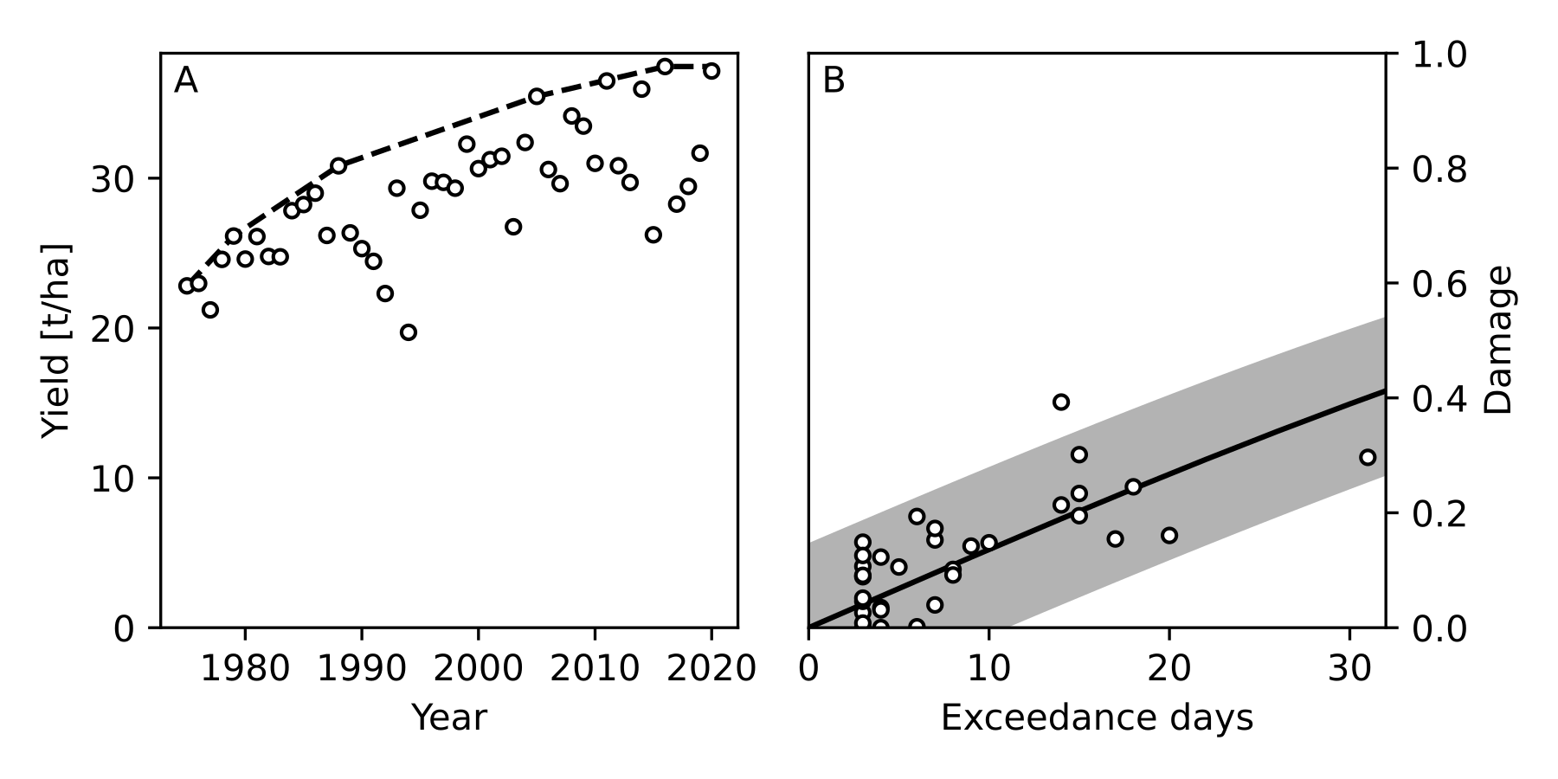Figure 3.1: (A) Upper segments of the convex-hull enveloping yield data for a selected example crop (potato) in the example Austrian region of ‘Ostösterreich’ (AT1). (B) Parametrized damage function (black line) with 95% confidence interval bands (grey) for yearly heat waves as exceedance days on the x-axis. The black-outlined dots show the relative damage calculated from the convex-hull segments’ deviation.

We use sub-national (NUTS1) annual (1975–2021) crop (68 groups) yield data from Eurostat and the annual exceedance magnitudes of the weather extremes introduced in Section 2.3. Years with substantial damage are identified by calculating the deviation of each year’s yield from the upper splines of a convex hull enveloping each crop yield time series. Figure 3.1 provides an example of our method for Ostösterreich (AT1), Austria. Damage functions (3070 functions) are derived using an ordinary least squares regression to fit a linear model. The independent variable is the magnitude of the selected weather extreme, and the dependent variable is an inverted logistic transform of the previously identified substantial yield damage years. We identify significant damage functions per extreme, spatial unit and crop type using the following four descriptive variables: yield data coverage, Spearman’s rank correlation coefficient, the significance of the correlation coefficient derived from time series randomization, and R-squared of the regression. The significant damage functions are used to estimate the mean impact of weather extremes on crop yield per crop group, NUTS1 unit for the past (1981–2021) and future (2022–2100) scenarios RCP 2.6, 4.5, and 8.5. We aggregate the predicted mean damages by production-weighted mean for each NUTS1 unit and crop group.

3.2 Past and future crop yield damages across Europe

For BIOCLIMAPATHS, we analyze the impact of three weather extremes, heat waves, cold waves, and flash droughts, on the agricultural sector in Europe on the sub-national scale. We use the relative damage on crop yield as a metric to measure the impact of weather extremes. However, there needs to be more sub-national yield data coverage to provide more scientific, sound damage functions and, therefore, a mean damage estimate for most crop groups and regions. In this study, we reject 70% (2134) of the functions for all extremes due to poor data coverage. Another 24% of the damage functions with heat waves are weakly correlated, and we removed 2% due to insignificant correlation. The remaining 4% of the functions are significant and used to estimate the impact of heat waves on crop yield across Europe.

For the historical scenario, our study shows that the mean yield damage caused by heat waves for most of the regions in Europe is below 20% (Figure 3.2). In comparison, only ten regions show heat damage above 20%, with the most severe damage in Centro Italy (39%). Predictions for RCP2.6, which overshoots the 1.5°C goal, show that the number of regions with mean yield damage exceeding 20% increases to 19, predominantly located in the south of Europe. An increasing temperature signal and, therefore, higher frequency of heat waves will lead to large-scale yield damage across Europe, as our analysis for RCP4.5 and 8.5 suggests. In more than half (30) of the regions under research (51), the mean damage is above 30% for RCP4.5, and RCP8.5 presents the most severe scenario, with damage above 50% in 37 regions. Our estimates of large-scale yield damage by heat waves for RCP4.5 and 8.5 are especially alarming due to the high likelihood of an increase in the frequency of heat waves across Europe (Seneviratne et al., 2021).

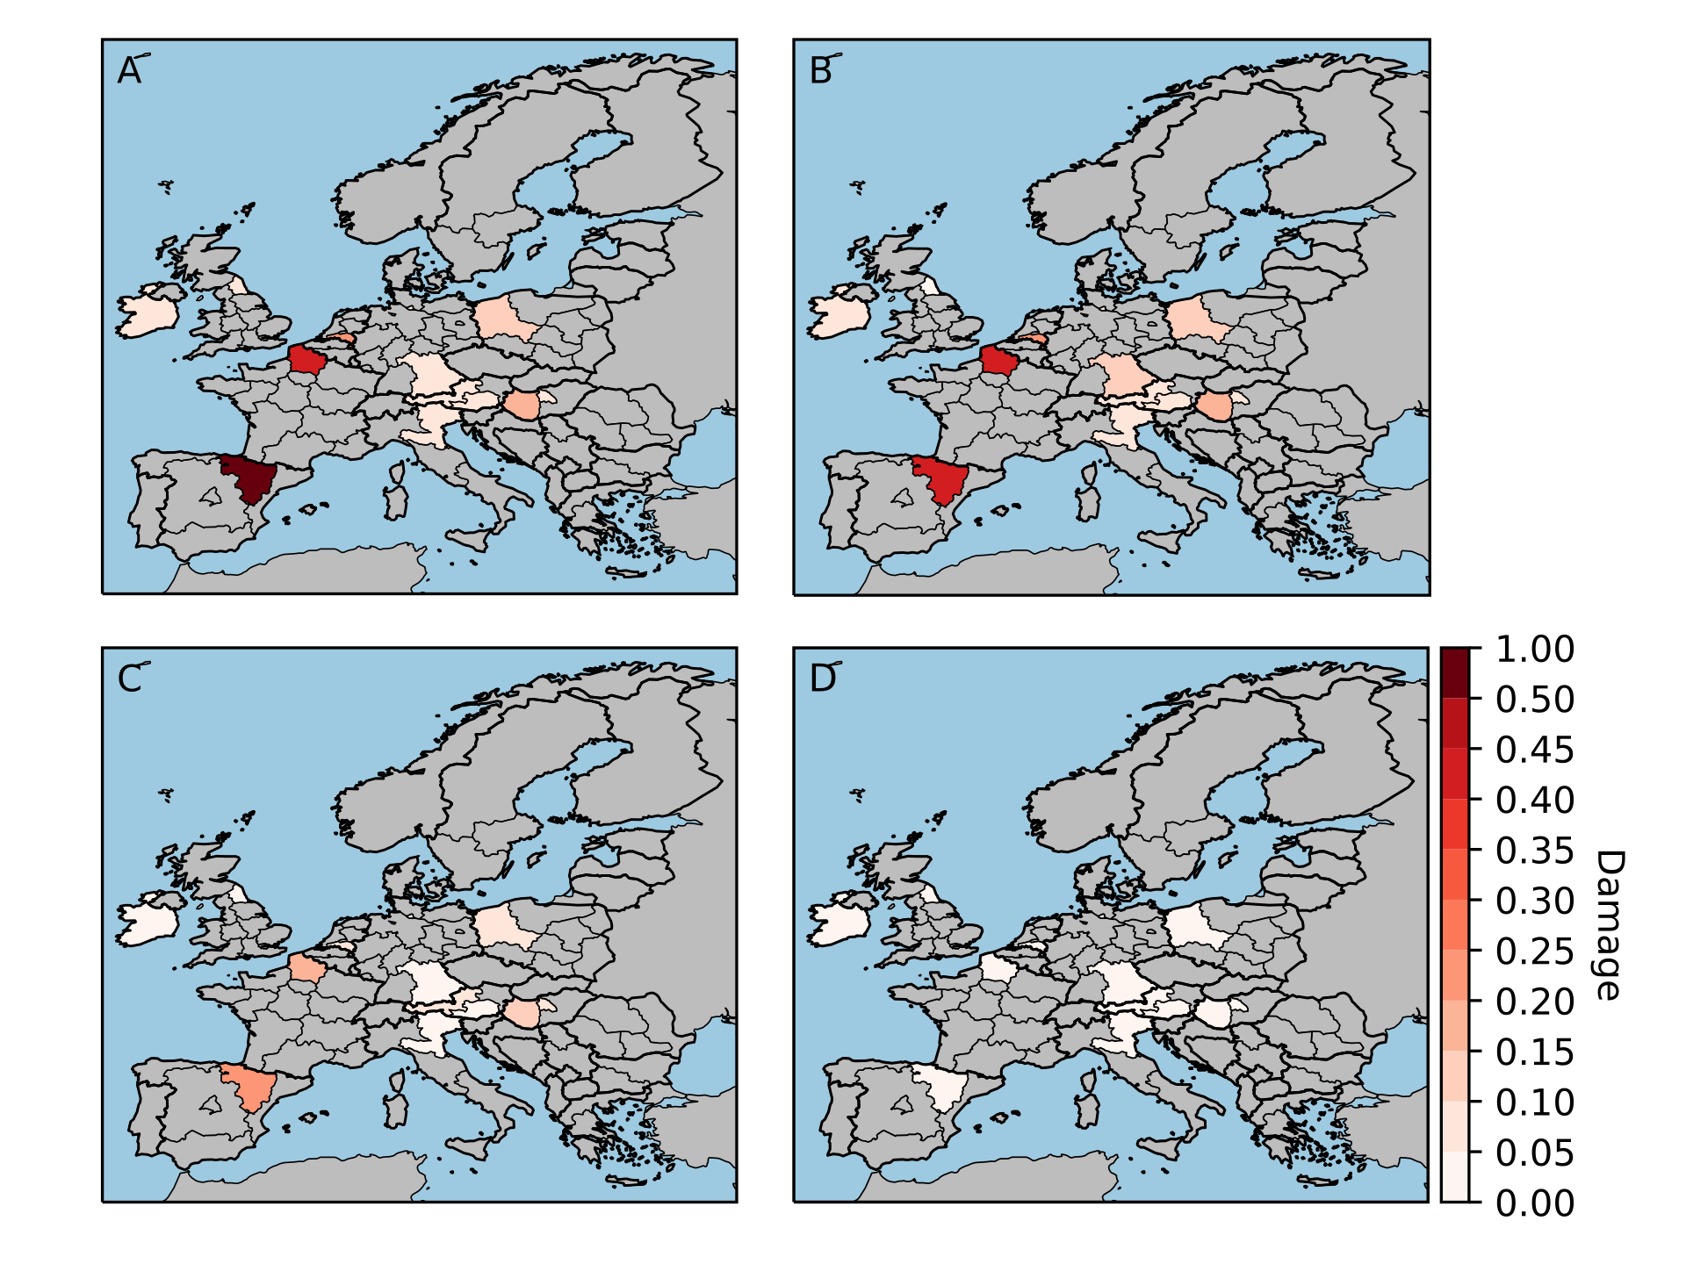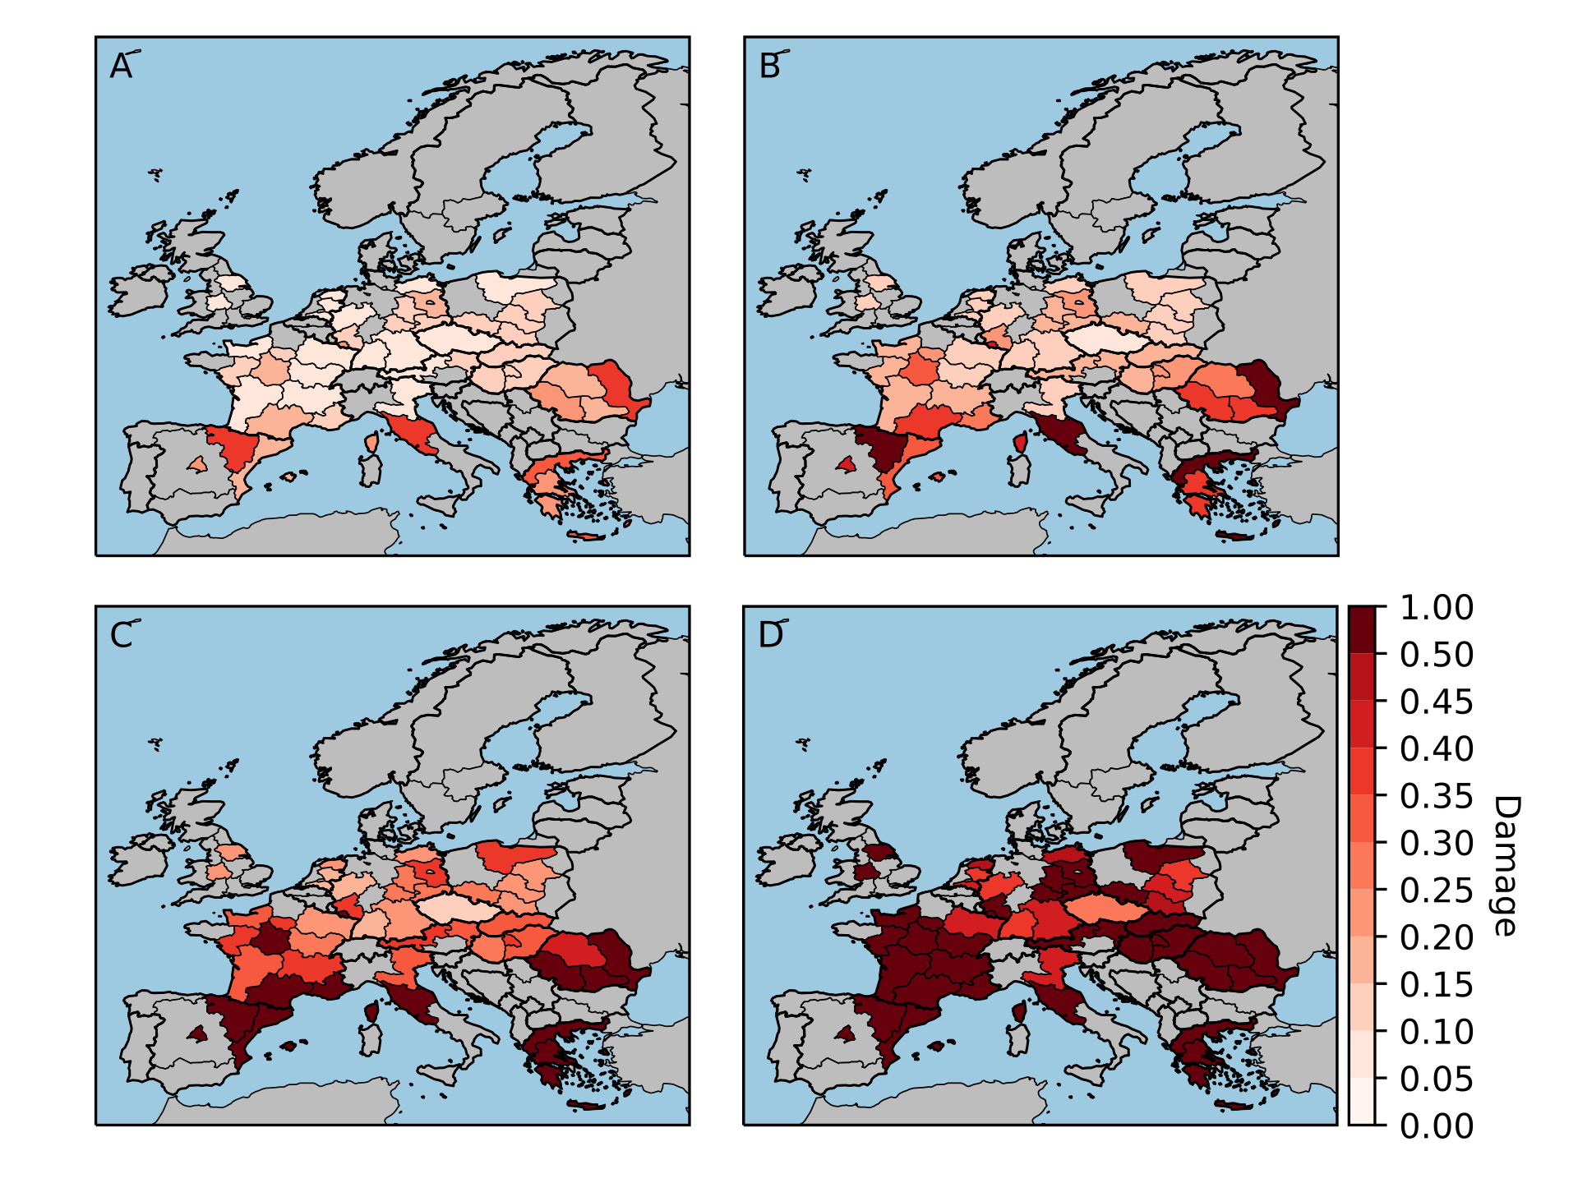

Figure 3.2:Aggregated predicted relative mean yield damage by heat waves (left panel) and cold waves (right panel) per NUTS1 unit for historical (A), RCP2.6 (B), 4.5 (C), and 8.5 (D). The legend highlights regions with significant damage according to the color gradient.

For cold waves, only 0.6% of the damage functions are significant, showing that this extreme has a minor impact on European crop yield. We rejected 29% of the functions due to weak correlation and 0.4% due to insignificant correlation. Our study shows that damage in the past is below 10% for eight regions, and for three regions, the estimated mean damage is between 10% and 25% (Figure 3.3). Two regions in Spain and France show damage above 40%; however, the 95% confidence interval is wide (Spain -9%–83% and France -39%–87%), limiting the mean estimates reliability. In the future, the impact of cold waves becomes neglectable, according to our analysis. The low future impact is related to the high likelihood of a decrease in the frequency of cold waves and the already relatively low impact of cold waves on crop yield (Seneviratne et al., 2021).

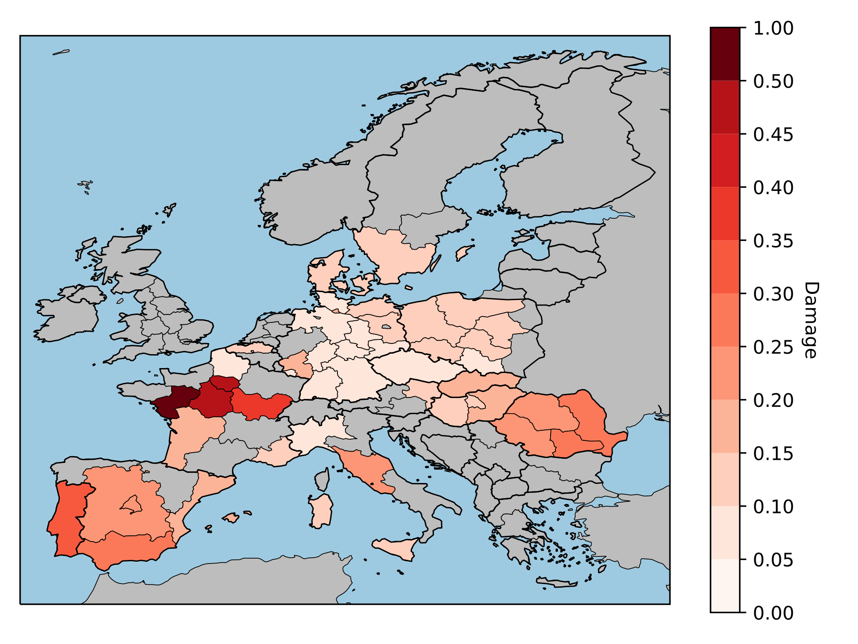

Figure 3.3:Historical mean yield damage by flash droughts per NUTS1 region. The legend highlights regions with significant damage according to the colour gradient.

Our analysis of flash drought impacts is solely available for the historical scenario. For EURO-CORDEX data, the required variable soil volumetric water content is not available as a precalculated product. As for heat waves, 4% of the damage functions are significant for flash droughts, and we reject 25% of the functions due to weak correlation and 1% due to insignificant correlation. In direct comparison with heat waves, droughts impact southern Spanish regions and Portugal (Figure 4). Central Germany, north Italy and France, and west Poland are regions that show impact by drought but not by heat waves. Additionally, droughts impact crop yield more than heat waves in central France. These dynamics strengthen the importance of analyzing extreme weather impacts within the framework of compounding extremes in future research.

3.3 EU hotspots of losses in biomass production due to climate extremes

When analysing impacts of climate extremes on primary production, not only the yield is important but also the area that has been planted and exposed to the climate extreme during critical cropping stages. Furthermore, as indicated in the previous section and in other studies (Monteleone et al., 2022), the eventual impact of climate extremes is the result of co-occurring or subsequent extremes during the growing season, in particular heat waves and (longer) drought periods. We therefore applied a different approach to assess the aggregate impact of co-occurring or consecutive climate extremes on regional biomass production, which includes all occurrences of climate extremes within one year. Based on a time series (1981-2020) of crop yields at the NUTS1 level (Eurostat), we estimated the yield losses as the percentage deviation of the actual yield from the 5-year rolling average. We assumed all yield deviations to be the result of climate extremes and related events such as insect plagues or crop diseases. The calculated yield deviation has been multiplied with the actual crop production record (Eurostat), which resulted in a time series of estimated production losses (and surpluses) due to variation in climate patterns. We filtered the years with the 25% most extreme production losses (percentile-based) and carried out a binomial logistic regression among production losses and the different weather exceedance indexes (75% percentile). We selected significant relations based on statistical odds ratios and pseudo-R2. The procedure has been applied to the sub-national (NUTS1) level and to the national level of the EU member states (+UK), albeit with a modified approach (see section 3.3.2).

### 3.3.1 Climate extreme impacts on crop production at the sub-national level of the EU

Subject to data limitations of biophysical records (yields, planted area, production) in Eurostat crop databases, significant correlations between years of (extreme) climate extremes and crop production at the NUTS1 level were limited to selected crops with relatively good data coverage. Figure 3.4 shows the average production losses of wheat, potatoes, rapeseed and green maize during the five most extreme years of climate extremes between 1981 and 2020. In general, production losses correlate with production volumes, so the figures also indicate important production regions for the selected crops (meaning that regions that produce little or no crops, will not show large losses due to climate extremes). For wheat, it can be seen that the most severe production losses (in 1000 tonnes) have occurred in Spanish and French regions and that significant losses occur all over the EU (with the exception of Swedish, Finnish and Dutch regions). For potatoes, the largest production losses in response to extreme weather are concentrated in north-eastern and northern regions, whereas rapeseed losses tend to be concentrated in regions in Central and Eastern Europe and in France. Green maize, a key fodder crop in dairy farming, is mainly affected in temperate climate zones in north-western, German and, to a lesser extent, north-eastern regions of the EU. Finally, and importantly, it should be noted that the years of most extreme impact vary among crops.

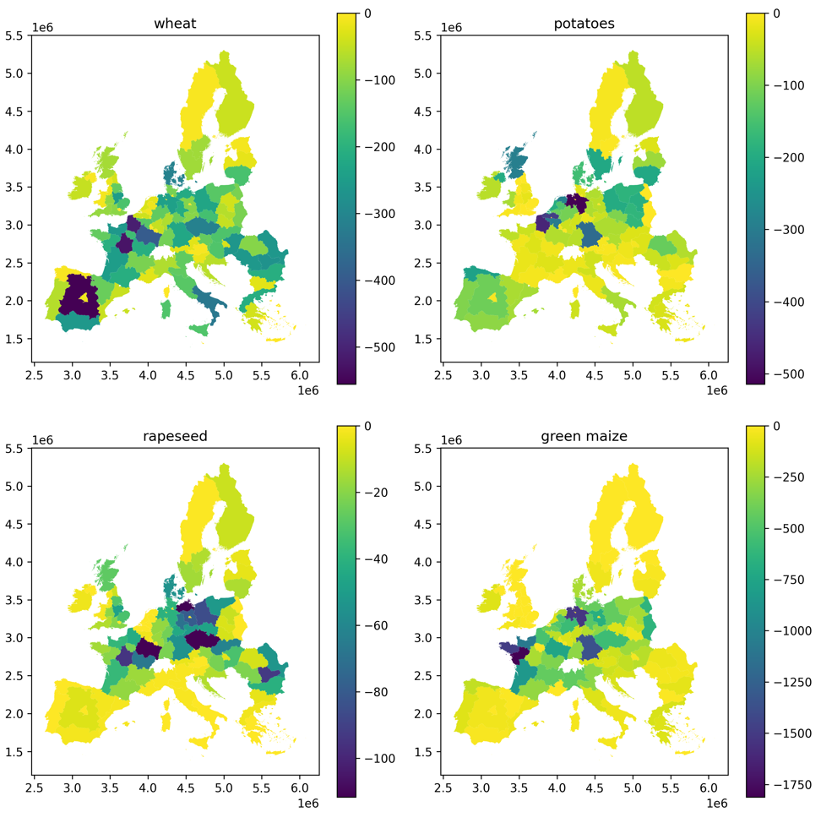

Figure 3.4: Average impact of 5 most extreme years in terms of estimated production losses (in 1000 tonnes) from climate extremes for selected crops (Own calculations based on Eurostat, ERA5-Land reanalysis dataset)

Figure 3.5 shows the 20 most important wheat producing (NUTS1) regions in the EU and their average losses in the years with the 10 most extreme climate conditions (in the time period 1980-2020). The percentages are the share of the loss in the average annual production. Importantly, the figure indicates that a substantial number of EU’s most important production regions for wheat, i.e. central Spain (ES4), the central France (FRB), the South of Italy (ITF) and several NUTS1 regions of Eastern Europe (Romania, Hungary and Poland) loose more than 10% of their production in years of extreme events. Figure 3.6 gives the same overview, yet for all crops produced by farmers in the 20 most important producing NUTS1 regions. Two main differences can be noted: first, that the most important biomass producing regions are mainly located in France and Germany. This is important in a plant-based bioeconomy context. Second, it can be noted that average biomass losses are lower than for wheat alone, indicating that crop diversity and rotation is important to mitigate extreme losses and reduce vulnerability for extreme events at the farm level. However, these findings are subject to high uncertainties as NUTS1 crop records for several crops and regions show omissions in the time series.

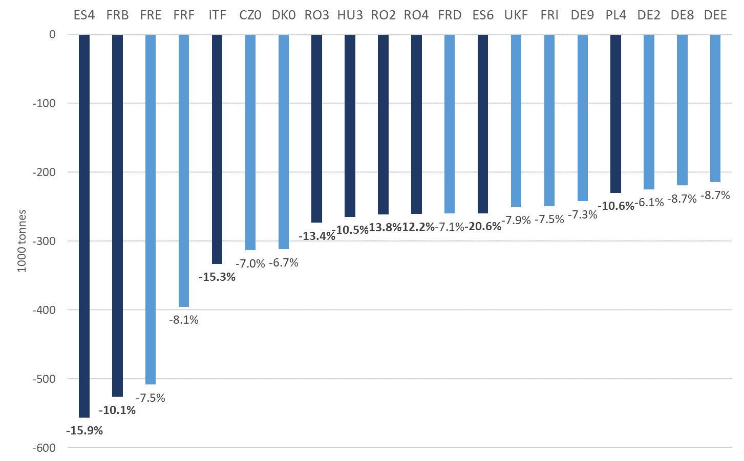

Figure 3.5: Average wheat production loss (absolute and as % of production) in a year of extreme climate conditions (based on years with “extreme climate extremes” between 1981-2020) in 20 most important wheat producing regions in the EU (NUTS1)

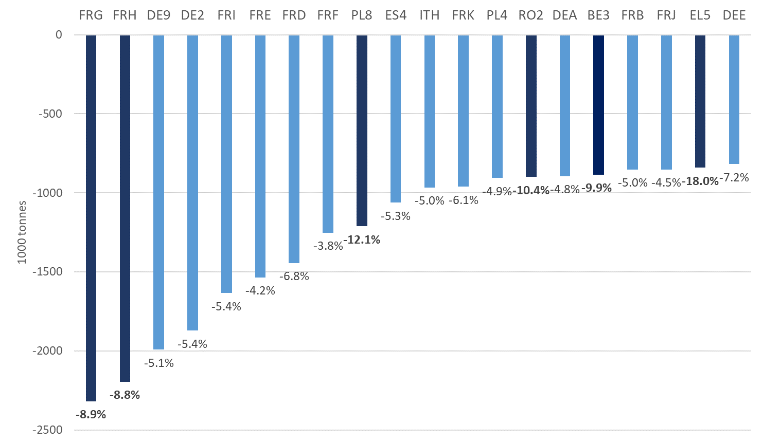

Figure 3.6: Average losses in production of all crops (in volume and as % of production in a year of extreme climate conditions (based on years with “extreme climate extremes” between 1981-2020) in 20 most important crop producing regions in the EU (NUTS1)

### 3.3.2 Climate extreme impacts on crop production at the national level of the EU

The previous section highlighted hotspots of historical production losses associated with aggregated patterns of climate extremes at the sub-national level, yet, due to data limitations, for a selected number of crops. In this section, we give a more comprehensive overview of crop impact hotspots due to climate extremes at the national level of the EU member states. National level data series have been collected from the Eurostat production statistics and omissions have been imputed from FAO crop statistics (when available) (FAOSTAT, 2022). However, as the weather exceedance indexes have been calculated at the NUTS1 level (see chapter 2), we could not relate the national production impacts directly to the sub-national weather exceedance indexes. Instead, we calculated a weighed climate exceedance index based on percentile-based (75%) climate extremes at the NUTS1 level, multiplied by the share of the NUTS1 level in national production per crop. We then calculated the odds ratio that yield based production losses at the national level (see section 3.1 for details) occurred as a result of the climate extreme exposed regions at the NUTS1 level. A percentile-based (75%) selection of the years with extreme production losses (of crops with a significant odds ratio and McFadden pseudo R-square) have been converted to national level hotspots of extreme losses as a share of EU level production losses (Figure 3.7) and of average production loss per crop and per extreme event between 2001-2020 (Figure 3.8).

From a national level perspective, 3.7 shows that France, Germany and Poland are the countries where most crops tend to be (co-)affected by extreme weather events. Basically, this reflects the scale and variety of crops produced in those countries and that climate extreme patterns tend to occur at larger (national) scales. From a crop-based perspective, production losses tend to be spread over three to four member states for most crops with the exception of fibre flax and hemp, of which losses seem to be concentrated in France.



Figure 3.7: National hotspots of estimated production losses per crop due to climate extremes between 2001 and 2020 (Own calculations based on Eurostat, FAO)

Figure 3.8 shows the average impact of extreme climate events on crop production per member state. Wheat production losses range from 6-8% in member states in N-W Europe to as high as an estimated 30% in Spain. It should be noted, though, that the table shows the results for the period 2001-2020, which, depending on the crop an dregion, can be biased towards the record extreme impact in the year 2003 (see section 1.2 and 3.4). Mean impacts for cereal crops in major producing countries tend to range between 10 and 20%, which is largely in line with the literature and with the regional level results in the previous section. Dry pulses shows high production losses (up to -30% in Bulgaria) in a large number regions, whereas soy production seems to have been severely hit in Bulgaria and Greece. It should also be noted, though, that the uncertainty measures of the inferred climate impact in crops with lower production volumes is higher than for high volume crops. Shocks in green maize seem to be particularly high in countries in central and eastern member states (Hungary, Czech Republic, Romania) whereas grassland and leguminous crops (e.g. Lucerne) show a mixed pattern of affected regions. As irrigation practices in grassland production are less common, grassland productivity is particularly sensitive to (increasing) drought extremes, which tend to also hit northern member states more frequently in recent years (Beillouin et al., 2020; Brás et al., 2021).



Figure 3.8: Average intensity (loss of production) in a year of extreme climate conditions (based on years with “extreme climate extremes” between 2001-2020)

3.4 Climate extreme impacts on crop production at the EU level

After the NUTS1 and national level assessment of climate extreme impacts, this section aggregates the national level impacts to identify the most extreme years of climate hazard impacts at the EU level. Climate extreme impacts at the EU level are of particular importance because of its potential price impact in the world market. For example, the 2018 heatwave and droughts have been associated with a 34% and 48% price increase for respectively soft wheat and barley (Brás et al. 2021). For the EU level analysis, we aggregated the 1981-2020 time series of the national level crop production losses and applied a percentile-based approach to filter the 10 most extreme years with production losses per crop at the aggregated level (Figure 3.9).



Figure 3.9: Aggregated production losses as a share of total production per crop and per year for the aggregated EU member states (Source: Own calculations)

The results indicate that cereal production losses due to extreme weather event range from -3% to -16% (in 2003), root crops (potatoes, sugar beet) from -2% to -9% (1994), oilseeds from -2% to -19% (2003), fiber crops from -3% to -31% (2001) and fodder crops from -2% to -18% (2003), among others. On average, per climate extreme event, cereal production losses range from -5% for barley to -8% for rye and sorghum, with wheat and spelt at -5.7%. Fiber crops and specialty crops and fodder crops show higher average impacts, at around -8%, whereas fodder crops range from -5.1% for green maize to -8.0% for grassland. In terms of most extreme years, it can be seen that the year **2003** has been an all-time record of impacts on agricultural production, with a large number of crops showing production losses more than 10%. With -5.9% crop losses on average, **2012** has been an exceptional year as well, followed by 2007 and 1983. Adding up both arable and fodder crop production losses, **2018** records an impact of -3.7%, which is one of the 10 most extreme years, yet in a medium impact range.

3.5 Synthesis of results

As the starting point of the climate risk transmission channel, Ch. 2 indicated changing patterns of climate extremes (“hazard”), to which sub-national EU agricultural and forestry activities are exposed. In this chapter, we translated such extreme weather patterns into (potential) crop yield damages by means of a relative damage function. The convex hull approach proves to be a novel and very useful non-parametric method to both analyse and estimate crop yield dependence on weather extremes. Our results show that that the mean yield damage caused by heat waves for most of the regions in Europe is below 20% and that the number of regions with mean yield damage exceeding 20% may increase substantially under future climate scenarios, in particular in the south of Europe, but also across Europe RCP4.5 and 8.5. However, databases to analyse crop yield damages show large data gaps for most crops and, as a consequence, reliable crop yield damage functions are limited to selected crops and regions. Furthermore, for droughts, which is a more complex climate extreme, estimation of damage functions would benefit from including information on soil conditions and land management strategies (e.g. access to irrigation), yet that may require parametric estimation procedures.

In the second part of the chapter, we have translated historical crop yield damages into losses of crop production due to climate extremes (“Shocks”), yet in a type of superposed epoch analysis. We thereby assume that extreme drops in crop yields have been caused by compound weather exceedance patterns, validated by significance tests. However, similar as the crop yields, the assessment of climate extreme induced production losses also suffered from incomplete databases. Nevertheless, we have shown average production losses in response to climate extremes for a limited number of crops at the sub-national level, ranging from 7% to 21% for wheat, to 4%-18% when all crop production losses are aggregated at the regional level. The lower average rates suggest that crop diversification reduces climate impact at the regional and local farm level, but further research is required.

At the national level, a more comprehensive picture of production losses in response to climate extremes has been provided, indicating that France, Germany and Poland suffer from the largest absolute losses for the majority of crops. Impact intensities for larger EU crops such as wheat, potatoes and rapeseed are largely in line with the literature, smaller crop volumes show relatively high losses in response to climate extremes. This may indicate that smaller crops are less adapted to climate extremes, or the data quality may be poor. At the EU level, finally, it has been shown that crop losses in response to climate extremes (all crops per year) result in a 5-6% production loss on average and that the year 2003 is an all-time extreme year (with 8.5% loss in total EU crop production and 12.1% loss in fodder crops). As we were not able to calculate future production losses under different climate extreme scenarios (in absence of scenarios for aggregated climate extremes), we identified three extreme years that will be further elaborated in terms of direct and indirect supply chain impacts in the following chapters, i.e. 2003, 2012, and 2018. In view of the increasing flash droughts and the fact that crop yields are most vulnerable for droughts (Monteleone et al., 2022), however, the results of this chapter suggest an important and increasing risk transmission channel from climate hazards to crop yields and primary production in food and non-food activities in the EU bioeconomy. This is particularly visible at the sub-national level in France, Spain and South-eastern Member States.

4. Indirect biophysical impacts of climate extremes in the EU bioeconomy

Building on the notion of increasing climate hazard risk in agricultural production (direct impacts), this chapter analyses risk propagating impacts of climate extremes through biobased supply chains on to the household level (indirect impacts), still from a biophysical perspective. Biobased supply chains concern all economic activities from primary production to final consumption, both in plant-based food, in livestock production and related animal based products, as well as non-food biobased products such as textiles and bioenergy. The main research questions guiding this part of the methodological approach are:

* What are vulnerable sectors in the EU bioeconomy, both in terms of supply chain and final consumption activities, subject to impacts of climate extremes?
* Which bioeconomy activities are (particularly) affected by climate induced shocks in their main inputs?
* How do resilient bioeconomy activities compensate for the losses in affected inputs?

4.1 Brief method description

For the analysis of indirect impacts in biobased supply chains, we have updated and analysed the biophysical supply-use framework “FABIO” (i.e. a food & agriculture biomass input-output model, see (Bruckner et al., 2019) and “FORBIO” (i.e. a forestry & wood biomass input-output model, (Rosadio et al., in preparation)). These global databases depict time series (FABIO: 1986-2020, FORBIO: 1997-2017) of the global production and consumption of > 100 different biomass products, connected by trade flows among all (>100) activities in each of the 192 regions. For the purpose of the analysis in BIOCLIMAPATHS, we focus on the EU member states and its trade relations with the rest of the world in order to assess interdependencies among the EU and RoW in years of climate extremes.

The analysis has been carried out in three steps:

(1) Based on the validated impacts of climate extremes on crop production at the member state level (Ch. 3.3), we selected the five most extreme years in terms of climate impact at the EU level, i.e. 2003, 2006, 2012, 2013 and 2018. We calculated the difference in biophysical inputs and outputs of the EU bioeconomy activities as the average of the most extreme years and compared that with the average of all other (non-extreme) years in the time series (1986-2020). We first analysed the distribution of the supply shocks to all industrial and final consumption activities (supply perspective, section 4.2);

(2) Based on the assumption that both industries and final consumption activities in the bioeconomy will respond to shocks in supply of their (main) inputs, we analysed the impact and the propagation channel of the shock in biobased inputs (all inputs that have been affected by climate extremes) by activity in the global trade network. We identified the main affected regions as well as the industrial and final demand activities therein. Furthermore, we analysed selected activities in terms of mitigation strategies (i.e. turning to other inputs and/or other regions) in the global resource system of the EU bioeconomy (use perspective, section 4.3).

4.2 Impact propagation of climate hazard related shocks in the EU Bioeconomy: supply perspective

Figure 4.1 indicates how climate hazards propagate through EU bioeconomy supply chains, i.e. from primary crop production to livestock production, further processing, final demand and export markets. Risk propagation is depicted in terms of biophysical losses in the 5 years with the most severe production losses due to climate extremes at the EU level, as compared to the average of years with less extreme climate patterns (between 1986 and 2020). Figure 4.1 takes a supply perspective, i.e. it shows a row-wise distribution of biophysical losses in the global bioeconomy.

First, from the last column in Table 4.1, it can be seen that cereals, livestock production, starch and sugar, dairy and oil crops are the products with the largest gross losses in domestic output when the EU bioeconomy is hit by large-scale patterns of climate extremes. Second, from the FABIO supply-use framework it has been derived that the majority share of impacts is absorbed by domestic final demand for a large number of products, in particular dairy, vegetables and processed plant-based products. As we will show in section 4.3, these losses are largely compensated by higher imports from the rest of the world. Third, a number of supply shocks propagate through the biobased supply chains, notably from climate affected production losses in cereals, protein and oil crops to monogastric livestock (mainly poultry and pigs) and meat processing, as well as from losses in protein crops and fodder production to ruminant production, milk production and processing of dairy products. In the non-food bioeconomy, it can be seen production that losses in starch and sugar crops and fruits affect alcoholic beverages and bioethanol production. Finally, exports of a wide range of products show to be affected by climate extremes, both for final demand and industrial products (mainly livestock and related products).

Figure 4.1: Average distribution of supply shocks in years of climate extremes in the EU bioeconomy to domestic industrial and final demand activities, as well as to the rest of the world (“RoW”) (Source: FABIO USE and Final Demand tables 1986-2020)



Figure 4.2 indicates the regions that absorb the largest shocks due to climate related production losses in the EU bioeconomy. The percentages in the figure indicate the share in gross loss of total output (as well as net loss, which includes the products that have not been affected by climate extremes and which may mitigate the impact of losses in affected products). The countries are ranked from highest gross loss to lowest and show that Germany, The Netherlands, France, Italy, Czech Republic and Portugal absorb nearly 80% of the gross loss due to climate extremes (for the selected years in this analysis, i.e. 2003, 2006, 2012, 2013, 2018). Also here it can be seen that the majority share of the impact is distributed to final demand and, to a lesser extent, to EU exports. The figure indicates that The Netherlands and Central & Eastern European member states in particular, tend to propagate EU supply shocks to world markets. Finally, it can be seen that countries with a net surplus in total bioeconomy output in years of climate extremes, e.g. Poland, Denmark and UK, tend to distribute losses to export markets, thereby limiting domestic impacts (although patterns may differ at the product level).

Figure 4.2: Propagation of biophysical shocks in terms of total Bioeconomy output by region in the global economy (average loss 5 most extreme years compared to the average of non-extreme years) Source: FABIO Use & Final Demand tables 1986-2020)



4.3 Impact propagation of climate hazard related shocks in the EU bioeconomy: industrial demand perspective

In this section, we analyse risk propagation channels of climate extremes from the perspective of industrial demand in the EU bioeconomy, i.e. the use of biobased inputs by bioeconomy activities. In a bioeconomy, the main carbon resource is biological carbon from biological production systems, mainly crops, grass and wood. In this chapter we analyse the impacts of climate affected agricultural inputs on primary, livestock and further processing activities in the EU bioeconomy. Wood activities will also be analysed, but outside the scope of this report. We first analyse the total use of agricultural inputs by EU bioeconomy activity and identify the countries and activities that have been affected most in years climate extremes at the EU level. Also from the use perspective, we analysed the input losses in the 5 most extreme years at the EU level (2003, 2006, 2012, 2013 and 2018) and compare the average “climate extreme year” with the average for the other, less-extreme, years in the 1986-2020 time series of the FABIO use tables. Annex I shows the detailed product and activity classification in the underlying database, which have been aggregated to the country and industry level in the following sections.

Figure 4.3 shows the relation between gross losses of total agricultural inputs and the use of other biobased inputs by activities in the EU bioeconomy. It can be seen that Germany, France and Poland show the largest gross losses in primary production (see also section 3.3.2), which tends to multiply in the EU bioeconomy as several activities produce and use residual or by-products that are used as inputs by other activities, in particular livestock, but also in the non-food bioeconomy for material and energy purposes. As a result, some countries with a relatively large (food and non-food) processing industry, such as in The Netherlands and Italy, show relatively large losses in total biobased input. In the right part of figure 4.3, it can be seen that, despite overall negative impacts of climate extremes on agricultural inputs in years with climate extremes, circa 50% of the EU member states is able to mitigate such losses and to show a higher than average consumption of industrial inputs. This can be both the result of a differentiated climate impact, where some regions have not been affected or not affected during critical growing stages of the planted area, or it may have sourced larger volumes from elsewhere (see section 4.5). Other countries, notably Germany and several member states in central and eastern Europe, show significant reductions in the use of biobased inputs in years of climate extremes, with impacts of between 5.8% and 6.6% of their use in “normal years”. These findings are in line with our finding sin chapter 3, where climate affected production losses tend to become more intensive in the northern and eastern regions of the EU.

Figure 4.3: Gross and net losses of biobased inputs for primary and (further) processing activities in the EU bioeconomy (Mln. tonnes, source: FABIO Use tables 1986-2020)



Figure 4.4 indicates which EU bioeconomy activities are most affected by climate extremes. The row colours indicate the nature of the activity: green is primary production, light orange is livestock production and dark orange indicates processing activities. It can be seen that the top of thetable is mostly light orange, meaning that livestock sectors are most affected by climate extreme related shocks in primary biomass supply, mainly because they use a large share of domestic supplies. Moreover, cattle husbandry, pig farming and poultry farming also show significant net losses in the use of (domestic and imported) inputs, meaning that their output is likely to be reduced and, with that, propagate the risk and impact of climate extremes further down in the supply chain (see also section 4.2). Another group of activities that is significantly affected by climate extremes is the oilseed processing industry, in particular rape oil extraction (p070). Rape oil in the EU is used for both food and, most importantly, biodiesel production. Together with the impacts on non-food alcohol production (p084), which mainly produces bioethanol, it can be assumed that the EU bioenergy sector is vulnerable for climate extreme impacts. In tres of primary production activities, peas, pulses and beans show the largest reductions in primary (seeds and seedlings) inputs.

Figure 4.4: Gross and net losses in the use of primary inputs by EU bioeconomy activities in years of climate extremes (Source: FABIO Use tables 1986-2020)



The outer right column of figure 4.4 shows the “Mitigation%”, which can be considered as an indicator of the capacity of a bioeconomy activity to compensate input shocks by other inputs or from other regions (imports). When aggregating all bioeconomy activities by country, national bioeconomies can be assessed on their resilience to climate extreme shocks, i.e. the capacity to mitigate losses in both primary inputs and total biobased inputs (including inter-industry use in the global trade network). Based on EU wide climate extremes and dependent on the scale of the activities within countries (with a large variety among regions and activities), figure 4.5 indicates that circa half of the EU member states show to be relatively resilient for shocks in climate extremes. The figure also indicates that, on the other end of the scale, Germany would be most vulnerable overall to climate related shocks in biobased inputs. However, as already indicated, the risk assessment scores are subject to large uncertainties and more research into underlying behaviour of industries under climate extremes is necessary. Furthermore, the underlying data are based on the commodity balance sheets of FAOSTAT, which may also be subject to allocation uncertainties (Bruckner et al. 2019).

Figure 4.5: Risk assessment of the resilience of national bioeconomies in the EU (in terms of aggregated capacity of bioeconomy activities to mitigate losses in inputs as a result of climate extremes)



4.4 Impact propagation of climate hazard related shocks in the EU bioeconomy: final demand perspective

Consumption in an economy consists of intermediate consumption (by industrial activities, see previous section) and final consumption, with households generally accounting for the majority share of consumption. Other final demand categories in FABIO are inventories (and changes therein), processed residuals, waste, losses and balancing items. In any crisis context, such as a climate extreme, monitoring and preventing impacts on household consumption and food security are of critical importance and of political concern. As such, although this chapter investigates biophysical impacts of climate extremes, the actual impacts in terms of food consumption also include social amplification channels of e.g. price shocks and policy measures.

Figure 4.6 indicates the level of shocks in final demand due to EU level climate extremes. As can be seen, the gross loss in final demand is more than 10% on average. Also net losses are substantial with most countries experiencing a net loss in final demand of between 4 and 15%. These figures indicate that impacts on final demand are higher than impacts on intermediate use in the bioeconomy. However, when looking at household consumption, it can be seen that the large majority of EU member states have higher consumption levels than the average of non-extreme years. In part, this can be explained by the bias of extreme years towards the end of the time series, where countries may have slightly larger population numbers, but it also indicates that the EU has effective shock mitigation measures in place, mainly by stock supplies and a reduction in waste, losses and other uses. Finally, losses in food supplies are sourced (by the wholesale and retail channel) from surpluses within the EU and from other world regions, in particular from North America, Oceania and non-EU Europe[4]. Figure 4.7 shows the net losses in total EU final demand by product and by origin (EU and Rest of the World).

Figure 4.6: Impacts of climate extremes on final demand in the EU bioeconomy (Source: FABIO Final Demand tables 1986-2020)



Figure 4.7: Net losses in EU final demand by product & origin (Source: FABIO Final Demand tables)



4.5 Synthesis of results

This chapter identified activities and regions in the EU bioeconomy that are exposed to climate extreme impacts. Germany, France, The Netherlands and Italy, as well as a number of central and eastern member show to be more vulnerable to impacts of climate extremes. In terms of activities, livestock production and oilseed processing activities tend to be most affected in years of EU-wide climate extremes, with the highest net losses for rape oil extraction (-10%) and ethanol production (-7%). Identified risk propagation channels of climate extremes in EU supply chains involve meat, dairy and alcohol production activities. EU final demand shows to be more affected by climate extremes than intermediary demand, with particularly large net losses in the supply of cereals and vegetables in years of extreme events. However, household consumption shows to be largely unaffected. In terms of total bioeconomy output, including industrial and final demand, we calculated that the EU showed a net loss of -0.4% in years of extreme events (as compared to years with no EU wide climate extremes), indicating that the EU as a whole is able to cope with climate related supply shocks. Our analyses show that losses are largely covered by imports from outside the EU. In this context it is important to note that the rest of the world also seems to have been affected by extreme events in (some of ) the extreme climate anomalies in Europe and that, while having a lower gross impact, the rest of the world absorbed a higher net loss (-1.2%) than the EU. Considering that a large share of the biobased resources are consumed by livestock and related activities, our findings also point at potential EU bioeconomy transition paths that can support global resilience and reduce climate hazard related vulnerabilities in the global resource system.

The applied method is a relatively simple and straight forward approach to gain insights on risk propagation channels of climate extremes in the global trade system, both at the EU level and at the national levels of the EU bioeconomy. In fact, when global disaster databases are taking into account, the approach can be extended to other world regions and provide a macro social-ecological perspective on X-sectoral and X-scale risk transmission paths in a climate extreme context. The empirical grounding of the FABIO database is of particular value here, because it is consistent with FAOSTAT production, trade and consumption statistics and it is available as a 34 year time series. Selecting years of climate extremes based on analyses of EU-wide climate patterns (Ch.2 ) and related shocks in crop yields and primary production (Ch. 3) allows for a “case study approach” of years characterised by extreme climate events as compared to years that are less or not extreme. Furthermore, the approach can be applied at the detailed industry level (not included here). However, the use of input-output type of databases for the analysis of response mechanisms at the detailed industrial and final demand level may be limited by database updating and balancing principles, especially for smaller scale activities and products. Nevertheless, our analysis results add new insights into the structure and mechanisms of EU climate risk mitigation and highlights potential risks in a context of bioeconomy development under more frequent and more intense patterns of climate extremes.

5. Monetary impacts of climate extremes in the EU bioeconomy

In this chapter, we develop and apply a quantitative approach to assess risk transmission channels of climate extremes in the EU bioeconomy. In particular, we quantify potential impacts of climate extremes on the total output of primary production and other bioeconomy activities, both at the EU, national and sub-national level. The main research questions are:

1. How can we assess indirect impacts of climate extremes on EU bioeconomy supply chains?
2. What are the potential impacts of climate extreme shocks at the EU, national and sub-national level of the EU bioeconomy?
3. What are (potentially) vulnerable activities and regions in the EU bioeconomy?

5.1. Database and frameworks

The analysis of the economic impact of biophysical shocks due to climate extremes requires a multi-sectoral framework that quantifies the interrelationships between production, demand and supply. For the elaboration of this database, called Bio-MRSUT (Bio-economic Multi-regional Supply-Use Tables) framework, we started from EXIOBASE (Stadler et al., 2018), in which multi-regional Supply-Use tables are available (in addition to the symmetric I-O in many cases) for a long period of time and with a broad level of sectoral development in agriculture and other bio-economic sectors, in addition to having geographical coverage for the 28 MS of the EU and for the main countries of the rest of the world. From the EXIOBASE data to obtaining the series of multi-regional SUT monetary marks, some estimation is required. First, by adapting the initial tables to the sectoral structure proposed in BIOCLIMAPATHS. Subsequently, to complete the database with additional information on certain bioeconomy sectors (agriculture, livestock, and biofuels), the 2010 and 2015 BioSAMs (Mainar-Causapé et al., 2021) carried out by the Joint Research Centre (JRC) of the European Commission have been used, building the pertinent extrapolations to complete the proposed time period. These BioSAMS, of national scope, provide a complete SUT framework for the 28 MS of the EU with a wide disaggregation (the most complete in this type of database) of the bio-economic sectors (primary sector and biofuels), in a way that can be complemented with previous estimates from EXIOBASE, allowing additional breakdowns on the initial structure. The result of these processes gave rise to multi-regional monetary SUT frameworks for the EU and its Member States with a very broad disaggregation of the bioeconomy sectors. These multiregional frameworks comprise, with reference to the year 2015, a total of 78 activities (44 of Bioeconomy) and 78 goods and services (44 of them bio-economics), for the 28 EU countries (including the United Kingdom) and the Rest of the World, (as well as the interrelationships and bilateral exchanges between all these territories). In addition, they contain the breakdown of final demand and added value, as well as taxes on activities and products and imports by origin (the resulting data matrix contains 4,529 rows and 4,669 columns).

Once the multiregional framework was built at the level of member states, it has been extended by regionalising the base, at NUTS 2 level, for Germany (38 regions), Austria (9 regions) and Spain (19 regions), maintaining the national aggregation in the rest of the territories (EU countries and Rest of the World). To do this, the main macro-magnitudes of these regions were compiled, both for added value and final demand, as well as for total sectoral output, in addition to taking the data on transactions and multi-regional relations (at the NUTS2 level) prepared by the JRC and PBL–Netherlands Environmental Assessment Agency (Thissen et al., 2019) as a reference for the disaggregation. After an initial estimate of the regionalised framework, we had the external collaboration of one of the authors of said database, Olga Ivanova (PBL), for its adjustment and balancing (in addition to the previous use and treatment of the database of relations between regions NUTS2). The result is a database that combines multi-regional and bio-economic Supply-Use tables (RegBio-MRSUT), with 78 activities and 78 goods and services (44 of the bio-economic activities and goods), for 92 territories and regions (with a total of 14,357 rows and 14,812 columns).

5.2. Analytical methods and main research products

Once the Bio-MRSUT and RegBio-MRSUT frameworks have been available and operational, the impact analysis of potential climate risks and their propagation has been carried out, using two multisectoral analysis techniques of different approaches, based on IOT / SUT. The two methodologies provide complementary information on the scope of the impact of potential shocks caused by climate extremes.

The traditional impact analysis model based on Input-Output models has begun to be applied, using the multiplier matrices resulting from the classic Leontief inverse, both in its usual version of a symmetric I-O matrix (Pyatt and Round, 1985), and in the SUT form (Wiedmann, 2017). This type of modelling allows, through the infinite backward linkages of the initial direct effects of a shock (in this case, on the production/disposal of bio-economy output caused by climate hazards), to reflect the effects in the whole of the European economy, both nationally and regionally (in the cases of Germany, Austria and Spain). This impact is measured both in production, employment or added value, both in an aggregate and sectoral way.

The impacts, information on the chain of transmission of these and which blocks of regions and sectors present a higher sensitivity to potential threats or small climatic catastrophes, or which are those that have a greater capacity to spread them in case of suffering them. It can be said that, in the context of this project, the use of the multipliers from the Leontief inverse provides information on the "maximum" effects and impacts of the aforementioned shocks, since they assume a complete prior use of productive resources and not consider a "reallocation" of production between the countries and/or regions considered.

The second model proposed tries to offer an alternative to the assumptions of the classic Leontief model, especially about the possibility of a reallocation of resources and production, both between the countries and regions of the EU, as well as with the Rest of the World. This model is based on the approach of Faturay et al. (2020) and Huang et al. (2022), who use novel developments for the analysis of disasters with input-output models. In the Faturay approach (which uses the technical coefficient matrix, but not its inverse) a maximisation of the joint output (or linked variables) of related zones or regions is proposed in the event of a catastrophic external shock, allowing the transfer of production between zones (regions and/or countries) and taking as the only restriction the maintenance of the supply as an input of the goods affected by the disaster. However, in the development of the final part of the project, it has been detected that the proposed optimisation algorithm generates a much more limited process of reallocation of output between regions than expected and that makes it hypersensitive to situations of strong initial shocks in production. This has led the work team to reformulate the model with the introduction of new restrictions and the relaxation of others, now allowing a flexible, more realistic reassignment that provides more coherent and feasible results.

Regarding the two types of models described above, both use the input-output methodology, but with different assumptions. Thus, the analysis based on the linear multipliers (obtained through the Leontief inverse, shows the final reduction in output caused by the initial shock, under the assumption of a production function with fixed coefficients and full use of the factors of production, not contemplating the possibility that production and/or inputs may move between regions and/or countries. However, the second method (onwards *‘alternative model’*), which improves the approach of Faturay et al. (2020) and Huang et al. (2022), uses the matrix of technical coefficients instead of the inverse and allows (and this is the most relevant issue) that the inputs and outputs can be reallocated from one region to another.

Both approaches have been put into practice following a double application: on the one hand, potential impacts on the selected economic variables have been calculated in each region, country and sector (in aggregate and disaggregated form), caused by identical shocks (same percentages) of production lost in the disaster zone and isolated. This resulted in a complete map of capacities and destructive effects on the economy of the possible real event of climatic threats on bio-economy activities and products. On the other hand, real scenarios have been applied with authentic initial shocks in production caused by events attributable to climatic hazards (droughts, fires, floods, etc.). Data were taken from three years: 2003 (year of extreme climatic impact - waves heat, drought - in all regions in the EU between 1986 and 2019), 2012 (extreme weather impacts on industrial crops and to a lesser extent also wheat and food crops) and 2018 (extremely dry year in the northernmost part of Europe: affected wheat and fodder crops, as well as timber). This database of production shocks (sectoral and for NUTS2 regions and EU Member States), carried out in collaboration with the other members of the consortium, is based on physical yield and related production responses (see chapter 3) and the FABIO database (Food and Agriculture Biomass Input–Output database) (Bruckner et al., 2019). For each of the selected years (2003, 2012, 2018), the joint scenario of all the shocks has been applied simultaneously, so that the effects can be characterized in the face of real and already described “catastrophes” or “disasters”.

5.3 Selected results

In general, the results of the application of the two methods explained above to the database built in this project (Mainar-Causapé et al., 2023), show the effects that a certain shock (both across all sectors and the bio-based sectors) in the economy of a region or country induces in the bioeconomy sectors of another region or country. In both cases, these effects are presented from two perspectives. On the one hand, they show the impacts that a fixed (arbitrary) reduction of 10% in each of the primary agricultural sectors (one by one or jointly in a region or country) would have on the total output of bio-based sectors (crops, livestock, food industry, bio-fuels,…), both domestically and in other regions or countries. On the other hand, the impact analysis is carried out for three real situations (years) of extreme climate hazard impact on European agriculture, simulated with the economic structure of 2015. Specifically, the primary production shocks corresponding to the years 2003, 2012 and 2018 propagate through the EU bioeconomy supply chains (their choice is explained in the previous section). For that, we extracted, for each of those years, exclusively the output reductions that occurred in the primary sectors and that could be attributed to climatic threats (see chapter 4). In this way, we can simulate the impact of these events on the European bioeconomy, filtering it from potential improvements in output in other sectors and/or regions due to other issues.

Regarding the two types of models described above, both use the input-output methodology, but with different assumptions. Thus, the analysis based on the linear multipliers (obtained through the Leontief inverse) shows the final reduction in output caused by the initial shock, under the assumption of a production function with fixed coefficients and full use of the factors of production, not contemplating the possibility that production and/or inputs may move between regions and/or countries. However, the second method (onwards *‘alternative model’*), which improves the approach of Faturay et al. (2020) and Huang et al. (2022), uses the matrix of technical coefficients instead of the inverse and allows (and this is the most relevant issue) that the inputs and outputs can be reallocated from one region to another.

Figures 5.1. and 5.2. show examples of the results based on the use of the Leontief inverse. The first indicates the value of the Leontief multiplier, that is, the system wide effect of a unit reduction in the supply of primary production sectors in the bioeconomy of a region. The second figure shows the impact of a 10% reduction (shock) in the supply of all primary agricultural sectors in each Member State, as a percentage of the aggregated EU bioeconomy output. Figure 5.2 mainly reflect the relative scale of the national bioeconomy in the EU bioeconomy.

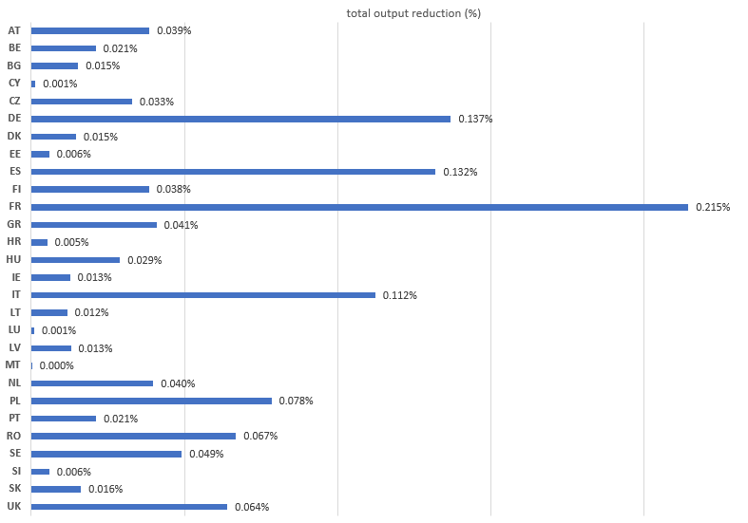

Figure 5.1: Percentage impact on total output reduction of the EU bioeconomy due to a 10% shock in crops sectors of each MS. Estimation based on Leontief multipliers.

As can be seen in Figure 5.1., France, Germany, Spain and Italy are the countries with the greatest absolute influence on the monetary output of bioeconomy sectors in the aggregated European Union. For example, a 10% reduction in the production of crops in France would lead, according to the classic Leontief model, to a reduction of slightly more than 0.21% in the joint output of the bio-based sectors in the EU.

It is clear that the size of these countries plays an essential role in their influence on the absolute EU-wide impacts. A complementary insight is gained from looking at the value of the multipliers that are presented in Figure 5.2. It can be seen that – per unit of crop reduction –the agricultural sectors with the greatest capacity to influence the European bioeconomy are those of Austria, Latvia and Slovakia. A reduction of one monetary unit in agricultural production in Austria, for example, would mean a reduction of 1.42 units in the European bioeconomy. However, the low weight of agricultural production in these countries in the EU total hides these strong relative effects.

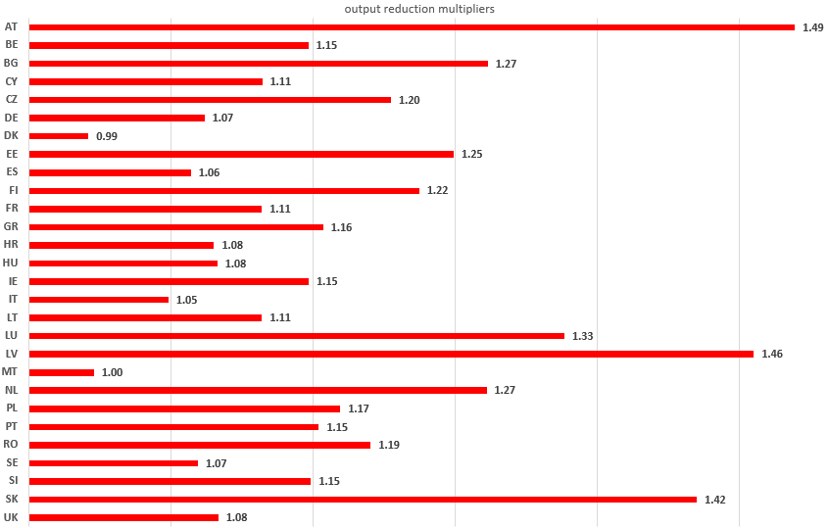

Figure 5.2: Impact on total output of EU bioeconomy sectors due to a unitary shock in crops sectors of a MS (multiplier). Estimation based on Leontief multipliers.

The model also allows estimating the impacts generated from production reductions in specific bioeconomy sectors. Using again the alternative method, the potential impact of a 10% reduction in the output of each of the crops (and Forestry) in the EU as a whole on the aggregated bioeconomy of the EU has also been estimated (see Figure 5.3).



Figure 5.3: Reductions in output caused in EU bio-based sectors by a 10% reduction in the output of each crop sector. Estimation based on alternative model proposed.

Accordingly, a reduction applied in the Forestry sector in all MS would cause a fall of 0.157% in the output of the bioeconomy of the aggregated EU. The activities ‘Other vegetables’ and ‘Wheat’ (0.120%) or ‘Fruits’ (0.114%) also stand out clearly.

Figure 5.4 is an example of the improved version of the method of Faturay et al. (2020) and Huang et al. (2022) (onwards, “alternative model”), applied to three years with actual climate extremes across the EU (i.e. 2003, 2012, 2018).

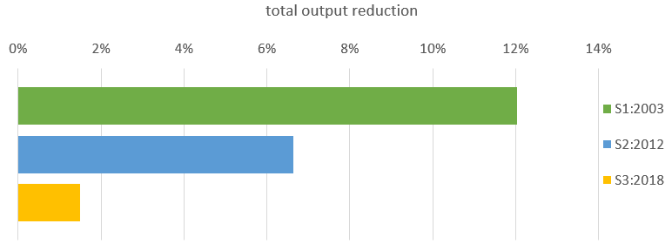

Figure 5.4: Impact (reduction) in total monetary bioeconomy output of the aggregated EU due to actual shocks occuring in the indicated year. Estimation based on alternative model proposed.

The negative incidents linked to the weather extremes and related production losses in the year 2003 observed across many EU MS would suppose, following the multisectoral structure of 2015 (as the baseline year applied in this project), a reduction in output in the aggregated EU bioeconomy sectors of more than 12%. The same exercise carried out for the years 2012 and 2018 would have a joint impact of 6.6% and 1.5%, respectively.

Figure 5.5. illustrates the impacts on total output reduction in bio-based sectors at the national level.

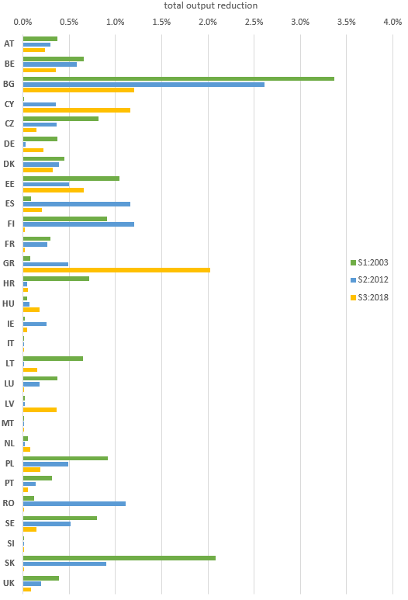

Figure 5.5: Impact of the supply shocks in 2003, 2012 and 2018 on output reductions of the national bioeconomy

The hypothetical impacts on the monetary value of the output, produced by the shocks described in each of these scenarios, vary substantially between the different EU countries. The impact of the first scenario (S1:2003) is especially important in Bulgaria and Slovakia, with reductions in bioeconomy output of 3.4% and 2.1%, respectively. Notable reductions are also observed, although to a lesser extent, in the Czech Republic, Finland, Hungary, Lithuania, Poland and Sweden. Regarding scenario 2 (S2:2012), its impact is generally lower than S1:2003, exceeding the 1% reduction in bioeconomy output only in Bulgaria, Spain, Finland, and Romania. Something similar occurs with S3:2018, with lower values, although its value in Greece is significant (2% reduction in output). The effects of the three scenarios on the national bioeconomy in Germany, France, Italy, Slovenia and the Netherlands, among others, are vey minor.

Compared with Figure 5.4 above, it becomes clear that in the years with strong climate extremes across many Member States within a single year, the monetary impacts have been significantly larger compared to the results that illustrated reductions in just one single MS.

Finally, based on our findings that regional level impacts can be higher than average national-level impacts (see chapter 3 above), we also carried out the shock analysis at the regional (NUTS2) level for Austria, Germany and Spain. Figure 5.6 illustrates the most heavily affected regions in these three countries, measured in terms of regional output reduction in bio-based sectors.

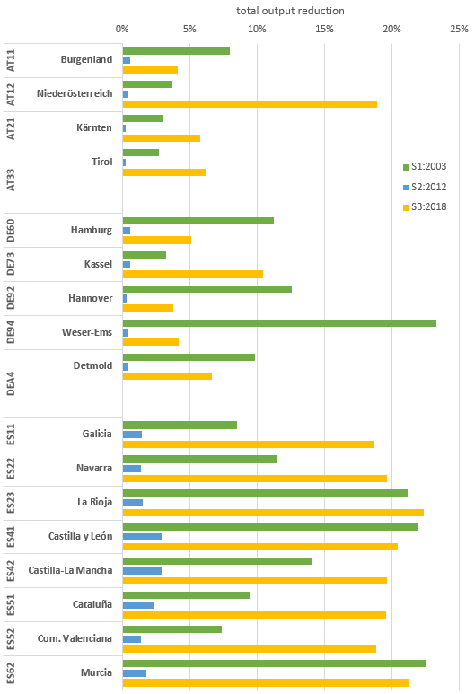

Figure 5.6: Impact of the supply shocks in 2003, 2012 and 2018 on output reductions of the regional bioeconomy

Regarding the regional impacts, the results of the impact estimates are more significant than when considering the country level. This is due to the fact that effects are not diluted in larger production structures as is the case at the national level. In addition, the model ensures the supply of agricultural production as an input to guarantee the prior production of other sectors in the different regions/countries. This results in lower output values in sectors facing a shock, which sacrifice their production for final demand, which is instead covered with production from other regions.

In Austria, the estimates for Burgenland (scenario S1:2003, loss of 8%) and Niederösterreich (scenario S3:2018, loss of almost 19%) are especially noteworthy. In general, in the Austrian NUTS2 assessments, S3 has the highest impacts, whereasa the output loss due to the weather extreme underlying S2 is almost neglibible. In Germany, in almost all the NUTS2 the effects are not very significant, although the impact in Weser-Ems (23.3% reduction in S2) stands out. In Spain, the regional effects are much more significant in the scenarios S1:2003 and S3:2018, with those of S2:2012 being of little relevance. Many regions were heavily effected by S1 and S3, with output losses of around 20%. The NUTS2 with the greatest weight in the primary sector and the agri-food industry (including Galicia, Navarra, La Rioja, Aragón, Castilla-León and Castilla-La Mancha, and Murcia) are those with the greatest estimated negative impacts.

5.4 Synthesis of results

In this chapter, we have shown a selection of results that could be generated with an advanced impact assessment based on the estimated databases, the soft-linking of biophysical and economic models, and the improved version of the method of Faturay et al. (2020). Additional estimations and results can be obtained in a very detailed and disaggregated way, both regarding sectors and regions. Hence, the approach developed in this project proved a very useful framework to quantify impacts on the monetary economy due to climate impacts, to gain insights in impacts on heterogeneous bioeconomy regions in the EU and to identify potential vulnerabilities for climate extremes (mainly heat and drought extremes) in the EU bioeconomy.

Obviously, there are some (and important) limitations to this methodology. One of the biggest limitations of the models used is the failure to consider price responses to supply shocks. Effects are assumed in the very short term, maintaining prices, which is clearly unrealistic in real-world situations. Also the databases are in need for more accurate estimates, especially interregional trade of biomass commodities. However, both tested methodological approaches, i.e. the Leontief-based approach and the “alternative approach” represent an important contribution to the study of the proposed objectives.

6. Vulnerabilities in regional bioeconomies under climate extremes (case study Austria)

In this chapter we extend the causal chain of hazard (climate extreme) 🡪 direct impacts (crop production losses) 🡪 indirect impacts (affected supply chain activities in the trade network), to the level of vulnerability analyses. To this end, we connect the biophysical shocks in the EU in years of extreme climate events (Ch. 3 & 4) to a monetary framework at the sub-national level of an economy (Austria) in order to identify (potentially) vulnerable regions, economic activities, and social groups in a bioeconomy context subject to climate extremes. The main research questions are:

* To what extent are heterogeneous regions affected differently by larger scale context?
* What are vulnerable activities in regional bioeconomies in a context of intensifying weather extremes?

## 6.1 Brief method description

To explore the vulnerabilities of the bioeconomy, we employed an agent-based model (ABM). ABMs have been used to study various risks and consequences of climate shocks; however, their application to the bioeconomy in a macroeconomic context is novel. Recently, it has been argued that ABMs are a suitable tool for modeling bioeconomy as they are capable of representing phenomena emerging from complex interactions of heterogeneous economic agents (e.g., firms and households) as well as addressing structural changes of the economy (Pyka et al., 2022) .

Thus, to study the short-term dynamic impact of a possible climate shock on food and non-food bioeconomy activities in Austria, we developed a customized version of the model of (Poledna et al., 2023). The model includes populations of individuals (household sector), financial and non-financial firms representing various industries (business sector), and government entities (public sector). Agents-individuals supply labor to firms, purchase goods and services from them for consumption, and invest in housing. They consume a fixed share of their income and plan their investments based on expectations of future output and price levels. Agents-firms produce output using labor, capital, and intermediate goods and services, produced by firms from other industries according to a Leontief production function calibrated on data from input-output tables. The general government agent collects taxes to fund government consumption and social benefits to individuals and to pay interest on public debt. The government budget deficit adds to the stock of the public debt. Households, firms, and government entities interact in the labor, credit, and goods/services markets according to a search-and-matching mechanism based on a randomized algorithm, whereby sellers are matched with buyers. For details on the model, see Poledna et al. (2023).

To focus on the bioeconomy in Austria, we disaggregated the 64-industry input-output table used for the calibration of the original ABM into 78 industries to include specific bioeconomy industries, such as the cultivation of various crops, fruit and vegetables, livestock breeding, manufacturing of plant- and animal-based products, manufacturing of biochemicals and biofuels, bioenergy generation and biowaste treatment. Furthermore, to account for regional differences in Austria, we calibrated the input-output tables and other model inputs, such as household populations and employment for each of the nine Austrian federal states (NUTS-2 regions) and connected them in a multi-regional input-output (MRIO) framework. In this framework, we also included trade connections (imports and exports) with other EU countries and the rest of the world. Therefore, the customized ABM is capable of modeling both domestic and imported (biomass) supply shocks and tracing the direct and indirect impacts of such shocks on the economy of Austria both on the macro- and industry level.

6.2 Impacts and vulnerabilities in the current bioeconomy in Austria

In order to study the possible impacts of climate shocks on the current bioeconomy in Austria using the developed ABM, we created a scenario impacting the amount of available biomass in certain industries, i.e., modeling a supply shock. To inform this scenario, we used data on the impacts of the 2003 drought in Europe. The shock was fed into the model as a physical shock (expressed in monetary units). Therefore, we did not account for any possible price effects caused by the shock. Similar to inoperability input-output models, we defined the shock as a percentage decrease in the outputs of selected industries (R. E. Miller and P. D. Blair, 2022). The shock is specified for all Austrian federal states as well as for imports from the rest of the world (Figure 6.1). The shock was applied in the first year of the simulation, i.e., 2016.

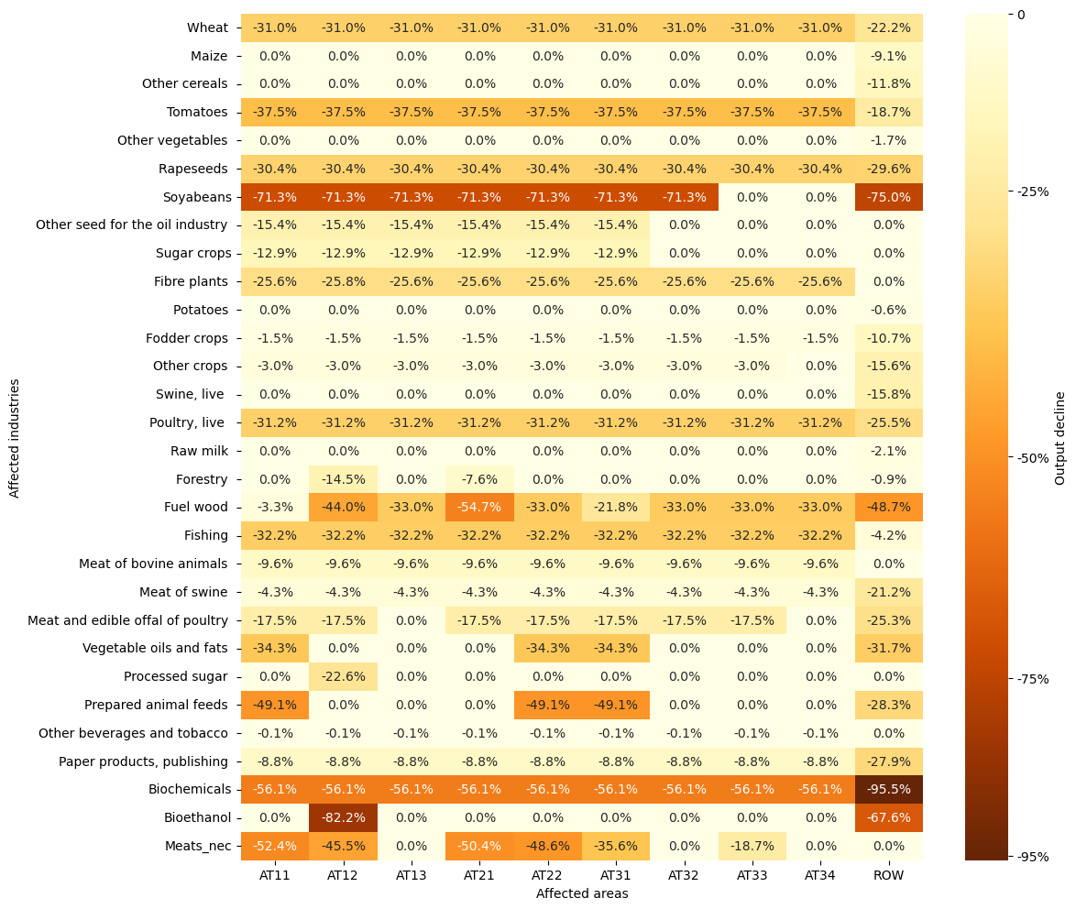

Figure 6.1. Definition of a hypothetic climate shock (based on 2003 extreme weather shock) specified for industries and NUTS-2 regions of Austria as well as for imports from the rest of the world. Only industries for which the shock affected at least one region or imports are displayed.

An ensemble of 500 simulations with different random seeds was used for both scenarios to account for uncertainties. Then the results were averaged across the ensembles. A comparison between the baseline and the climate shock scenarios is presented in Figure 6.2. Namely, the climate shock leads to a decrease in GDP growth, i.e., in the climate shock scenario, the GDP growth rate in the year of the shock is 0.35 percentage points (p.p.) below the baseline scenario. However, in the next year, it bounces back, ultimately almost converging with the GDP growth rate in the baseline scenario. Household consumption exhibits a more noticeable impact – in the year of the shock, it declines with the growth rate reaching almost one p.p. below the baseline scenario. Similar to the GDP growth rate, it bounces back the year after the shock and converges with the baseline scenario value two years after the shock. The imports behave in a similar pattern, however, the magnitude of the impact is even larger, with the imports growth rate declining by almost two p.p. in the shock year and exceeding by almost two p.p. the value of the baseline scenario in the first after-shock year. Ultimately, the real value of the imports in the shock scenario converges with its counterpart of the baseline scenario value two years after the climate shock has occurred.



Figure 6.2. Macroeconomic indicators of the Austrian national economy in the baseline and climate shock scenarios over the simulation period of four years. The shaded areas denote standard deviations (spreads) of the climate shock scenario simulation ensemble.

On the industry level, there is a higher heterogeneity observed. Most industries affected by the simulated climate shock directly, including those affected by declining imports, demonstrate a decline in output in the year of the shock. However, the magnitude of this decline and recovery patterns differ significantly (Figure 6.3).

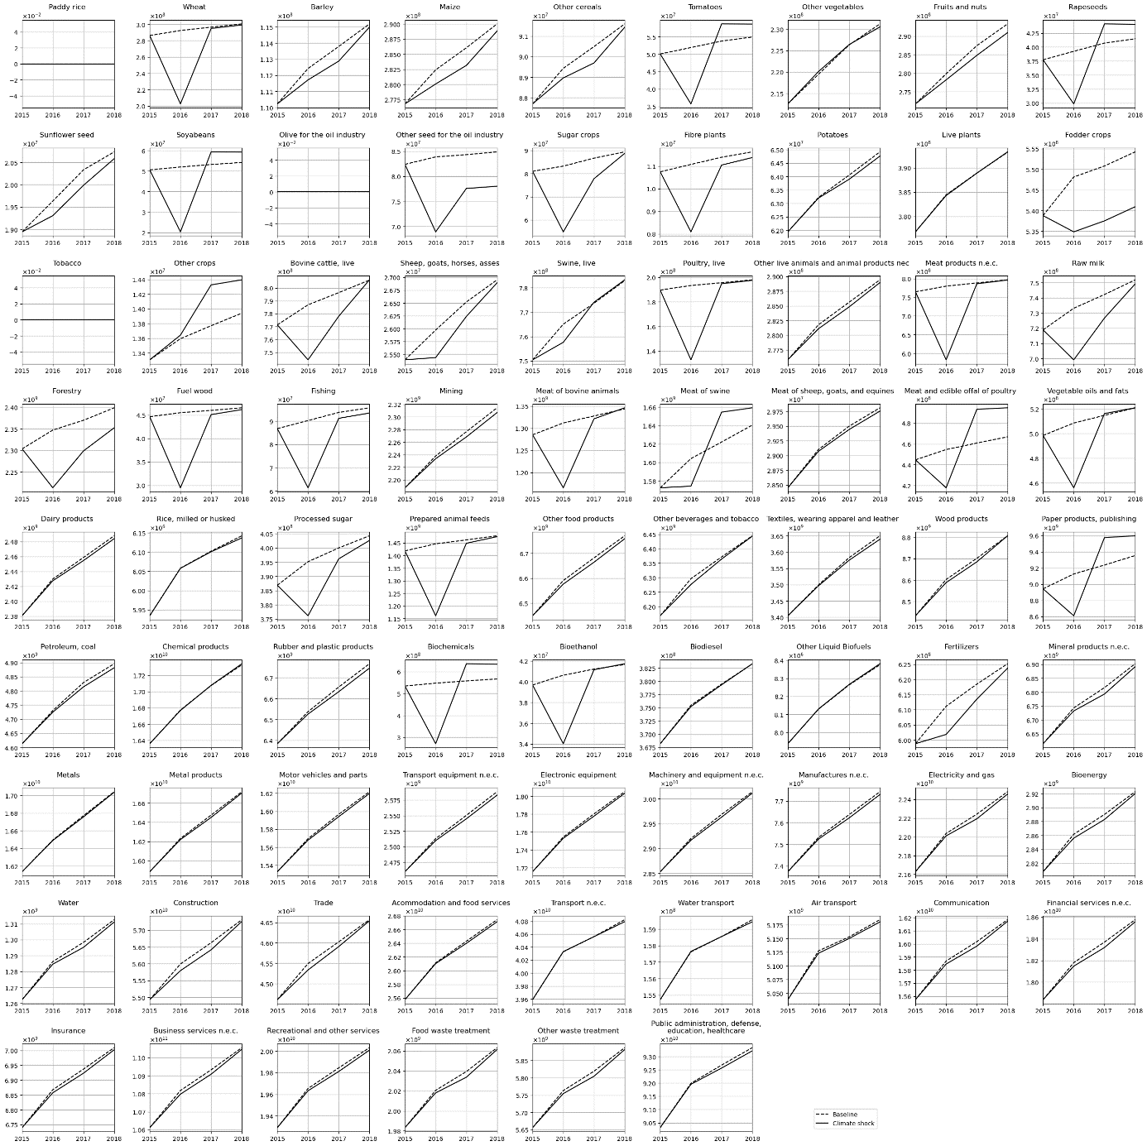

Figure 6.3. Total outputs of 78 industries of the Austrian economy in the baseline and climate shock scenarios over the simulation period of four years.

On top of the 24 industries affected by the shock directly, several other industries unaffected by the shock, such as bovine cattle breeding and breeding of sheep, goats, horses, and asses, demonstrate a sharp (up to 6%) decline in output. Similarly, raw milk production facing only a small import shock (2.1%) demonstrates an almost 5% decline in output in the year of the shock. This indicates a high dependence of these industries on the input from the industries using biomass as an input to their production, such as fodder crops and prepared animal feeds. On the contrary, a large-magnitude shock faced by the biochemicals and the bioethanol industries does not propagate to other industries as outputs of these industries are currently only marginally used as inputs by other industries.

About one-third of all industries are sharply affected by the simulated climate shock (either directly or indirectly), however, these industries begin recovering rapidly after the shock ends. Two years after the shock, their output reaches the output in the baseline scenario at that time (assuming an absence of climate extremes). This is typical for wheat production, growing live and fibre plants, animal production, biogasoline and biodiesel industries, and the manufacturing of fertilizers. In some cases, two years after the shock, the total output of the industries affected by the shock even exceeds the total output in the baseline scenario – this is observed for the production of tomatoes, rapeseed, and soya beans as well as production of swine and poultry meat, manufacturing of paper products, chemical products, and biochemicals. For example, the total output of the biochemical industry in the climate shock scenario measured two years after the shock exceeds its baseline counterpart by almost 12%.

The majority of service and heavy manufacturing industries, as well as the construction industry, are affected by the climate shock only marginally, however, for some of them, the difference between their output in the climate shock scenario and the baseline scenario continues to increase also after the shock ends, i.e., in the first after-shock year. Only two years after the shock, the output growth rate increased. Production of some crops (barley, maize, sunflower seed, and other cereals), fruits and nuts, as well as generation of electricity (including bioelectricity), supply of water, mining, and (conventional) petroleum refinement industry, are affected in a similar way, however, with a larger magnitude.

Numerous industries are not able to recover from the shock, having their output lower than in the baseline scenario not growing at the end of the simulation period and, i.e., accommodation and food services, the entire public sector (public administration, healthcare, education) as well as production of potatoes and rice and manufacturing of textile, wearing apparel and leather – however, the magnitude of these effects are marginal. The most profound effect is observed for the fodder crops industry – two years after the shock, its output is lower by almost 3% than in the baseline scenario.

Several industries are in an intermediate position – despite consistent growth after the shock, their output is still lower than in the baseline scenario at the end of the simulation period. This phenomenon is observed for forestry (2% output decline at the end of the simulation period) and other seeds for the oil industry (more than 8% output decline).

Some industries, such as water and land transport, as well as the production of other vegetables, face delayed consequences of the climate shock – their output begins to decline only in the year following the shock. However, the magnitude of this decline does not exceed 0,3% of their total output. Finally, some industries demonstrate paradoxical growth for the entire simulation period, namely, the manufacturing of other liquid biofuels and the production of other crops (4% growth at the end of the simulation period).

6.3 Synthesis of results and outlook

The possible impacts of climate shocks on the current bioeconomy in Austria were studied using a novel hybrid IO-ABM approach. Although the developed model enables a comprehensive analysis of the macroeconomic consequences of a potential climate shock, it has some important limitations in a bioeconomy transition context. The first limitation concerns the economic databases. Since official regional input-output data for Austria are only partially available, the MRIO table reflecting the structure of the Austrian economy, which was used as the basis for the ABM, was estimated using multiple statistical sources, hybrid (semi-survey) assumptions (Fritz et al., 2005) and non-survey estimation techniques (see chapter 5). In particular, such assumptions and estimations concern interregional flows, as a result of which the analysis of risk propagation channels may become a function of the assumptions on (the lack of) trade links in the MRIO. In the first version of the regionalized MRIO table, to which the ABM model has been calibrated, interregional trade flows were not very well captured (i.e. largely missing). This means that the presented results largely reflect (responses to) direct impacts and likely underrepresent the total (i.e. direct + indirect) impacts of climate extremes in a bioeconomy context.

Secondly, and probably most important, the presented model lacks an empirical grounding of bioeconomy agents’ responses to shocks in crop production and forestry. The hybrid IO-ABM model is designed to simulate agent-based responses in a spatially explicit shock scenario, for example in response to (isolated) floods or earthquakes, after which physical and social systems need to be recovered, largely with capital investments and labor. In a bioeconomy, however, climate extreme shocks tend to be short-term and generally followed by better years, inducing learning effects that help to increase extreme shock resilience. Bioeconomy agents, especially farmers, are used to climate-related volatility in their harvests and related commodity prices, and it would be important to get more insights into tipping points where new (behavioral) patterns emerge. Broader patterns of droughts and heat waves in Europe affect multiple crops and regions and may trigger sectoral or social response and/or protection strategies. For example, farmers in a region prone to patterns of intensifying heat waves may switch to heat-resistant crops, whereas an increase in drought extremes may lead to investments in irrigation or nature-based solutions that improve the water retention capacity of soils. Further downstream in the bioeconomy supply chains, animal feed companies, commodity traders and biorefineries may manage a diverse trade portfolio and/or strategic inventories in order to reduce the impact of shock exposure risk in their main inputs. BIOCLIMAPATHS foresaw the need for stakeholder collaborations to coproduce such relevant information, yet due to time, budgetary, and pandemic-related constraints, the model has been developed without such contextualized behavioral rules and heuristics.

Finally, the considered climate shock scenario was also produced synthetically. Specifically for Austria, where potential bioeconomy transition paths tend to be (also) related to forestry and biorefineries based on secondary products from wood processing, more insights are needed to understand the complex relationship between climate extremes, wood harvesting, and ecosystem resilience. For example, at the stakeholder event that was organized to collect research priorities in BIOCLIMAPATHS, stakeholders pointed out the potentially strong relation between patterns of climate extremes, in particular droughts, and the increasing incidences of insect and/or disease-affected forests. As such, wood supply from exposed forests may show an inverse relation with climate extremes, i.e. an increase in biomass harvest, but only for a couple of years after which the forest ecosystem’s provisioning capacities may collapse. For this reason, both longer time series of climate patterns (available in BIOCLIMAPATHS) and a closer integration with databases on spatially explicit ecosystems and their services are important to improve the power of the hybrid IO-ABM.

The flexibility of the developed ABM and high granularity of the underlying MRIO table enable future studies such as simulating consequences of further climatic and other shocks (such as a migration or energy crisis) as well as developing possible scenarios of the Austrian (bio)economy structure in the future. To this end, the model would need to be developed further in three directions:

First, to study price effects, the model needs to be extended to a model of a large open economy where the actions of agents do affect world prices. This extension could be realized, for example, with a two-country model of Austria in the euro area. Second, to study climate shocks on the future bioeconomy with potentially a larger share of GDP, further bioeconomy transition paths, such as the regionalized transition paths in chapter 7 of this report, need to be incorporated. Under these transition paths, heterogeneous impacts of climate extreme shocks may be much more widespread and severe. Third, a closer integration with spatially explicit databases on (services of) agricultural and forestry ecosystems is required to capture the complex feedback loops between social and ecological systems in a bioeconomy. Related to this, and also mentioned above, knowledge co-production with stakeholders is pivotal to developing the hybrid IO-ABM model in a bioeconomy transition context. These extensions are the subject of a future research project.

7. Bioeconomy transition paths for Austria

So far, in the previous chapters, risk propagation of climate extremes has mainly been concerned with impacts on activities and products, as well as vulnerabilities, in current (bio)economies. Current activities in the EU, as well as most national or regional bioeconomies, consist for the majority share of food (manufacturing) activities and, depending on the context, of wood- or crop-based bioenergy, as well as paper, pulp, chemistry or other material applications. In this chapter, we will develop scenarios for transition paths towards more advanced regional bioeconomies in case study country Austria, with the purpose of assessing these scenarios in terms of climate mitigation, environmental impacts and susceptibility to climate extremes (research ongoing).

7.1 Brief method description

In BIOCLIMAPATHS, we developed four bioeconomy transition paths for the 9 Austrian NUTS 2 regions (“Bundesländer”) based on the foresight scenarios for the EU bioeconomy towards 2050 (Fritsche et al. 2021). The foresight scenarios for the EU bioeconomy provide distinct assumptions for feasible supply, demand and technology futures. In terms of structural change, we assumed bioeconomy transition paths to replace fossil fuels from centralized fossil refinery activities by biobased products from decentralized biorefinery activities (based on (Kircher, 2019)). The level at which fossil carbon will be replaced by biobased carbon depends on (1) the current use of fossil fuels in the economy, (2) the specific bioeconomy transition path (scenario), (3) provisioning capacities of biological carbon (from crops, green biomass, wood, organic waste) at the regional level, (4) total regional demand (the market) for biobased carbon, and (5) conversion factors (fossil to biobased products). A final step (not included in this chapter), involved a literature review on biorefinery production functions, which allowed the calculation and implementation of contextualized (Leontief) production functions for the regional biorefinery activities. These production functions have been implemented as an additional activity and product in the BIOCLIMAPATHS multiregional supply use framework (BCP MRSUT, see section 5.1) where they will be assessed in terms of their climate mitigation potential, as well as in terms of novel vulnerabilities in a context of intensifying climate extreme shocks (ongoing research). In the following, we provide a brief overview of the five modeling steps and the resulting replacement capacities of biorefineries at the sub-national level in Austria. The replacement capacity of fossil by biobased carbon products in the productive activities of the regional economies (this chapter)

7.2 Regional assessment of fossil carbon use

Before developing the sub-national bioeconomy transition paths (scenarios), we identified fossil and biological resource use in the baseline year (YR2015). For this purpose, we constructed physical carbon accounts for the supply and use of fossil fuels and biobased commodities by economic activities and final demand at the regional (NUTS2) level. The estimation of these carbon supply and use accounts (CSU) accounts has been based on the 2015 hybrid multiregional use table of EXIOBASE[5] (updated from the year 2011), available at the national level. The national level has been (proportionally) allocated to the NUTS2 level on the basis of 2015 production values of regional industrial activities and final demand based on NUTS2 household budget surveys for the year 2015 (for more information see section 5.1 on the construction of the multiregional supply use tables in BIOCLIMAPATHS). Among others, the CSU accounts show the regional hotspots of fossil carbon use in the baseline year 2015 (see Table 7.1). In the table, it can be seen that AT12 (Niederösterreich) and AT13 (Vienna) account for the majority share in fossil fuel use and that this is mainly related to the energy sector. This can be largely explained by the relatively large population (and related final demand) and the concentration of the fossil fuel refinery and related services.

Table 7.**Error! Use the Home tab to apply 0 to the text that you want to appear here.**‑2: Estimation of fossil carbon use hotspots at the NUTS2 level of the Austrian economy (own calculations based on EXIOBASE)

|  |  |  |  |  |  |  |  |  |  |
| --- | --- | --- | --- | --- | --- | --- | --- | --- | --- |
|  | AT11 | AT12 | AT13 | AT21 | AT22 | AT31 | AT32 | AT33 | AT34 |
|  | Burgenland | Niederösterreich | Wien | Kärnten | Steiermark | Oberösterreich | Salzburg | Tirol | Vorarlberg |
| Agriculture | 6649 | 28178 | 1128 | 3546 | 8477 | 15473 | 1706 | 1941 | 892 |
| Forestry | 1014 | 6811 | 61 | 3812 | 6549 | 4417 | 1693 | 2399 | 521 |
| Mining | 5397 | 46873 | 1531 | 33592 | 51531 | 58033 | 12733 | 19932 | 8898 |
| Food industry | 2379 | 24713 | 6963 | 1391 | 6822 | 16073 | 20657 | 1706 | 2780 |
| Paper & Pulp | 52970 | 306068 | 200277 | 86177 | 453244 | 372407 | 207914 | 135395 | 112465 |
| Wood processing | 354 | 4186 | 212 | 3381 | 3990 | 3849 | 3450 | 3636 | 645 |
| Chemical industry | 24345 | 284506 | 142703 | 56141 | 79028 | 490978 | 41394 | 1066404 | 38004 |
| Other industry | 11254 | 89149 | 65613 | 206213 | 1362358 | 2350468 | 53674 | 518853 | 121449 |
| Fossil fuel refining & energy services | 259800 | 14467728 | 10046634 | 763161 | 1041023 | 1611239 | 714714 | 720654 | 315077 |
| Other services | 39738 | 757805 | 868620 | 84235 | 378083 | 466227 | 163746 | 194911 | 95458 |
| Government | 7016 | 39107 | 73662 | 15442 | 35384 | 36647 | 16209 | 21909 | 9578 |
| Final demand | 145989 | 2465964 | 2101297 | 632072 | 1376789 | 1725883 | 711517 | 873498 | 437532 |
| **C-FOS total** | 556906 | 18521087 | 13508702 | 1889162 | 4803278 | 7151693 | 1949406 | 3561239 | 1143300 |
| % of AT total | 1% | 35% | 25% | 4% | 9% | 13% | 4% | 7% | 2% |

7.2 Scenarios for bioeconomy transition paths

In BIOCLIMAPATHS, we built on the foresight scenarios for the EU bioeconomy towards 2050 (Fritsche et al., 2021), adapted for the Austrian context. Based on a co-creation approach with stakeholders across industry, academia and policy domains, Fritsche and colleagues developed 4 generic scenarios for the EU bioeconomy towards 2050. The scenarios were built around a 2-axis scheme of (1) the attitude of society towards change (responsible consumption and production) and (2) the capacity of the EU political system to implement effective policies directed at climate-neutrality and the SDGs. From the scenario descriptions, we selected the supply and demand factors that are applicable to the Austrian context. Yet, based on the relatively high share of organic agriculture and potential increase in productivity and growing season in response to higher atmospheric carbon levels in Austria, we assumed a positive impact of warming and higher carbon fertilization levels in Austria, as compared to negative impacts for the EU average. The following four bioeconomy transition paths have been defined for the Austrian regions:

1. Technological progress (supply side bioeconomy transition). A proactive policy support on the supply side of the bioeconomy, yet no societal change towards sustainable consumption, resulting in a stable demand and adverse effects with respect to climate change (+2o by 2100). Due to technological progress, domestic agricultural production increases with 0.5% annually between 2015 and 2030, after which yields are projected to stabilize. Wood supply from Austrian forests increases by 10% in 2050 (sustainable yield limit). Cascading use of biomass in non-food applications is assumed to reach a factor of 1.3 by 2050. Prices and imports are assumed to remain constant. In line with the EU level scenario, policy measures and related climate extreme shocks will assume a +2o increase in temperature.
2. Technological progress and increase in imports (industrial transformation scenario). A proactive policy support on the supply side, resulting in the same technological progress as under scenario 1, yet with an increase in imports to replace fossil carbon use in the capital region of Vienna, which is generally dependent on proximate and distal land resources for food and non-food biobased products. No active or reactive changes towards sustainable consumption are assumed and, with more competition for biological resources in the EU and world markets, the climate target will be missed (+2.5o by 2100).
3. Sustainable consumption & technological progress (societal transformation). A proactive policy support on the supply side, resulting in the same technological progress as under scenario 1, yet complemented with integrative policy approaches to support a transition towards sustainable consumption and climate change mitigation (+1.5o by 2100). Meat and dairy production and consumption levels fall to 65% of the 2015 levels, complemented by an increase of 25% of plant-based products. Wood develops as under scenario 1. Large parts of grassland that were 'freed' by less animal protein demand are used for decentral grass biorefineries co-producing proteins.
4. Organic agriculture and sustainable consumption (social-ecological transformation). Fundamental societal change towards sustainable consumption, led by social movements, followed by reactive policy support towards agro-forestry and other nature based solutions to capture organic carbon on the supply side. In this scenario, sustainable consumption entails a 35% drop in the consumption and production of animal based products as well as a 25% increase in the consumption of plant-based products. In this scenario, which includes elements of nature-based solutions and degrowth strategies, we assume an increase of 1.5o by 2100 (not all EU member states are assumed to follow this pattern).

7.3 Regional assessment of biobased carbon supply and use

Biological carbon can be supplied from terrestrial ecosystems (crops, green biomass, wood), aquatic ecosystems (not included) and as secondary products and organic waste streams from industrial and final consumption activities. With respect to crops, regional supply has been collected from the Eurostat production statistics (in physical units). Allocation to feed, food and non-food use (equaling domestic supply for that purpose) is based on the regionalization of the national use table in FABIO (Bruckner et al., 2019) on the basis of the regional shares in national use in monetary units (in the BCP MRSUT). For green biomass (“fodder crops” and “grazing” in FABIO) we distinguish feed and non-food biomass and the amounts have been calculated in the same way as for crops. In wood, we distinguish timber for construction purposes, fuel wood (energy) and wood processing waste streams (material and energy purposes), which has also been calculated in the same way, but now on the basis of the 2015 FORBIO supply and use table for Austria (distinguishing detailed wood supply chain activities and products) (Rosadio et al., in preparation). In the baseline year (2015), we have included the domestic supply of biomass for non-food purposes, including rapeseed for biodiesel, sugar and corn for bioethanol, wood for construction materials and bioenergy, and wood and food related waste flows from the supply tables that have not been used by animal feed or processed wood activities. As for organic biowaste, we only included biowaste at the household level, thereby assuming that secondary product streams from food and agricultural activities are already included in the use of feed crops, which has been regionalized on the basis of population shares in the national level (from FABIO final demand account for Austria). The regional supply of manure, finally, has been estimated on the basis of (Reinberg et al., 2020).

The current (2015) repository of biomass supply at the regional level, by biomass category in physical units, is given in Table 7.2. Currently, the largest share of domestic biomass supply at the national level is consumed as fodder crops (47%), followed by wood residues (19%), food crops (12%) and wood (11%). The high share of wood based biomass is of course typical for a forest-rich country such as Austria. Niederösterreich (29% in total biomass supply), Oberösterreich (22%) and Steiermark (19%) are the three most important regions in a bioeconomy context. They also provide the largest forest-based supplies.

Table 7.2: Regional biomass supply and use in Austria (Source: Own calculations based on FABIO, FORBIO, BCP MRSUT)

|  |  |  |  |  |  |  |  |  |  |
| --- | --- | --- | --- | --- | --- | --- | --- | --- | --- |
| **Type of biomass** | **AT11** | **AT12** | **AT13** | **AT21** | **AT22** | **AT31** | **AT32** | **AT33** | **AT34** |
|  | Burgenland | Niederösterreich | Wien | Kärnten | Steiermark | Oberösterreich | Salzburg | Tirol | Vorarlberg |
| Food crops | 919405 | 4160734 | 163153 | 165766 | 507220 | 856429 | 24037 | 68435 | 13831 |
| Feed crops | 44855 | 573225 | 312 | 149609 | 510524 | 779965 | 0 | 0 | 0 |
| Non-food crops | 99620 | 703449 | 5130 | 4735 | 26738 | 112365 | 225 | 505 | 212 |
| Feed (fodder) | 478572 | 5481823 | 10877 | 2866251 | 4799184 | 6900964 | 2398556 | 2505769 | 961805 |
| Wood | 245160 | 1368000 | 1935 | 883865 | 1739012 | 999993 | 316127 | 348385 | 135483 |
| Wood residues | 434364 | 2822000 | 3429 | 1565997 | 2933988 | 1771748 | 560101 | 617254 | 240043 |
| Biowaste | 20217 | 114774 | 125890 | 39096 | 85645 | 100781 | 37755 | 51102 | 26548 |
| Manure | 85239 | 796026 | 0 | 78425 | 278505 | 965268 | 33310 | 24486 | 48510 |
| **Total** | **2327432** | **16020030** | **310727** | **5753743** | **10880817** | **12487512** | **3370112** | **3615936** | **1426432** |
| Share in total | 4% | 29% | 1% | 10% | 19% | 22% | 6% | 6% | 3% |

7.4 Regional markets for biobased carbon and conversion factors for biorefinery products

In order to compensate for the higher feedstock, transportation and labour costs, it is argued that decentralized bioeconomy networks need to be developed towards industrial symbiosis in proximate and circular material and energy systems with cascading practices for efficiently recycled product and energy flows (based on Kircher, 2021 and (Vom Berg C. et al., 2022). In that sense, regional bioeconomies may develop different from global supply chains of bio-based chemicals and materials, with their high labour productivities and rapidly growing markets for solvents, polymers, packaging, biofuels and agrochemicals (European Commission, 2022). By reducing the amount of virgin biomass and valorizing food and non-food waste flows, it is argued that bioeconomy has the potential to contribute to a more circular and environmentally friendly industrial system at the regional level (Stegmann et al., 2020; Vom Berg C. et al., 2022). Industrial symbiosis has been developing in the field of paper and pulp, bioplastics and chemicals, pharmaceuticals, fertilizers and bioenergy, among other. In BIOCLIMAPATHS, we therefore assumed market developments at the sub-national level, where heterogeneous, context based biorefineries allocate their product range to the replacement of fossil carbon use in chemical, paper and pulp, and energy related activities. Based on estimations of current fossil fuel use by regional industries (Table 7.1) and a 50% carbon conversion rate (from fossil to biobased) in all biorefinery conversion pathways (based on Kircher, 2021), we estimated the fossil replacement capacity of regional bioeconomies in Austria (see Table 7.3).

Table 7.3: Potential replacement of fossil carbon by biorefinery products (in %) in interindustry use at the regional level in Austria based on estimations of 2015 fossil fuel use

|  |  |  |  |  |  |  |  |  |  |  |  |
| --- | --- | --- | --- | --- | --- | --- | --- | --- | --- | --- | --- |
|  | Type of scenario | AT | AT11 | AT12 | AT13 | AT21 | AT22 | AT31 | AT32 | AT33 | AT34 |
|  |  |  | Burgenland | Niederösterreich | Wien | Kärnten | Steiermark | Oberösterreich | Salzburg | Tirol | Vorarlberg |
| Scenario 1 | Tech progress | 13% | 47% | 12% | 1% | 33% | 26% | 26% | 20% | 12% | 16% |
| Scenario 2 | Imports | 21% | 40% | 11% | 34% | 35% | 27% | 26% | 21% | 12% | 17% |
| Scenario 3 | Sust. Cons. | 18% | 32% | 12% | 1% | 54% | 39% | 37% | 38% | 22% | 28% |
| Scenario 4 | Nature-based | 12% | 8% | 6% | 0% | 38% | 27% | 29% | 30% | 17% | 22% |

Table 7.3 shows the level of reduction in fossil fuel use by industrial activities in Austrian regions. Both the technological progress (0.5% yield increase until 2050) and the nature based scenario (with more organic agriculture and agro-forestry resulting in a 15% yield reduction until 2050) give a similar bioeconomy transition with 12-13% reduction in fossil carbon use. The import scenario (replacing 25% of Vienna’s industrial fossil fuel use) shows the largest reduction, whereas the sustainable consumption scenario (35% reduction in production and consumption of animal based products) is projected to result in 18% drop in industrial fossil fuel use. It should be noted that regional final demand has not been taken into account in, as we assume an industrial bioeconomy transition path that produces biobased products for final demand. However, lower overall fossil carbon replacement capacities need to be anticipated when imported fossil fuels for household mobility are taken into account.

7.5. Synthesis of results and outlook

In this chapter, we described the construction of four distinct bioeconomy transition paths at the regional level in Austria. Preliminary estimations show that, depending on the scenario, between 12% and 21% of industrial carbon use can be replaced by biobased carbon. Regional bioeconomy transition paths suggest heterogeneity in structural change, which is largely related to the biophysical resource context and the industrial activities with which the biorefinery can establish synergies in industrial symbiosis. Furthermore, based on feedstock availability per region and the cost structure for the appropriate biorefinery technology, we calculated the capacity and related feedstock and factor costs for regional biorefineries. Economic and environmental impact assessments are still missing and need to be included in order to serve as a transition perspective for stakeholders. To this end, contextualised production functions have been derived from a review of socio-economic, financial and environmental impact assessments of different biorefinery technologies in the literature. By implementing the regional biorefineries in the BCP MRSUT, and extending the framework with environmental extensions, the bioeconomy scenarios will be assessed in the wider context of the SDGs (ongoing work), including their contribution to climate resilience (Schutter et al., forthcoming).

8. Interactions between SDGs and bioeconomy

## 8.1 Introduction

The gradual replacement of fossil resources in industrial production and energy supply with renewable biogenic raw materials could provide the path for a more sustainable, resource-efficient transformation. However, the bioeconomy, by default, is neither circular nor sustainable. The high demand for biomass could result in monocultures or deforestation. This degradation of ecosystems, in turn, has adverse effects on the climate, causing loss of soil carbon and biodiversity. To minimise the risk of transitioning towards an unsustainable bioeconomy, Sustainable Development Goals (SDGs) are integrated into bioeconomy strategies to monitor the transformative change. Additionally, 62 ministers of agriculture agreed on the importance of seizing opportunities to implement a bioeconomy sustainably at the Global Forum for Food and Agriculture in January 2015. They recommended that the United Nations Food and Agriculture Organization (FAO) coordinates international work on sustainable bioeconomy. Through the International Sustainable Bioeconomy Working Group (ISBWG), a multistakeholder group, FAO established an indicator framework to monitor the transition to a sustainable and circular bioeconomy incorporating the 2030 Agenda for Sustainable Development. As the world is currently not on track to meet the SDGs, and since crises, such as conflicts, climate catastrophes, pandemics, and other socioeconomic challenges, decelerating progress, developing a bioeconomy can function as an enabler to push for rapid SDG progress.

In 2015, the United Nations adopted the 2030 Agenda for Sustainable Development for transformative changes to shift the world onto a sustainable and resilient path by balancing the three sustainability dimensions ­– social, economic, and environmental. It comprises 17 SDGs and 169 targets to be achieved by 2030, and 231 unique indicators to monitor progress. Instead of a just collection of goals, targets, and indicators, SDGs are systems of interacting components with synergies and trade-offs (Pradhan, 2019). Synergies are positive interactions where progress in one SDG or target favours advancement in another. Due to the current unsustainable practices, the progress of one SDG or target may hinder another's advancement, which is called a trade-off. For transformative changes, adequate actions must resolve trade-offs and generate win-win solutions, such as creating entry points for progress like transitioning to a bioeconomy.

Currently, however, there are different opinions on how and to which SDG the bioeconomy can contribute and vice versa. This chapter briefly reports our investigations on SDGs and bioeconomy interlinkages. Mainly, we first briefly described SDG and bioeconomy databases we compiled. Subsequently, we highlight the key findings based on published results or obtained preliminary findings that represent three necessary action points: *(1) advancements of bioeconomy framework, including credible bioeconomy indicators with measurable data, (2) consideration of synergies and trade-offs between bioeconomy and SDGs via prioritisation, (3) uniform agreement of bioeconomy strategies for guiding decision-making based on urgencies.* We will publish scientific articles after finalising these preliminary findings.

## 8.2 Data for SDGs and bioeconomy

Due to the integrated nature of SDGs and the associated targets, progress towards one target is also linked through complex feedback loops to other targets. We outline which SDGs and targets need prioritisation when implementing a bioeconomy according to EU policy concepts. We, therefore, apply a multi-criteria analysis decision framework that assesses interlinkages between SDGs and bioeconomy indicators. The methodological approach combines recent publications and guidelines on SDG and bioeconomy implementations. We apply a range of complementary qualitative and quantitative methods within the assessment framework, including baseline assessment, benchmarking, correlation analyses, literature review, network analyses, and policy gap analyses. We develop a unified SDG database for our data-driven analyses and fill the *FAO Bioeconomy indicator framework* with data from various official sources. On the one hand, our results will add to the debate on how bioeconomy implementation strategies in the EU benefit or hinder the fulfilment of the 2030 Agenda and where prioritisation is needed. And on the other hand, how the approach to achieve the SDGs by 2030 in Europe can contribute to achieving EU policy bioeconomy priorities. We detect those bioeconomy and sustainable development strategies that cause trade-offs and require revision. This creates intervention points for a successful implementation of the bioeconomy and 2030 Agenda in the EU.

### 8.2.1 Unified SDG database

We built a unified SDG data database by compiling the three global SDG databases (Warchold et al., 2022). They are provided by the United Nations (UN), the World Bank Group (WB), and the Bertelsmann Stiftung & Sustainable Development Solutions Network (BE-SDSN). See Warchold et al. (2022) for details on these databases and the compiling method. Mainly, we assigned all provided indicators to match the 17 SDGs and 169 targets of the officially adopted global SDG indicator framework based on the lowest common denominator of the years - 2000 to 2019 - as a comparison period. It maximised the number of indicators per target, covering more aspects of their multidimensionality. We included the highest data availability indicators over time and space for identical or similar indicators. Still, the three SDG databases uncovered or insufficiently covered several SDG targets. Therefore, there is a need to continuously improve data for SDG monitoring.

### 8.2.2 Bioeconomy database

Given the challenges and opportunities in the transition to a sustainable and circular bioeconomy, the ISBWG agreed on a set of "Aspirational Principles and Criteria for a Sustainable Bioeconomy" (Bracco et al., 2019). The framework includes ten principles, 24 criteria, and several impact categories designed to ensure that the bioeconomy, when properly implemented, benefits individual communities and the global environment in ways that are aligned with the SDGs. Since the principles and criteria cross-cutting across the sustainability's social, economic, environmental and governance dimensions, the framework can be used to monitor and evaluate progress in making this shift. To accomplish this monitoring, the FAO has defined a series of indicators for each principle and criterion. The proposed indicators have diverse typologies: qualitative or quantitative indicators, descriptive or performance indicators, and direct, indirect or proxy indicators. Despite considering that a single indicator might not be sufficient to understand the complex phenomena of sustainable bioeconomy, the framework remains aspirational, as actual data for the indicator is currently unavailable.

We tried to tackle this challenge by retrieving data from national or international accounts or databases such as EUROSTAT, FAOSTAT, WDI, the Joint Research Centre (JRC) of the European Commission, the Global Footprint Network, or the unified SDG database. Figure 8.1 lists the accomplished data coverage according to the FAOs bioeconomy framework. Based on the number of bioeconomy criteria, we could cover 80% with data disaggregated in terms of demographic but most of all non-demographic factors such as type of sector, commodity, or process. A detailed overview of all bioeconomy indicators used with the respective sources and other characteristics will be made available in upcoming publications by the BIOCLIMAPATH consortium.

|  |  |
| --- | --- |
|  |  |
| Figure 8.1: Bioeconomy data coverage based on FAO Bioeconomy framework. The ten principles (left figure source: FAO.2021. Aspirational Principles and Criteria for a Sustainable Bioeconomy), covering aspects of sustainable bioeconomy (SBE) are divided into different criteria (sunburst diagram, second level), which in turn are represented by different impact categories (third level). Each impact category is covered by at least one indicator and data from multiple sources. Data covers all principles, 19 of 24 criteria, and 51 of 69 impact categories covered. | |

Despite being able to cover a decent amount of criteria, credible bioeconomy indicators, especially in terms of environmental and governance perspectives, are still missing. Modern agricultural and bioeconomic production processes generate large and diverse amounts of data - from sensor data from agricultural machinery to satellite and aerial images, weather and climate data, and soil properties and fertility data. Following the large body of research showing that the 2030 Agenda is a complex, dynamic framework, bioeconomy research needs to be similarly holistic to capture bioeconomic activities in their entirety and support a long-term policy perspective. Consequently, the proposed bioeconomy indicator framework constitutes a starting point but is also still a work in progress.

## 8.3 Synergies and trade-offs between SDGs and bioeconomy

The FAO argues that achieving the ten principles and 24 criteria defining a sustainable bioeconomy in the transition to a greener, fairer and more prosperous economy will also enable the achievement of all SDGs (FAO, 2021). In this section, however, we will show that the bioeconomy and SDGs exhibit both synergies and trade-offs, and that officially published national European bioeconomy strategies do not cover all SDGs simultaneously or to the same extent. Analysing these interlinkages and bioeconomy strategies is crucial to understand the impacts and possible enablers for sustainable bioeconomy transformation pathways. Before highlighting interactions between SDG and bioeconomy, we briefly describe key findings from our SDG interaction studies. These studies are conducted to develop systematic methods for investigating interactions among SDGs and between SDGs and other sectors.

### 8.3.1 SDG interactions

Based on the first systematic quantification of SDG interactions, Pradhan and colleagues highlighted more synergies than trade-offs within and among SDGs in most countries (Pradhan et al., 2017). Interestingly, they showed SDG12 (Responsible Consumption and Production) as a bottleneck to achieving the 2030 Agenda due to its trade-offs with most other SDGs. This finding emphasised the need to transition from a fossil-based to a sustainable bio-based economy. Kroll and colleagues investigated the development of SDG interactions between 2010 and 2018 (Kroll et al., 2019). They highlighted that climate actions are crucial for sustainability, and there are positive changes with notable synergies for some SDGs. Based on a cross-sectional analysis, Warchold and colleagues presented how SDG interaction can vary to a country's income and region, along with the gender, age, and location of its population (Warchold et al., 2021).

We also used quantitative SDG interaction analysis results for developing SDG networks and models. For example, Warchold and colleagues highlighted the changes in SDG network structures at goal and target levels with SDG data selection by comparing the unified SDG database and the three global databases (Warchold et al., 2022). Considering direct and indirect SDG interactions, Anderson and colleagues built an SDG systems model (Anderson et al., 2022). They showed that most SDGs and targets act as levers rather than hurdles towards achieving the 2030 Agenda.

Besides quantitative studies, we contributed and conducted qualitative studies on SDG interactions and other sectors. For example, our literature assessment showed that sustainable food system transformation can convert the current trade-offs between food systems and SDGs into synergies (Pradhan et al., 2021b). One strategy for sustainable food system transformation is optimum nitrogen fertiliser management which can positively impact most SDGs (Ladha et al., 2020). Further, our expert elicitation-based study highlighted that the COVID-19 pandemic negatively impacted most SDGs (Pradhan et al., 2021a). However, it also opened an opportunity for sustainable transformation, which was short-lived.

### 8.3.2 SDGs and bioeconomy interlinkage

Our statistical analysis of interlinkages between bioeconomy and SDGs indicates a consistent level of synergies and trade-offs between principles and goals at the European level (Figure 8.2). Hence, the implementation of a bioeconomy is facing constant challenges, which may negatively impact the SDGs and vice versa. On average, however, synergies outweigh trade-offs implying that the indicators are more coherent than conflicting, which is a positive starting point for a joint action plan to achieve both agendas.

In particular, improvements in bioeconomy principles 8 and 10 have significant synergy with all SDGs. Consequently, enhanced cooperation and sharing of resources, skills and technologies among European countries without hampering their local economies but rather supporting them via the trade of biomass and related technologies will significantly contribute to SDG achievements. Similarly, improvements in SDGs 6 and 7 have substantial positive impacts on most of the bioeconomy principles. However, our analysis also reveals a non-neglectable number of trade-offs. For example, we observe the negative impacts of the proportion of members of developing countries in international organisations [SDG 16] with coherent policies, and regulations in the bioeconomy sectors [P6]. This indicates the pressures of European countries and policymakers to pursue international commitments while simultaneously improving bioeconomy commitments and disbursement.

The variation in synergies and trade-offs is actually low at the European level but increases at the country level. Despite similarities among the countries, the increase in differences suggests that envisioned improvements in both agendas are highly country-specific, requiring the multi-criteria analysis to be conducted at the country level (see section 8.3.4 below).

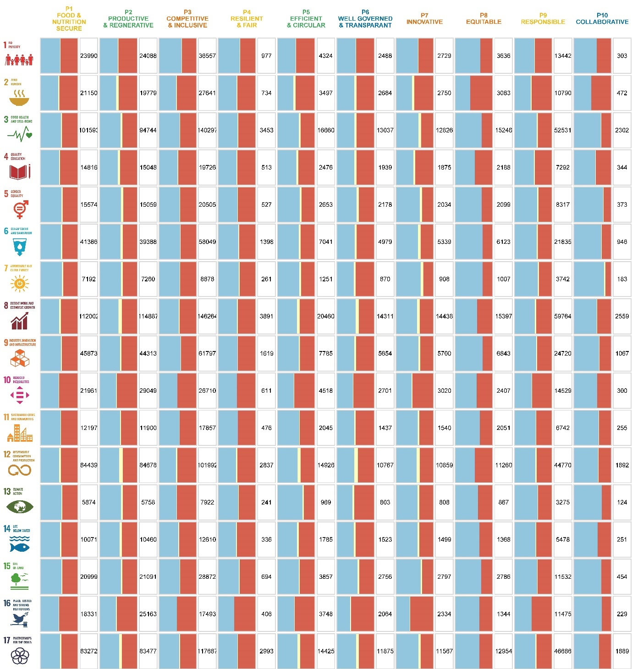

Figure 8.2: Observed interactions between bioeconomy principles and Sustainable Development Goals (SDGs) at the European level: The colors represent the shares of synergies (blue), not-classified (yellow), and trade-offs (red). The numbers in the boxes represent the number of indicator data pairs used for the analysis. The SDGs are represented with the icons on the left.

### 8.3.3 EU bioeconomy strategies/policy and SDGs

An increasing number of European countries have implemented bioeconomy strategies and documented these efforts in their national strategy papers. The bioeconomy is further at the centre of EU sustainable development strategies to contribute to many SDGs. Currently, there are ten EU-member countries with published bioeconomy policies: Austria, Czech Republic, Finland, France, Germany, Ireland, Italy, Latvia, Netherlands, and Spain, as well as two non-EU members but within the geographic borders: Norway and the United Kingdom (Figure 8.3A). Some of these countries have already revised strategies, resulting in multiple publishing years, some publish only in native languages, and others have their strategies still under development.

Applying content analysing techniques using a lexical search program, we examined ten European national bioeconomy strategies and the EU strategy paper regarding their SDG target representation. Each of the 169 SDG targets is defined by a set of keywords. The analysis results in text passages within each strategy paper matched to at least one SDG target. This translates into a frequency of SDG goals and target representation within each bioeconomy strategy (Figure 8.3).

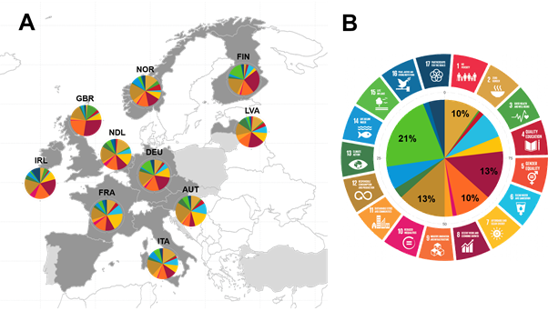

Figure 8.3: SDG representation in (A) the national bioeconomy strategies and (B) the EU bioeconomy strategy: Country names are abbreviated according to UN country coding- The colouring is according to the UN colour coding of SDGs. Countries mapped in dark grey have published national bioeconomy strategies in English, except Czechia and Spain. Countries in light grey colour have bioeconomy strategies under development.

The SDG representation shows similarities and differences among the countries compared to the overarching EU strategy. SDG 2, 8, 9 and 12, as well as the targets 2.4[6], 8.3[7], 9.4[8] and 12.2[9], are highly represented in each national strategy. This finding is in line with the presentation of the SDGs in the EU Bioeconomy Strategy. In contrast, SDG 7 (and target 7.2[10]) is one of the goals (targets) mentioned relatively frequently by individual policies but not as much at the supranational level. SDG 15, the most frequently mentioned goal in the EU strategy, is, however, underrepresented in national strategies. Despite the direct link to the other environment-related SDGs, these have been severely neglected in all strategy papers, and SDG 5 is never mentioned.

Whether the frequency of goals and target mentioned in strategies reflects their urgency for development remains. Therefore, based on the publication year, we compared the results to the SDG performance of the Sustainable Development Reports published by Sachs et al. (2022) based on the publication year. The higher the performance score of an SDG, the further the country has accomplished the goal's development. The three most discussed SDGs exhibit relatively high-performance scores. For example, Austria, the country with the highest representation of SDG 6 among all strategies, has an SDG 6 score of 92.4%. Despite the potential to improve climate actions through bioeconomy, SDG 13 is rarely mentioned in the Austrian bioeconomy strategy, even though it has a low SDG score of 53.9% and needs urgent development. This contradiction is no exception and applies equally to almost all strategies.

The discrepancies between the strategies indicate that the EU member countries, European countries and other non-European nations (such as G20 nations which have already published strategies) should promote a common understanding of bioeconomy objectives and strategies. Countries should revise their national plans and refrain from mainstreaming some goals at the expense of others. To increase the importance of the bioeconomy as an effective global tool for achieving the SDGs, it is essential to approach them holistically, taking into account synergies and trade-offs.

### 8.3.4 Multi-Criteria Assessment

The risk of transitioning towards an unsustainable bioeconomy remains, although the SDGs were included in the framework for precisely this purpose. The multi-criteria assessment integrated the results from the different analysis approaches described in the above chapters to provide an overall evaluation of each SDG based on their score in three criteria: level of urgency, level of systemic impact, and policy gap (an approach similar to Allen et al., 2019).

European countries need prioritisation to push for progress without neglecting other SDGs or principles. In the case of Austria and Germany, our results reveal that there are good and bad practices in this regard (Table 8.1). For example, achieving SDG 12 still faces significant challenges in Austria. However, implementing a bioeconomy has synergistic rather than constraining effects on SDG 12, and this potential is clearly reflected in the Austrian bioeconomy strategy. In contrast, the SDGs related to biodiversity urgently need to be improved or even measured first. Yet, despite their high share of synergies with improvement among all bioeconomy principles, these environmental aspects tend to be neglected in the policy strategies. Further, many of the most frequently mentioned SDGs are almost accomplished (e.g. SDG 6 to 9), whereas there is still a great lack of progress in other goals. A similar pattern emerges for Germany. In this context, the integration of SDG 12 can be perceived as good practice, and the consideration of environmental goals (SDG 13-15) as bad practice.

Table 8.1: Results from the multi-criteria assessment of Sustainable Development Goals (SDGs) in relation to a bioeconomy in Austria and Germany. Criteria 1 shows the SDG index score obtained by the Sustainable Development Report (Sachs et al., 2022) to reflect each SDGs performance (see legend beneath the table). Criteria 2 sums up the average shares of synergies and trade-offs of each SDG in relation to the ten bioeconomy principles. Criteria 3 represents the SDG representation in the respective bioeconomy strategies (see Figure 8.3).

|  |  |  |  |  |  |  |  |
| --- | --- | --- | --- | --- | --- | --- | --- |
|  |  | **Criteria 1 Urgency** | | **Criteria 2 Impact [average share in %]** | | | **Criteria 3 Policy [occurrence in %]** |
| **Synergy** |  | **Trade-off** |
| **AUSTRIA** | SDG 1 | green | **↑** | 51,88 | > | 47,23 | 0 |
| SDG 2 | orange | **➚** | 44,74 | < | 52,13 | 10,26 |
| SDG 3 | orange | **➚** | 56,99 | > | 40,73 | 1,54 |
| SDG 4 | yellow | **➚** | 50,94 | > | 46,55 | 4,62 |
| SDG 5 | yellow | **➚** | 56,71 | > | 39,49 | 0 |
| SDG 6 | yellow | **↑** | 56,28 | > | 40,43 | 11,79 |
| SDG 7 | green | **↑** | 56,90 | > | 39,26 | 17,44 |
| SDG 8 | yellow | **➚** | 50,95 | > | 43,18 | 6,15 |
| SDG 9 | yellow | **➚** | 56,53 | > | 40,98 | 7,18 |
| SDG 10 | yellow | **→** | 41,05 | < | 57,66 | 0,51 |
| SDG 11 | yellow | **↑** | 47,94 | < | 49,84 | 2,05 |
| SDG 12 | red | **➚** | 50,10 | > | 43,85 | 22,56 |
| SDG 13 | red | **➚** | 46,82 | < | 50,45 | 6,15 |
| SDG 14 | grey |  | 61,64 | > | 35,16 | 0 |
| SDG 15 | orange | **→** | 60,11 | > | 37,93 | 6,15 |
| SDG 16 | yellow | **➚** | 41,72 | < | 57,95 | 1,03 |
| SDG 17 | red | **➚** | 52,68 | > | 42,61 | 2,56 |
| **GERMANY** | SDG 1 | green | **↑** | 52,58 | > | 46,77 | 0 |
| SDG 2 | orange | **➚** | 36,61 | < | 57,96 | 8,61 |
| SDG 3 | orange | **➚** | 58,85 | > | 36,49 | 0,59 |
| SDG 4 | orange | **➚** | 52,70 | > | 43,38 | 2,37 |
| SDG 5 | yellow | **➚** | 65,23 | > | 31,06 | 0,00 |
| SDG 6 | yellow | **↑** | 64,28 | > | 32,83 | 5,34 |
| SDG 7 | yellow | **↑** | 67,82 | > | 30,13 | 10,39 |
| SDG 8 | yellow | **↑** | 61,90 | > | 33,39 | 17,80 |
| SDG 9 | yellow | **↑** | 61,98 | > | 36,08 | 14,54 |
| SDG 10 | yellow | **➚** | 43,24 | < | 55,97 | 2,08 |
| SDG 11 | yellow | **➚** | 64,46 | > | 33,15 | 2,08 |
| SDG 12 | red | **➚** | 58,06 | > | 35,35 | 15,43 |
| SDG 13 | red | **➚** | 65,41 | > | 31,84 | 3,26 |
| SDG 14 | orange | **→** | 59,09 | > | 36,58 | 1,48 |
| SDG 15 | orange | **➚** | 66,84 | > | 31,5 | 11,57 |
| SDG 16 | yellow | **↑** | 44,44 | < | 53,53 | 0,89 |
| SDG 17 | yellow | **↑** | 61,61 | > | 34,47 | 3,56 |
|  |  | |  |  | | --- | --- | | green | Goal Achievement | | yellow | Challenges remain | | orange | Significant challenges | | red | Major challenges | | grey | Insufficient data | |  |  | | **↑** | On track or maintaining achievement | | **➚** | Moderately Increasing | | **→** | Stagnating | | **↓** | Decreasing | | | | | | |

The evaluation of our data implementation, as well as the results obtained from the multi-criteria analysis, lead to the following key findings:

1. the need to advance the bioeconomy framework, including credible bioeconomy indicators with measurable data,
2. the need to holistically consider synergies and trade-offs between bioeconomy and SDGs via directed prioritisation,
3. uniform agreement of bioeconomy strategies for guiding decision-making based on urgencies.

Further in-depth analysis at the bioeconomy criteria level and SDG target level, for more profound recommendations, will be conducted and published in scientific papers by the BIOCLIMAPATH consortium.

9. Synthesis

9.1 Reflection and discussion on the interdisciplinary approach

BIOCLIMAPATHS has been grounded in a social-ecological systems perspective to define research questions and advance understanding of interdependencies among weather patterns, yield damages, bioeconomy supply chains and social vulnerabilities in the global resource system. Getting better insights on those relations, we argue, is pivotal and a first step for designing and implementing climate resilient, safe and just bioeconomy transition paths in a climate change context. To this end, the BIOCLIMAPATHS consortium implemented an interdisciplinary approach to provide insights on key relations between bioeconomy activities and the climate system, thereby aiming to generate a comprehensive understanding of climate risk transmission channels in a bioeconomy transition context (see Table 9.1).

Importantly, Table 9.1 indicates how the project covered the risk transmission channel from climate hazard to supply shocks, biophysical and economic impacts, social vulnerabilities, adaptation and mitigation strategies, as well as synergies with the SDGs, in order to support climate resilient bioeconomy transition paths in society. The BIOCLIMAPATHS consortium developed a quantitative method based on a mix of parametric and non-parametric approaches for statistical inferences, input-output analysis and agent-based modeling. The main strength of the approach is that, although each research step has clear boundaries and outputs, it also builds on the previous step, thereby supporting the interdisciplinarity based on soft-linking biophysical and economic models. Apart from methodological challenges, interdisciplinarity involves an interested and open approach among team members from different disciplines, each with their own language and working mode, requiring time and efforts to listen to each other and understand the background and the vision for the joint work.

The main limitation of the research approach relates to the underlying crop databases (based on Eurostat), which show large omissions, changes in crop categories and changes in territorial (NUTS) definitions over time. For several crops, smaller crops in particular, but also vegetables and fruits, data are largely or even completely missing. The project team needed to revert the biophysical analysis of crop yield and production impacts to the NUTS1 level because of poor data coverage at the NUTS2 level. In addition, data related uncertainties “multiply” with each (dis)aggregation step in the research approach. Furthermore, due to a lack of sub-national forestry data, we were not able to produce wood-related damage functions for the forest-based bioeconomy in the EU. We think that, in a context of climate change, related extreme events and their intensifying impacts on agriculture and forestry, it is urgent to have access to standardised crop and forestry statistics available at the sub-national level.

To a lesser extent, but also increasingly important in food and non-food bioeconomy contexts, are the economic databases at the sub-national level. In general, EU & national statistical offices provide agricultural accounts at the NUTS2 level, but key data such as labour input is missing. Also here, we think that a better integration with e.g. EU’s FADN database would have reduced uncertainty in the results. In food and non-food bioeconomy activities, no standardized databases are available which requires estimations of output, inputs and (interregional) trade flows. All these estimation steps bear a considerable uncertainty range, which affects the quality of the results. We are aware that, both for cost and data protection reasons, not all individual farm and firm data can be aggregated and shared, but we argue that a discussion to which extent this is desirable in a climate risk context would be important. Other limitations mainly relate to the lack of price responses to shocks in commodity markets and the lack of stakeholder inputs with respect to risk mitigation and adaptation (governance perspective).

Table 9.1: Summary of steps and methodological aspects of the interdisciplinary research approach in BIOCLIMAPATHS (by Chapter)

|  |  |  |  |  |
| --- | --- | --- | --- | --- |
| **Relation (chapter nr.)** | **Risk component** | **Methodology** | **Strengths** | **Limitations** |
| 1. Climate change & weather extremes | Hazard (heat -/cold waves, droughts, precipitation) | Statistical non-parametric approach (percentile-based) | Robust assessment of historical extreme events | Scenarios of climate extremes generally underestimated in climate models  Uncertainty from large scale circulation patterns |
| 2. Climate extremes & crop yields | Direct impacts | Relative yield damage based on non-parametric convex hull approach | Deals with complex climate extreme context from (1) by “fuzzy” regression | **Crop data limitations**  Lack of insights in compound & more complex climate extreme effects |
| 3. Climate affected crop yields & shocks in production | Direct impacts (shock) | Logistic regression analysis of climate extremes and extreme production losses | Insights in EU hotspots of production losses based on yield damages from (2) | Other production factors (i.e. farm heterogeneity, farm management etc.) not taken into account |
| 4. Biophysical supply shocks & supply chain impacts | Indirect impacts  Mitigation strategy  Resilience | Quantitative analysis of shock allocation to users (supply perspective)  Quantitative analysis of shock absorption (use perspective) | Soft-linking production damages from (3) with biophysical supply-use tables (FABIO & FORBIO models) | Uncertainty in use of inputs (FAO-based)  Relation climate extremes uncertain (database limitations, concordance & aggregation issues) |
| 5. Biophysical supply shocks & economic supply chain impacts | Direct & indirect impacts  Mitigation strategy  Resilience | Multi-regional supply use tables (MRSUT)  Biophysical impact matrix  Leontief multiplier  Scenario analysis | Soft-linking biophysical and economic models  Shock replacement allowed in Leontief production function | Uncertainties in regional SUT estimation procedures  Lack of price function in shocked commodity markets |
| 6. Biophysical shocks & vulnerability and resilience in society | Impacts  Vulnerability  Adaptation | Hybrid agent-based model with sub-national detail: agent interactions constrained by input-output relations | Insights in heterogeneous impacts, vulnera-bilities and agent responses after shock simulation | Lack of price function to market shocks  Interregional trade underrepresented  Lack of heuristic behavioral rules in shocked bioeconomy |
| 7. Bioeonomy transition paths & climate change mitigation | Mitigation | Carbon accounting  Environmentally extended input-output modeling | Contextualised bioeconomy strategies & impact assessments | Large number of assumptions  Lack of investment & governance perspective |
| 8. Bioeconomy transition paths & SDGs | Adaptation  Trade-offs  Resilience | SDG-based multi-criteria assessment for bioeconomy strategies | Focus on synergies & climate change mitigation | High level of abstraction |

9.2 Summary of results and their potential use

Table 9.2 gives an overview of the project’s main results, key insights and their potential applications in a bioeconomy transition context. In terms of main results, we find that weather extremes are becoming more frequent, persistent and co-occuring across Europe and that trend will intensify, depending on climate change scenarios. There is strong evidence that these weather extremes translate into yield losses and resulting production losses. Absolute impacts in terms of production losses are concentrated in some major production countries, such as France, Germany and Poland. Some past weather extremes, most notably in the year 2003, caused losses with regard to many crops simultaneously, of around 10% of production across the EU. Our analyses also show that livestock sectors, oilseed processing and alcohol production (bioethanol), as well as final demand, are significantly affected by climate extremes. This poses an increasing challenge and increases vulnerabilities with respect to the expansion of the EU bioeconomy, which should receive much more attention.

In addition to the biophysical effects, we also investigated direct and indirect monetary impacts of shocks caused by production losses in certain sectors and regions. With shock simulations and impact assessments of climate extremes, we found significant heterogeneity in climate extreme impacts on total output (up to 3.5% at the national level of Bulgaria). Breaking down this assessment to single NUTS2 regions shows even higher impacts of extreme years on production loss (up to around 20%). From the three investigated countries with regional detail, i.e. Germany, Austria and Spain, the latter seems particularly vulnerable to output loss. Regional supply shocks have been further assessed with a regionalised IO-ABM model, indicating higher vulnerability of agents that use higher levels of biomass (e.g. livestock sectors). Four distinct bioeconomy bioeconomy transition paths have been developed for the Austrian regions, as well as a multi-criteria assessment framework to assess (and address) synergies between bioeconomy strategies and the 2030 Agenda.

Table 9.2: Summary of BIOCLIMAPATHS results, key insights and their potential applications (by Chapter)

|  |  |  |
| --- | --- | --- |
| **Results** | **Key insights** | **Use value/ impact** |
| 1. Databases and hotspot maps of (changes in) climate extremes | More frequent, co-occurring, and persistent climate extremes (same year, same location)  Heat and cold waves low uncertainty. | Robust indicator of hotspots of (changes in) heat and cold extremes (drought more complex)  Patterns of climate extremes as early warning signal for tipping dynamics in ecosystem functioning |
| 2. Yield damage functions dependent on weather exceedance patterns at the sub-national (NUTS1) level | Mean yield damages from heat waves for most EU regions <20%.  Yield damages from flash droughts concentrated in France, Spain and Eastern Europe.  Mean yield damage exceeding 20% likely to increase under climate change scenarios, in particular S-EU | Comprehensive indicator and useful for shock scenario modelling  Changing patterns of yield damages as early warning signal for tipping dynamics in ecosystem provision services |
| 3. Hotspots of crop specific production losses due to climate extremes at sub-national, national and EU level | France, Germany and Poland most critical production hotspots of climate extreme impacts  Relative production losses in oil-, fibre- and fodder crops tend to be higher than in cereals and root crops  Crop diversification may reduce impact intensity of climate extremes | Hotspots of production losses may serve as warning signal for volatility in biobased commodity markets and food security  Hotspots indicate priority regions for adaptation measures in agriculture  Hotspots of production losses important for (regional/ national) bioeconomy strategy design |
| 4. Analysis of biophysical impacts and identification of vulnerable activities (industrial and final demand) and regions in years of climate extremes | Final demand more affected than bioeconomy activities  Production losses tend to be reduced by interregional trade  Livestock, oil extraction and alcohol production most affected by extremes | Insights on climate risk propagation channels and vulnerable activities and regions in the EU bioeconomy important for governance of food security in the global resource system |
| 5. Innovative approach (based on MRSUT framework produced in the project) to estimate quantitative impact of production shocks on economic output in the EU bioeconomy | In years of simulated climate extremes reductions in total output ranged from <0.5% (most member states) to 2%-3.5% (Bulgaria, Greece, Slovakia)  At the regional (NUTS2) level, (potential) output reductions in Austria and Germany are higher than national levels. Spain showed output reductions around 20% for most regions | Assessment of risk transmission channel in terms of economic impact and vulnerabilities in EU, national and regional economies.  Many details at activity level, final demand level can be generated.  Insights important for policy makers and investors in biobased activities |
| 6. Novel agent-based model (prototype), linked to regional input-output tables and soft-linked to biophysical shock database, calibrated for the Austrian bioeconomy | In case study country Austria, activities with large biomass input (e.g. livestock) are vulnerable to shocks in biomass supply, whereas industrial activities are not (small share of inputs) | Macro-/meso-economic impact analyses of climate extreme impacts for policy makers, insurance companies  Potentially also possible to simulate adaptation measures and e.g. social policies to protect vulnerable households/ farms |
| 7. Impact assessment of potential bioeconomy transition paths for Austrian regions | Four context-based bioeconomy transition paths  Fossil carbon replacement capacity of regional bioeconomies  Social &environmental impact analysis (ongoing) | Sustainability assessment for bioeconomy stakeholders  Discussions with stakeholders on regional/national bioeconomy strategy development paths. |
| 8. Multi-criteria assessment for SDG aligned bioeconomy strategy development and implementation | Synergies between national bioeconomy strategies and the SDGs | Creating intervention points for a successful implementation of the bioeconomy and 2030 Agenda |

9.3 Recommendations for further research

Building on the methods and model prototypes that have been developed in BIOCLIMAPATHS, we recommend that further research should focus on the last research question in the project (see p. 4):

*How is socio-economic and social-ecological resilience, in particular food, climate and economic security, affected and promoted in different bioeconomy transition paths subject to climate hazard risk?*

This question has not been fully addressed in the project, mainly because it requires a **knowledge co-production** approach with stakeholders to reflect on the meaning of the generated results in a specific bioeconomy transition context. Further, input from stakeholders is required on the potential mitigation and adaptation measures that can help reducing uncertainty and increasing resilience to unexpected, emergent behavior in the climate system. In terms of reducing uncertainty in the project results, **data coverage and quality of the underlying databases** would have to be improved, which can also benefit from a co-production approach. Importantly, and highlighted in relation to the results of the economic impact analyses, a **price response function** needs to be developed for shocks in commodity markets and trade in the economic models (both the BCP MRSUT and the IO-ABM). Only then, the full risk transmission channel of climate extremes, including the biophysical risk propagation channel (this project) and the social amplification channel of biophysical shocks, can be fully taken into account. Especially the ABM would then become a strong tool for modeling e.g. effects of trade restrictions and policy measures in response to extreme events. BIOCIMAPATHS has realised the first steps, but important research gaps still remain in relation to the design and simulation of **scenarios for climate resilient bioeconomy transition paths**.

References

AghaKouchak, A., Chiang, F., Huning, L.S., Love, C.A., Mallakpour, I., Mazdiyasni, O., Moftakhari, H., Papalexiou, S.M., Ragno, E., Sadegh, M., 2020. Climate Extremes and Compound Hazards in a Warming World. Annu. Rev. Earth Planet. Sci. 48 (1), 519–548. 10.1146/annurev-earth-071719-055228.

Aguiar, F.C., Bentz, J., Silva, J.M.N., Fonseca, A.L., Swart, R., Santos, F.D., Penha-Lopes, G., 2018. Adaptation to climate change at local level in Europe: An overview. Environmental Science & Policy 86, 38–63. 10.1016/j.envsci.2018.04.010.

Allen, C., Metternicht, G., Wiedmann, T., 2019. Prioritising SDG targets: assessing baselines, gaps and interlinkages. Sustain Sci 14 (2), 421–438. 10.1007/s11625-018-0596-8.

Anderies, J.M., Janssen, M.A., Ostrom, E., 2004. A Framework to Analyze the Robustness of Social-ecological Systems from an Institutional Perspective. Ecology and Society 9 (1).

Anderson, C.C., Denich, M., Warchold, A., Kropp, J.P., Pradhan, P., 2022. A systems model of SDG target influence on the 2030 Agenda for Sustainable Development. Sustain Sci 17 (4), 1459–1472. 10.1007/s11625-021-01040-8.

Arto, I., Capellán-Pérez, I., Filatova, T., González-Eguinob, M., Hasselmann, K., Kovalevsky, D.V., Markandya, A., Moghayer, S.M., Tariku, M.B., 2014. Review of existing literature on methodologies to model non-linearity, thresholds and irreversibility in high-impact climate change events in the presence of environmental tipping points.

Bednar-Friedl, B., Knittel, N., Raich, J., Adams, K., 2022. Adaptation to transboundary climate risks in trade: Investigating actors and strategies for an emerging challenge. Wiley Interdisciplinary Reviews: Climate Change 13 (2), e758. 10.1002/wcc.758.

Beillouin, D., Schauberger, B., Bastos, A., Ciais, P., Makowski, D., 2020. Impact of extreme weather conditions on European crop production in 2018. Philosophical transactions of the Royal Society of London. Series B, Biological sciences 375 (1810), 20190510. 10.1098/rstb.2019.0510.

Biber-Freudenberger, L., Basukala, A., Bruckner, M., Börner, J., 2018. Sustainability Performance of National Bio-Economies. Sustainability 10 (8), 2705. 10.3390/su10082705.

Biggs, B., Bente Clausen, Siegfried Demuth, Miriam Fendeková, Lars Gottschalk, Alan Gustard, Hege Hisdal, Matthew G. R. Holmes, Ian G. Jowett, Ladislav Kašpárek, Artur Kasprzyk, Elzbieta Kupczyk, Henny A.J. Van Lanen, Henrik Madsen, Terry J. Marsh, Bjarne Moeslund, Oldřich Novický, Elisabeth Peters, Wojciech Pokojski, Erik P. Querner, Gwyn Rees, Lars Roald, Kerstin Stahl, Lena M. Tallaksen, and Andrew R. Young, 2004. Hydrological Drought: Processes and Estimation Methods for Stream- flow and Groundwater. Elsevier.

Bono, A. de, Peduzzi, P., Kluser, S., Giuliani, G., 2004. Impacts of Summer 2003 Heat Wave in Europe. Environment Alert Bulletin 2, 4.

Bracco, S., Almona Tani, Özgül Çalıcıoğlu, Marta Gomez San Juan, Anne Bogdanski, 2019. Indicators to monitor and evaluate the sustainability of bioeconomy. Overview and a proposed way forward. FAO, Rome.

Brás, T.A., Júlia Seixas, Nuno Carvalhais, Jonas Jägermeyr, 2021. Severity of drought and heatwave crop losses tripled over the last five decades in Europe. Environ. Res. Lett. 16 (6), 65012. 10.1088/1748-9326/abf004.

Bruckner, M., Wood, R., Moran, Daniel, Kuschnig, N., Wieland, H., Maus, V., Börner, J., 2019. FABIO – The Construction of the Food and Agriculture Biomass Input–Output Model. Environmental Science & Technology 53 (19), 11302–11312. 10.1021/acs.est.9b03554.

Challinor, A.J., Adger, W.N., Benton, T.G., Conway, D., Joshi, M., Frame, D., 2018. Transmission of climate risks across sectors and borders. Philosophical transactions. Series A, Mathematical, physical, and engineering sciences 376 (2121). 10.1098/rsta.2017.0301.

Christensen, O., Gutowski, W., Nikulin, G., Legutke, S., 2020. CORDEX Archive Design. https://is-enes-data.github.io/cordex_archive_specifications.pdf.

Copa-Cogeca, 2003. Assessment of the impact of the heat wave and drought of the summer 2003 on agriculture and forestry.

Cornes, R., van der Schrier, G., van den Besselaar, E., Jones, P., 2018. An Ensemble Version of the E-OBS Temperature and Precipitation Data Sets. Journal of Geophysical Research: Atmospheres 123 (17), 9391–9409. 10.1029/2017JD028200.

Dalin, C., Wada, Y., Kastner, T., Puma, M.J., 2017. Groundwater depletion embedded in international food trade. Nature 543 (7647), 700.

Deryng, D., Declan Conway, Navin Ramankutty, Jeff Price, Rachel Warren, 2014. Global crop yield response to extreme heat stress under multiple climate change futures. Environ. Res. Lett. 9 (3), 34011. 10.1088/1748-9326/9/3/034011.

Díaz Simal, P., Torres Ortega, S., 2011. Contributions towards climate change vulnerability and resilience from institutional economics. EARN, 143–160. 10.7201/earn.2011.01.07.

European Commission, 2012. Innovating for sustainable growth: a bioeconomy for Europe. DG Research and Innovation, Brussels.

European Commission, 2018. A sustainable Bioeconomy for Europe: strengthening the connection between economy, society and the environment. Updated Bioeconomy Strategy, Brussels. https://ec.europa.eu/research/bioeconomy/pdf/ec_bioeconomy_strategy_2018.pdf#view=fit&pagemode=none.

European Commission, 2022. EU Bioeconomy Strategy Progress Report European Bioeconomy Policy: stocktaking and future developments 283 final. European Commission, Brussels.

FAO, 2011. The State of Food Insecurity in the World: How Does International Price Volatility Affect Domestic Economies and Food Security. FAO, Rome.

FAO, 2021. Aspirational principles and criteria for a sustainable bioeconomy, Rome.

FAOSTAT, 2022. FAO Statistical Databases: Agriculture, Fisheries, Forestry, Nutrition. Available at http://faostat.fao.org. https://www.fao.org/faostat/en/#data/.

Faturay, F., Sun, Y.-Y., Dietzenbacher, E., Malik, A., Geschke, A., Lenzen, M., 2020. Using virtual laboratories for disaster analysis – a case study of Taiwan. Economic Systems Research 32 (1), 58–83. 10.1080/09535314.2019.1617677.

Forzieri, G., Bianchi, A., Silva, F.B.e., Marin Herrera, M.A., Leblois, A., Lavalle, C., Aerts, J.C.J.H., Feyen, L., 2018. Escalating impacts of climate extremes on critical infrastructures in Europe. Global Environmental Change 48, 97–107. 10.1016/j.gloenvcha.2017.11.007.

Forzieri, G., Feyen, L., Russo, S., Vousdoukas, M., Alfieri, L., Outten, S., Migliavacca, M., Bianchi, A., Rojas, R., Cid, A., 2016. Multi-hazard assessment in Europe under climate change. Climatic Change 137 (1), 105–119. 10.1007/s10584-016-1661-x.

Foti, N.J., Pauls, S., Rockmore, D.N., 2013. Stability of the World Trade Web over time – An extinction analysis. Journal of Economic Dynamics and control 37 (9), 1889–1910. 10.1016/j.jedc.2013.04.009.

Frieler, K., Lange, S., Piontek, F., Reyer, C.P.O., Schewe, J., Warszawski, L., Zhao, F., Chini, L., Denvil, S., Emanuel, K., Geiger, T., Halladay, K., Hurtt, G., Mengel, M., Murakami, D., Ostberg, S., Popp, A., Riva, R., Stevanovic, M., Suzuki, T., Volkholz, J., Burke, E., Ciais, P., Ebi, K., Eddy, T.D., Elliott, J., Galbraith, E., Gosling, S.N., Hattermann, F., Hickler, T., Hinkel, J., Hof, C., Huber, V., Jägermeyr, J., Krysanova, V., Marcé, R., Müller Schmied, H., Mouratiadou, I., Pierson, D., Tittensor, D.P., Vautard, R., van Vliet, M., Biber, M.F., Betts, R.A., Bodirsky, B.L., Deryng, D., Frolking, S., Jones, C.D., Lotze, H.K., Lotze-Campen, H., Sahajpal, R., Thonicke, K., Tian, H., Yamagata, Y., 2017. Assessing the impacts of 1.5 °C global warming – simulation protocol of the Inter-Sectoral Impact Model Intercomparison Project (ISIMIP2b). Geoscientific Model Development 10 (12), 4321–4345. 10.5194/gmd-10-4321-2017.

Fritsche, U., Brunori, G., Chiaramonti, D., Galanakis, C., Matthews, R., Panoutsou, C., 2021. Future transitions for the Bioeconomy towards Sustainable Development and a Climate-Neutral Economy-Foresight Scenarios for the EU bioeconomy in 2050.

Fritz, O., Streicher, G., Zakarias, G., 2005. MultiREG - ein multiregionales, multisektorales prognise- und Analysemodell für Österreich: Monatsberichte 8/2005. WIFO, Wien.

Global Bioeconomy Summit, 2018. Innovation in the Global Bioeconomy for Sustainable and Inclusive Transformation and Wellbeing, Berlin.

Hallegatte, S., Vogt-Schilb, A., Bangalore, M., Rozenberg, J., 2016. Unbreakable: building the resilience of the poor in the face of natural disasters.

Hallegatte, S., Vogt-Schilb, A., Rozenberg, J., Bangalore, M., Beaudet, C., 2020. From poverty to disaster and back: A review of the literature: Economics of Disasters and Climate Change.

Hansen, J., Sato, M., Glascoe, J., Ruedy, R., 1998. A common-sense climate index: Is climate changing noticeably? Proceedings of the National Academy of Sciences 95 (8), 4113–4120. 10.1073/pnas.95.8.4113.

Huang, R., Malik, A., Lenzen, M., Jin, Y., Wang, Y., Faturay, F., Zhu, Z., 2022. Supply-chain impacts of Sichuan earthquake: a case study using disaster input–output analysis. Nat Hazards 110 (3), 2227–2248. 10.1007/s11069-021-05034-8.

Iglesias, A., Garrote, L., 2015. Adaptation strategies for agricultural water management under climate change in Europe.

IPCC, 2022. Climate Change 2022: Impacts, Adaptation and Vulnerability. Intergovernmental Panel on Climate Change, Geneva, Switzerland.

Kircher, M., 2019. Bioeconomy: Markets, Implications, and Investment Opportunities. Economies 7 (3), 73. 10.3390/economies7030073.

Kircher, M., 2021. Bioeconomy – present status and future needs of industrial value chains. New Biotechnology 60, 96–104. 10.1016/j.nbt.2020.09.005.

Kroll, C., Warchold, A., Pradhan, P., 2019. Sustainable Development Goals (SDGs): Are we successful in turning trade-offs into synergies? Palgrave Commun 5 (1), 1–11. 10.1057/s41599-019-0335-5.

Ladha, J.K., Jat, M.L., Stirling, C.M., Chakraborty, D., Pradhan, P., Krupnik, T.J., Sapkota, T.B., Pathak, H., Rana, D.S., Tesfaye, K., Gerard, B., 2020. Chapter Two - Achieving the sustainable development goals in agriculture: The crucial role of nitrogen in cereal-based systems, in: Sparks, D.L. (Ed.), Advances in Agronomy, vol. 163. Academic Press, pp. 39–116.

Lehner, B., Döll, P., Alcamo, J., Henrichs, T., Kaspar, F., 2006. Estimating the Impact of Global Change on Flood and Drought Risks in Europe: A Continental, Integrated Analysis. Climatic Change 75 (3), 273–299. 10.1007/s10584-006-6338-4.

Lesk, C., Rowhani, P., Ramankutty, N., 2016. Influence of extreme weather disasters on global crop production. Nature 529 (7584), 84–87. 10.1038/nature16467.

Mainar-Causapé, A.J., Fuentes-Saguar, P., Schutter, L.d., Giljum S., 2023. BCP/Bio-MRSUT 2015. Bio-economic Multi-regional Supply-Use Tables. [Data set]. Zenodo. https://doi.org/10.5281/zenodo.7499271.

Mainar-Causapé, A.J., Philippidis, G., Sanjuán-López, A.I., 2021. Constructing an open access economy-wide database for bioeconomy impact assessment in the European Union member states. Economic Systems Research 33 (2), 133–156. 10.1080/09535314.2020.1785848.

Mamonov, M., Pestova, A., Ongena, S., 2022. The price of war: Macroeconomic effects of the 2022 sanctions on Russia. Global economic consequences of the war in Ukraine : Sanctions, supply chains and sustainability, London.

Monteleone, B., Borzí, I., Bonaccorso, B., Martina, M., 2022. Quantifying crop vulnerability to weather-related extreme events and climate change through vulnerability curves. Nat Hazards, 1–36. 10.1007/s11069-022-05791-0.

Muñoz, J., 2019. ERA5-Land hourly data from 1981 to present. Copernicus Climate Change Service (C3S) Climate Data Store (CDS).

Pagliacci, F., Russo, M., 2019. Multi-hazard, exposure and vulnerability in Italian municipalities, in: , Resilience and Urban Disasters. Edward Elgar Publishing, pp. 175–198.

Piontek, F., Müller, C., Pugh, T.A.M., Clark, D.B., Deryng, D., Elliott, J., Colón González, Felipe de Jesus, Flörke, M., Folberth, C., Franssen, W., Frieler, K., Friend, A.D., Gosling, S.N., Hemming, D., Khabarov, N., Kim, H., Lomas, M.R., Masaki, Y., Mengel, M., Morse, A., Neumann, K., Nishina, K., Ostberg, S., Pavlick, R., Ruane, A.C., Schewe, J., Schmid, E., Stacke, T., Tang, Q., Tessler, Z.D., Tompkins, A.M., Warszawski, L., Wisser, D., Schellnhuber, H.J., 2014. Multisectoral climate impact hotspots in a warming world. Proceedings of the National Academy of Sciences 111 (9), 3233–3238. 10.1073/pnas.1222471110.

Poledna, S., Miess, M.G., Hommes, C., Rabitsch, K., 2023. Economic forecasting with an agent-based model. European Economic Review 151, 104306. 10.1016/j.euroecorev.2022.104306.

Pradhan, P., Daya Raj Subedi, Dilip Khatiwada, Kirti Kusum Joshi, Sagar Kafle, Raju Pandit Chhetri, Shobhakar Dhakal, Ambika Prasad Gautam, Padma Prasad Khatiwada, Jony Mainaly, Sharad Onta, Vishnu Prasad Pandey, Keshav Parajuly, Sijal Pokharel, Poshendra Satyal, Devendra Raj Singh, Rocky Talchabhadel, Rupesh Tha, Bhesh Raj Thapa, Kamal Adhikari, Shankar Adhikari, Ram Chandra Bastakoti, Pitambar Bhandari, Saraswoti Bharati, Yub Raj Bhusal, Man Bahadur BK, Ramji Bogati, Simrin Kafle, Manohara Khadka, Nawa Raj Khatiwada, Ajay Chandra Lal, Dinesh Neupane, Kaustuv Raj Neupane, Rajit Ojha, Narayan Prasad Regmi, Maheswar Rupakheti, Alka Sapkota, Rupak Sapkota, Mahashram Sharma, Gitta Shrestha, Indira Shrestha, Khadga Bahadur Shrestha, Sarmila Tandukar, Shyam Upadhyaya, Jürgen P. Kropp, Dinesh Raj Bhuju, 2021a. The COVID-19 Pandemic Not Only Poses Challenges, but Also Opens Opportunities for Sustainable Transformation. Earth's Future 9 (7), e2021EF001996. 10.1029/2021EF001996.

Pradhan, P., Luís Costa, Diego Rybski, Wolfgang Lucht, Jürgen P. Kropp, 2017. A Systematic Study of Sustainable Development Goal (SDG) Interactions. Earth's Future 5 (11), 1169–1179. 10.1002/2017EF000632.

Pradhan, P., Sapkota, T., Kropp, J., 2021b. Why food systems transformation is crucial for achieving the SDGs. Rural 21, 10–12.

Pradhan, P., Seydewitz, T., Zhou, B., Lüdeke, M.K.B., Kropp, J.P., 2022. Climate Extremes are Becoming More Frequent, Co-occurring, and Persistent in Europe. Anthropocene Science 1 (2), 264–277. 10.1007/s44177-022-00022-4.

Prakash, A., 2011. Safeguarding food security in volatile global markets. Food and Agriculture Organization of the United Nations, Rome.

Puma, M., Bose, S., Chon, S., Cook, B., 2015. Assessing the evolving fragility of the global food system. Environ. Res. Lett. 10 (2), 24007. 10.1088/1748-9326/10/2/024007.

Pyatt, G., Round, J., 1985. Social Accounting Matrices: a Basis for Planning. The World Bank, Washington D.C.

Pyka, A., Cardellini, G., van Meijl, H., Verkerk, P.J., 2022. Modelling the bioeconomy: Emerging approaches to address policy needs. Journal of Cleaner Production 330, 129801. 10.1016/j.jclepro.2021.129801.

R. E. Miller, P. D. Blair, 2022. Input-output analysis: foundations and extensions.

Reinberg, V., T. Steffl, M. Gronalt, E. Ganglberger, J. Thaler, M. Müller, A. Biebl, J. Niederwieser, J. Kisser, 2020. Austrian Biocycles: Biobasierte Industrie als Bestandteil der Kreislaufwirtschaft. Berichte aus Energie und Umweltforschung, Wien.

Rosadio, Z., Bruckner, M., S. Giljum, in preparation. FORBIO: A global dataset of Forestry Biomass Input-Output, Supply and Use Tables from 1997 to 2017.

Sachs, J., Lafortune, G., Kroll, C., Fuller, G., Woelm, F., 2022. From Crisis to Sustainable Development: the SDGs as Roadmap to 2030 and Beyond. Sustainable Development Report 2022, Cambridge.

Schewe, J., Gosling, S.N., Reyer, C., Zhao, F., Ciais, P., Elliott, J., Francois, L., Huber, V., Lotze, H.K., Seneviratne, S.I., van Vliet, Michelle T. H., Vautard, R., Wada, Y., Breuer, L., Büchner, M., Carozza, D.A., Chang, J., Coll, M., Deryng, D., Wit, A. de, Eddy, T.D., Folberth, C., Frieler, K., Friend, A.D., Gerten, D., Gudmundsson, L., Hanasaki, N., Ito, A., Khabarov, N., Kim, H., Lawrence, P., Morfopoulos, C., Müller, C., Müller Schmied, H., Orth, R., Ostberg, S., Pokhrel, Y., Pugh, T.A.M., Sakurai, G., Satoh, Y., Schmid, E., Stacke, T., Steenbeek, J., Steinkamp, J., Tang, Q., Tian, H., Tittensor, D.P., Volkholz, J., Wang, X., Warszawski, L., 2019. State-of-the-art global models underestimate impacts from climate extremes. Nat Commun 10 (1), 1–14. 10.1038/s41467-019-08745-6.

Schutter, L. de, Giljum, S., Häyhä, T., Bruckner, M., Naqvi, A., Omann, I., Stagl, S., 2019. Bioeconomy Transitions through the Lens of Coupled Social-Ecological Systems: A Framework for Place-Based Responsibility in the Global Resource System. Sustainability (11), 5705. 10.3390/su11205705.

Schutter, L. de, Mainar-Causapé, A., Wisma W., Giljum, S., forthcoming. Impact assessment of regional bioeconomy scenarios for Austria.

Seneviratne, S., X. Zhang, M. Adnan, W. Badi, C. Dereczynski, A. Di Luca, S. Ghosh, I. Iskandar, J. Kossin, S. Lewis, F. Otto, I. Pinto, X. Satoh, S.M. Vicente-Serrano, M. Wehner, B. Zhou, 2021. Weather and Climate Extreme Events in a Changing Climate. Cambridge University Press, Cambridge.

Seydewitz, T., 2022. Past and future weather extremes across Europe (v0.1) [Data set]. Zenodo. https://doi.org/10.5281/zenodo.7463485.

Spinoni, J., Vogt, J., Naumann, G., Barbosa, P., Dosio, A., 2018. Will drought events become more frequent and severe in Europe? International Journal of Climatology 38 (4), 1718–1736. 10.1002/joc.5291.

Stadler, K., Wood, R., Bulavskaya, T., Södersten, C.-J., Simas, M., Schmidt, S., Usubiaga, A., Acosta-Fernández, J., Kuenen, J., Bruckner, M., Giljum, S., Lutter, S., Merciai, S., Schmidt, J.H., Theurl, M.C., Plutzar, C., Kastner, T., Eisenmenger, N., Erb, K.-H., Koning, A.d., Tukker, A., 2018. EXIOBASE 3: Developing a Time Series of Detailed Environmentally Extended Multi-Regional Input-Output Tables. Journal of Industrial Ecology 22 (3), 502–515. 10.1111/jiec.12715.

Stegmann, P., Londo, M., Junginger, M., 2020. The circular bioeconomy: Its elements and role in European bioeconomy clusters.

Su, J., Zhang, R., Wang, H., 2017. Consecutive record-breaking high temperatures marked the handover from hiatus to accelerated warming. Sci Rep 7 (1), 1–9. 10.1038/srep43735.

Sun, Y., Susan Solomon, Aiguo Dai, Robert W. Portmann, 2007. How Often Will It Rain? Journal of Climate 20 (19), 4801–4818. 10.1175/JCLI4263.1.

Sutanto, S.J., Vitolo, C., Di Napoli, C., D’Andrea, M., van Lanen, H.A.J., 2020. Heatwaves, droughts, and fires: Exploring compound and cascading dry hazards at the pan-European scale. Environment International 134, 105276. 10.1016/j.envint.2019.105276.

Thissen, M., Ivanova, O., Mandras, G., Husby, T., 2019. European NUTS 2 regions: construction of interregional trade-linked Supply and Use tables with consistent transport flows: JRC Working Papers on Territorial Modelling and Analysis No. 01/2019, Sevilla.

Trenberth, K., Aiguo Dai, Roy M. Rasmussen, David B. Parsons, 2003. The Changing Character of Precipitation. Bulletin of the American Meteorological Society 84 (9), 1205–1218. 10.1175/BAMS-84-9-1205.

Tubiello, F.N., Karl, K., Flammini, A., Gütschow, J., Obli-Layrea, G., Conchedda, G., Pan, X., Qi, S.Y., Halldórudóttir Heiðarsdóttir, H., Wanner, N., Quadrelli, R., Rocha Souza, L., Benoit, P., Hayek, M., Sandalow, D., Mencos-Contreras, E., Rosenzweig, C., Rosero Moncayo, J., Conforti, P., Torero, M., 2021. Pre- and post-production processes along supply chains increasingly dominate GHG emissions from agri-food systems globally and in most countries. Earth System Science Data Discussions, 1–24. 10.5194/essd-2021-389.

Vermeulen, S.J., Campbell, B.M., Ingram, J.S.I., 2012. Climate Change and Food Systems. Annu. Rev. Environ. Resour. 37 (1), 195–222. 10.1146/annurev-environ-020411-130608.

Vom Berg C., M. Carus, G. Piltz, L. Dammer, E. Breitmayer, R. Essel, 2022. The Biomass Utilisation Factor (BUF).

Warchold, A., Prajal Pradhan, Jürgen P. Kropp, 2021. Variations in sustainable development goal interactions: Population, regional, and income disaggregation. Sustainable Development 29 (2), 285–299. 10.1002/sd.2145.

Warchold, A., Prajal Pradhan, Pratibha Thapa, Muhammad Panji Islam Fajar Putra, Jürgen P. Kropp, 2022. Building a unified sustainable development goal database: Why does sustainable development goal data selection matter? Sustainable Development 30 (5), 1278–1293. 10.1002/sd.2316.

Wiedmann, T., 2017. On the decomposition of total impact multipliers in a supply and use framework. Economic Structures 6 (1), 1–11. 10.1186/s40008-017-0072-0.

Zhang, X., Hegerl, G., Zwiers, F., Kenyon, J., 2005. Avoiding Inhomogeneity in Percentile-Based Indices of Temperature Extremes. Journal of Climate 18 (11), 1641–1651. 10.1175/JCLI3366.1.

ANNEX I

Product classification in the FABIO Multiregional Supply Use Tables (MRSUT)



Activity classification in the FABIO Multiregional Supply Use Tables (MRSUT)



1. <https://jpi-climate.eu/programme/axis/>
2. It should be noted that we were not able to carry out the direct impact analysis for forests and timber due to poor data coverage at the sub-national level.
3. <https://www.socialeurope.eu/stop-eu-money-for-labour-exploitation-in-agriculture>
4. Food imports from non-EU Europe by the EU mainly involved cereals and oilseeds from Russia and Ukraine, which have been suspended and/or interrupted due to the war situation.
5. <https://www.exiobase.eu/index.php/data-download/exiobase3hyb>
6. SDG Target 2.4: By 2030, ensure sustainable food production systems and implement resilient agricultural practices that increase productivity and production, that help maintain ecosystems, that strengthen capacity for adaptation to climate change, extreme weather, drought, flooding and other disasters and that progressively improve land and soil quality
7. SDG Target 8.3: Promote development-oriented policies that support productive activities, decent job creation, entrepreneurship, creativity and innovation, and encourage the formalization and growth of micro-, small- and medium-sized enterprises, including through access to financial services
8. SDG Target 9.4: By 2030, upgrade infrastructure and retrofit industries to make them sustainable, with increased resource-use efficiency and greater adoption of clean and environmentally sound technologies and industrial processes, with all countries acting in accordance with their respective capabilities
9. SDG Target 12.2: By 2030, achieve the sustainable management and efficient use of natural resources
10. SDG Target 7.2: By 2030, increase substantially the share of renewable energy in the global energy mix